3PR REVIEW COMMENTS:
Final Areawide Environmental Impact Statement (FAEIS)
on Phosphate Mining in the Central Florida
Phosphate District (CFPD)
US Army Corps of Engineers, Jacksonville District, April 2013

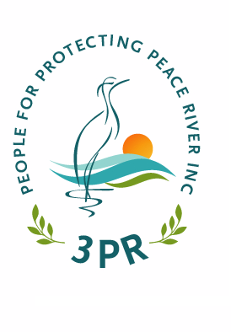

Submitted On:
3-June-2013

Submitted By:
People for Protecting Peace River, Inc. (3PR)
P.O. Box 155
Wauchula, FL 33873

Submitted To:
John Fellows, FAEIS Project Manager
US Army Corps of Engineers (USACE)
10117 Princess Palm Ave, Suite 120
Tampa, FL 33610-8302
Phone: (813) 769-7067

OBJECTION NOTICE
This document and the comments, narratives, references and other items contained herein are being submitted under protest and objection. Although People For Protecting Peace River, Inc. (3PR) submitted its comments on the Draft Areawide Environmental Impact Statement on Phosphate Mining in the Central Florida Phosphate District (FAEIS) in a timely manner, and the acceptance of the comments was acknowledged via email by Mr. John Fellows / USACE, the comments were not reviewed, no responses were incorporated into the FAEIS, and they were not included or attached to the FAEIS.
Facsimiles of the contents of Mr. Fellows' acknowledgement of receiving 3PR's DAEIS comments (Exhibit A), the letter emailed to Mr. Fellows (Exhibit B), and his email reply (Exhibit C) are as follows:

Exhibit A
From: Dennis Mader [mailto:protectpeaceriver@gmail.com]
Sent: Monday, May 20, 2013 10:26 AM
To: Fellows, John P SAJ
Subject: Public Comments - FAEIS
Dear Mr. Fellows:
Re: People for Protecting Peace River, Inc. (3PR) DAEIS Comments of 31-July-2012
On Thursday, 16-May-2013, I notified you by phone that the U.S. Army Corps of Engineers had:
1. Failed to respond to 3PR's written comments on the DAEIS, which were transmitted directly to you in a timely fashon.
2. Failed to include 3PR's writtent comments on the DAEIS with the Final FAEIS.
So far 3PR has not received a response from you regarding this question/issue.
On behalf of 3PR, I am requesting a clear, complete and immediate response.
Sincerely,
Dennis Mader,
Executive Director / 3PR

Exhibit B
From: Fellows, John P SAJ <John.P.Fellows@usace.army.mil>
Date: Tue, Jul 31, 2012 at 2:39 PM
Subject: RE: DAEIS Comments - 3PR (UNCLASSIFIED)
To: Dennis Mader <protectpeaceriver@gmail.com>
Classification: UNCLASSIFIED
Caveats: NONE
Hello Mr. Mader -
I have received 3PR comments, and I will make sure that CH2M HILL gets them.
Thank you again,
John
John Fellows
US Army Corps of Engineers
10117 Princess Palm Avenue, Suite 120
Tampa, FL 33610-8302
Phone: 813-769-7067
Fax: 813-769-7061
The Corps Jacksonville District Regulatory Division is committed to
improving service to our customers. We strive to perform our duty in a
friendly and timely manner while working to preserve our environment. We
invite you to take a few minutes to visit the following link and complete
our automated Customer Service Survey:
http://per2.nwp.usace.army.mil/survey.html
Your input is appreciated -favorable or otherwise.

Exhibit C
From: Fellows, John P SAJ <John.P.Fellows@usace.army.mil>
Date: Mon, May 20, 2013 at 1:03 PM
Subject: RE: Public Comments - FAEIS (UNCLASSIFIED)
To: Dennis Mader <protectpeaceriver@gmail.com>
Classification: UNCLASSIFIED
Caveats: NONE
Hello Mr. Mader -
Thank you for bringing this matter to the Corps' attention. You are correct, the Final FAEIS did not include a response to your July 31, 2012, comment letter. That letter was received in a timely manner.
The Corps will prepare an addendum to the Final FAEIS to address the comments in that letter, provide a public notice of the availability of that addendum, and allow the public additional time to review the addendum before making decisions on any of the four pending applications for individual permits for phosphate mines. We anticipate preparing that addendum within the next few weeks.
Very respectfully,
John Fellows
US Army Corps of Engineers
10117 Princess Palm Avenue, Suite 120
Tampa, FL 33610-8302
Phone: 813-769-7070
Fax: 813-769-7061
The Corps Jacksonville District Regulatory Division is committed to
improving service to our customers. We strive to perform our duty in a
friendly and timely manner while working to preserve our environment. We
invite you to take a few minutes to visit the following link and complete
our automated Customer Service Survey:
http://per2.nwp.usace.army.mil/survey.html
Your input is appreciated -
favorable or otherwise.

3PR's DAEIS and FAEIS comments have been prepared at great expense in terms of money and man-hours. 3PR's DAEIS comments were based on NEPA requirements and submitted in good faith. It was anticipated that the USACE would respond also in good faith, in accordance with federal law. However, it seems that this was not the case.
Because 3PR's comments were withheld by the USACE, not responded to, and not incorporated into the FAEIS as required by NEPA, it is 3PR's position that the FAEIS is legally compromised and therefore invalid, as set forth in the letter from Earthjustice to USACE, on behalf of 3PR, dated June 3, 2012.

____________________________________ Date: 3-June-2013
Dennis Mader, Executive Director
People for Protecting Peace River, Inc.
P.O. Box 155
Wauchula, FL 33873
TABLE OF CONTENTS

OBJECTION NOTICE 2
INTRODUCTION 1
3PR GENERAL POSITION STATEMENT 3
INAPPROPRIATE FAEIS SCOPE 4
FAEIS CONSISTENTLY AVOIDS NEPA PURPOSE 5
FAEIS VOLUMINOUS - LACKING "REAL" INFORMATION 6
FAEIS CONSISTENTLY PROMOTES THE APPLICANT'S NEEDS AND VIEWPOINTS 7
FAEIS IGNORES THE PROTECTION OF ECOSYSTEMS 7
SCOPING PROCESS BIASED AND RESTRICTIVE 8
3PR SCOPING PROCESS OBJECTION 9
PUBLIC INVOLVEMENT LACKING 10
"ENVIRONMENT JUSTICE" NEEDED FOR MINORITIES AND LOW-INCOME 10
CUMULATIVE IMPACTS NOT CONSIDERED 17
LOSS OF BIODIVERSITY IGNORED 18
OBJECTION TO FAEIS REVIEW TIME LIMIT 19
RELATED DOCUMENTS LARGE AND/OR INACCESSIBLE 22
FAEIS INAPPROPRIATE AND POOR QUALITY 23
PERMIT DURATIONS FAR TOO LONG 24
IMPROPER PURPOSE AND NEED 25
MINING NOT A TEMPORARY IMPACT 26
CUMULATIVE IMPACT ANALYSIS 26
ADDITIONAL HYDROLOGIC / EVAPOTRANSPIRATION IMPACTS 28
DESTRUCTION OF A VERY LARGE NUMBER OF BASINS 29
UNQUALIFIED ECOSYSTEM STUDIES 30
USACE INSUFFICIENT CAPABILITY TO EVALUATE DATA AND ANALYSIS 31
UNIQUE PHYSIOGRAPHY / GEOMORPHOLOGY 32
PHOSPHATE STRIP MINING IMPACTS 5 MAJOR RIVERS 33
LACK OF CONSIDERATION FOR ENDEMISM AND GENETIC DIVERSITY 35
SPECIAL ECOSYSTEM ANALYSES NEEDED 36
FAEIS GENERALLY INAPPROPRIATE 36
SIGNIFICANT ENVIRONMENTAL ISSUES 38
FAEIS ERRONEOUS AND BIASED STATEMENTS 42
FAEIS NOT SCIENTIFICALLY QUALIFIED 42
INADEQUATE PUBLIC NOTICE AND EDUCATION 45
SCOPE AND DETAIL OF FAEIS INSUFFICIENT 45
FAEIS PREDETERMINES APPROVAL THROUGHOUT 46
INADEQUATE PUBLIC EDUCATION AND INVOLVEMENT 46
RANGE OF ALTERNATIVES IMPROPER AND INCONSISTENT 47
AFFECTED ENVIRONMENT ANALYSIS GROSSLY INSUFFICIENT 48
SOILS ESSENTIAL TO NATIVE ECOSYSTEMS AND HYDROLOGY IGNORED 49
COORDINATION AND CONSISTENCY WITH LOCAL AGENCIES LACKING 50
WILDLIFE COMMENTS NOT RELEVANT OR REASONABLE 53
RADIUM-226 IN BIRDS, WILDLIFE, AND PLANTS 58
MORE ON INCREASED RADIOACTIVITY AND RADIATION CONTAMINATION 61
PROTECTION OF CHILDREN FROM ENVIRONMENTAL HEALTH RISKS & SAFETY RISKS. 67
WATER RESOURCES 69
WATER QUALITY - NONPOINT POLLUTION 70
IMPORTANCE OF UPPER SAS OMITTED: (HYDROLOGY OF NATIVE SOILS) 70
WETLANDS AND STREAMS NOT RESTORABLE 71
WELLS IMPACTED BY MINING 72
WATER DEMANDS VERSUS WETLAND HYDROLOGY AND ECOLOGY 73
WATER USE, "DOWNSTREAM" USERS, AND CHARLOTTE HARBOR 74
MINING'S HISTORY OF SPILLS, DISCHARGES, AND POLLUTION 77
PROCESSING REAGENTS ("CHEMICALS") IN THE ENVIRONMENT 79
ECONOMIC LIABILITY FOR CLEANUP, MAINTENANCE AND MANAGEMENT COSTS 82
DISASTER LIABILITY: HOW CAN THE PUBLIC EVER PAY? 83
PLANT AND ANIMAL RELOCATION AND MITIGATION IN GENERAL 84
ENDANGERED PLANT SPECIES 86
RELOCATION OF PLANTS AND ANIMALS 86
INACCURATE WILDLIFE SURVEYS 88
"COGONGRASS" INFESTATIONS ON MINED LANDS 89
FAEIS REFERENCES INAPPROPRIATE 90
PROBLEMS WITH FAEIS REFERENCES 93
3PR COMMENTS ARE SUPPORTED BY SCIENTIFIC LITERATURE 94
PROVIDED RESEARCH AND COMMENTS MUST BE INCORPORATED 132
3PR FINAL RECOMMENDATIONS 132

3PR REVIEW COMMENTS:
Final Areawide Environmental Impact Statement (FAEIS)
on Phosphate Mining in the Central Florida
Phosphate District (CFPD)
US Army Corps of Engineers, Jacksonville District, April 2013

Re: Final AreaWide Environmental Impact Statement (FAEIS)
On Phosphate Mining In The Central Florida Phosphate District (CFPD)

Submitted By: Dennis Mader, Executive Director
People for Protecting Peace River, Inc.
P.O. Box 155
Wauchula, FL 33873

Submitted To: John Fellows, FAEIS Project Manager
US Army Corps of Engineers
10117 Princess Palm Ave, Suite 120
Tampa, FL 33610-8302
Phone: 813.769.7067
Via (1): www.PhosphateFAEIS.org
Via (2): teamFAEIS@phosphateFAEIS.org

Date Submitted: 3-June-2013

INTRODUCTION
The "Substantive Comments" contained herein are prepared and submitted by the People for Protecting Peace River, Inc. (3PR), a Florida non-profit organization. They are provided in response to the document entitled "Final Areawide Environmental Impact Statement on Phosphate Mining in the Central Florida Phosphate District (FAEIS)" issued by the US Army Corps of Engineers (USACE), Jacksonville District, and Dated April 2013". 3PR has been an active and public participant in phosphate mining/planning/permitting issues and is interested in all environmental concerns which have the potential to affect west Central Florida.
The FAEIS was prepared by the US Army Corps of Engineers, Jacksonville District. It is required to have been prepared based on, and consistent with, the policies, regulations, and public laws of the United States including, but not limited to, The National Environmental Policy Act (NEPA), hereafter referred to as the "Act" or "NEPA", and 40 CFR, which is administered by the United States Environmental Protection Agency (USEPA).
The Congress of the United States has declared as a "National Policy", "to promote efforts which will prevent or eliminate damage to the environment and biosphere":
42 USC § 4321 - Congressional declaration of purpose
The purposes of this chapter are: To declare a national policy which will encourage productive and enjoyable harmony between man and his environment; to promote efforts which will prevent or eliminate damage to the environment and biosphere and stimulate the health and welfare of man; to enrich the understanding of the ecological systems and natural resources important to the Nation; and to establish a Council on Environmental Quality.

Additionally, "Congress recognized that nearly all federal activities affect the environment in some way and mandated that before federal agencies make decisions, they must consider the effects of their actions on the quality of the human environment".
The specific purpose and mandate of NEPA, "as our basic national charter", is "Protection of the Environment" through actions which "protect, restore, and enhance the environment", through "accurate scientific analysis" and "decisions that are based on understanding of environmental consequences", without including "needless detail". Its provisions require that the information upon which decisions are made must be of "high quality". The Act also stresses that "expert agency comments and public scrutiny are essential".
40 CFR 1500.1 Purpose
(a) The National Environmental Policy Act (NEPA) is our basic national charter for protection of the environment. It establishes policy, sets goals (section 101), and provides means (section 102) for carrying out the policy.
(b) NEPA procedures must insure that environmental information is available to public officials and citizens before decisions are made and before actions are taken. The information must be of high quality. Accurate scientific analysis, expert agency comments, and public scrutiny are essential to implementing NEPA. Most important, NEPA documents must concentrate on the issues that are truly significant to the action in question, rather than amassing needless detail.
(c) Ultimately, of course, it is not better documents but better decisions that count. NEPA's purpose is not to generate paperwork--even excellent paperwork--but to foster excellent action. The NEPA process is intended to help public officials make decisions that are based on understanding of environmental consequences, and take actions that protect, restore, and enhance the environment.

40 CFR 1500.3 Mandate
Parts 1500 through 1508 of this title provide regulations applicable to and binding on all Federal agencies for implementing the procedural provisions of the National Environmental Policy Act

In preparing its substantive comments for the FAEIS, 3PR is relying on adherence to the Act and other relevant federal laws by all federal agencies.
3PR is questioning the information and analysis contained in the FAEIS in terms of it accuracy and adequacy, and is doing so by presenting its assertions with sound and reasonable basis. As cited below, 40 CFR provides that the comments may address the adequacy of the FAEIS and merits of the alternatives, and that the agency will assess, consider, and respond to all comments:
40 CFR 1503.3 Specificity of Comments
(a) Comments on an environmental impact statement or on a proposed action shall be as specific as possible and may address either the adequacy of the statement or the merits of the alternatives discussed or both.

40 CFR 1503.4: Response to Comments
(a) An agency preparing a final environmental impact statement shall assess and consider comments both individually and collectively, and shall respond by one or more of the means listed below, stating its response in the final statement. Possible responses are to:
- Modify alternatives including the proposed action.
- Develop and evaluate alternatives not previously given serious consideration by the agency.
- Supplement, improve, or modify its analyses.
- Make factual corrections.
- Explain why the comments do not warrant further agency response, citing the sources, authorities, or reasons which support the agency's position and, if appropriate, indicate those circumstances which would trigger agency reappraisal or further response.

The legal purposes of an Environmental Impact Statement include, but are not limited to, ensuring a "full and fair discussion of significant environmental impacts" and the development of reasonable alternatives which avoid or minimize adverse impacts. It is required to be "concise, clear, and to the point", and "supported by evidence that the agency has made the necessary environmental analyses":
40 CFR 1502: "Environmental Impact Statement"
1502.1: Purpose - The primary purpose of an environmental impact statement is to serve as an action-forcing device to insure that the policies and goals defined in the Act are infused into the ongoing programs and actions of the Federal Government. It shall provide full and fair discussion of significant environmental impacts and shall inform decision makers and the public of the reasonable alternatives which would avoid or minimize adverse impacts or enhance the quality of the human environment. Agencies shall focus on significant environmental issues and alternatives and shall reduce paperwork and the accumulation of extraneous background data. Statements shall be concise, clear, and to the point, and shall be supported by evidence that the agency has made the necessary environmental analyses. An environmental impact statement is more than a disclosure document. It shall be used by Federal officials in conjunction with other relevant material to plan actions and make decisions.

3PR GENERAL POSITION STATEMENT
* Substantive Comment:
3PR presents its comments as respectfully as is morally possible. In our comments we have strived for objectivity and sincerity. Even so, it is "truth", "transparency", and "compliance" in federal permitting that we wish to further. When 3PR submitted its comments on the Draft Areawide Environmental Impact Statement (DAEIS), we fully anticipated forthright, sober evaluations, faithful consideration, and complete replies to our comments. We were wrong! The USACE did not respond to, or include our comments in the DAEIS. Also, no explanation has since been provided. Therefore, we do not know if the USACE will abide by federal law or not in their treatment of the comments contained herein?
In the sections which follow, 3PR supports with sound, legal, and scientific basis that the information provided in the FAEIS is generally inadequate and inaccurate for its intended purposes of "Protection of the Environment". 3PR considers that many statements and portions of the FAEIS consists merely of large volumes of pro forma data and analyses which do not further the "understanding of environmental consequences, and take actions that protect, restore, and enhance the environment" as required by NEPA. Statements are often supported only vaguely, without qualified scientific support, almost invariably lacking and failing to acknowledge the large body of existing relevant published research including, but not limited to, those offered by 3PR and other FAEIS commenters/parties.
In general, 3PR contends that the environmental analysis is so highly inadequate, inaccurate, and/or antiquated, and in many instances misleading, that the FAEIS should be completely rejected in favor of the development of a new, more objective, complete, reasonable, clear and concise document which provides the meaningful and measurable directives needed to protect west-central Florida from the diverse negative impacts associated with phosphate strip mining.

INAPPROPRIATE FAEIS SCOPE
* Substantive Comment:
3PR objects to the narrow and short-sighted view of the FAEIS because its narratives nowhere express proper concern for the scale and intensity of mining impacts, the diversity of impacts, or especially the inestimable cumulative impacts and legacy of environmental disaster which phosphate strip mining has bequeathed west-central Florida. Also, numerous direct and indirect impacts of phosphate strip mining are avoided or merely minimized or explained away without adequate scientific bases, such as the massive chemical waste disposal/usage of the industry, gypsum waste stockpiling, and radioactivity distributed in products.
The FAEIS purports to include an "affected area" or "study area" designated as the Central Florida Phosphate District (CFPD)[ which is actually the FDEP 'Conceptual Mineable Limit'] (Figure 1) that encompasses approximately 1.32 million acres of land (actually closer to 1.35 million acres), and physically extends through parts of six counties. It is obvious that phosphate strip mining within the CFPD will not only profoundly affect the landscape of west-central Florida, but that the negative effects of mining will extend far outside of this artificial boundary, especially impacting "downstream" jurisdictions including Charlotte, Lee and Sarasota counties.
The boundary of the CFPD represents merely the mineable limit, that is, the extent to which the phosphate industry eventually will mine, or the current economically feasible phosphate strip mining limit. However, an Environmental Impact Statement must include all regions and all types of potential "impact", including environmental impacts, economic impacts, and impacts to human society. For this reason, a much broader study area is needed. The study area should include the mineable limit plus a broad buffer extending downstream along the four affected major rivers (and Horse Creek) to, and including, the receiving bays and estuaries. The extended study area should also include potential impacts to farmlands and underlying groundwater from phosphate fertilizers and other products, as well as the water quality impacts of phosphate fertilizers to lakes, waterway, and other resources including, but not limited to, the Florida Everglades, Florida Bay, Tampa Bay, the Great Barrier Reef of Australia, and many other sensitive and important ecosystems which have been reported degraded. Such a study area would then better represent the "affected area", or at least would represent a small subset of the potentially world-wide negative impacts of phosphate strip mining, processing, and product distribution.
The four phosphate strip mining approvals would, if permitted to, result in mining that would extend over decades, transcending politics, political terms, and changes in socioeconomic patterns. All post-mining scenarios will result in perpetual maintenance and management of inestimable mining liabilities such as CSAs, onsite chemical reagent pollution on reclaimed land, pollution spills to external lands and waster resource systems, eternal elevated radiation, and various forms of other contamination. The negative economics of environmentally damaging industries "are generally hidden from traditional economic accounting" (Daily 1997). Eventually future generations, all of whom had no role or voice in the current permitting processes, and who did not share in any of the short-term economic benefits, such as the very slight increases in jobs for local residents, will inherit the exceedingly sad environmental and economic legacy left by phosphate strip mining. That is, the counties actually being sacrificed for mining will not share significantly in its huge profits.

FAEIS CONSISTENTLY AVOIDS NEPA PURPOSE
* Substantive Comment:
3PR contends that the FAEIS is substantially incomplete because it disproportionately focuses on Section 404 (CWA) Dredge and Fill permitting as though the vast and controversial phosphate strip mining proposals were merely small, necessary, business or residential projects with no significant environmental impacts, and as though wetland permitting were one of only a few "real" issues. Nowhere does the FAEIS provide sufficient data, analysis, and direction commensurate and consistent with fulfilling NEPA's purpose of "Protection of the Environment" in preparing and administering "Environmental Impact Statements". Incredibly, Alternative-1 ("No-Action") does not appear to restrict or prohibit continued mining in uplands and upland ecosystems, which is where the most profound, irreparable and incomprehensibly devastating impacts of phosphate strip mining take place. Such mining "strips" away vast regions of wildlife habitat, traditional farmlands, and scenic natural landscapes, then "mines" the earth (matrix) below it. It appears that the FAEIS allows, even with "no permit", that the most significant and devastating of all aspects of phosphate strip mining will still be allowed to take place. The direct impacts include, but are not limited to: near total topographic alteration of entire regions, destruction of their aquifers, vast and extensive alteration of recharge systems, area-wide reconfiguration of the surface-water runoff patterns of rivers, creeks, and seepage regimes, and area-wide alteration of evapotranspiration rates. In addition, vast areas remain without native wetland and upland habitats for long periods of time.
The totality of upland transfiguration and ecosystem destruction will also have profound negative impacts to water quality and quantity. In fact, the FAEIS cites that phosphate strip mining in uplands will result in excavation of pits and pumping, potential reductions in water table elevations of "20 feet", and direct impacts to the surficial aquifer system (SAS), hydrology and sensitive habitats, groundwater dewatering, impacts to shallow wells, lowering of local water tables, and further extensive alterations to surface water management systems by ditching and construction of clay waste disposal (CSAs) sites including dams and berms. Acknowledgement or analysis of the relationship of the specialized vegetative communities which occur in the Southwestern Florida Flatwoods Ecoregion (Figure 4) and their high degree of correlation to regionally specific and unique soils is conspicuously absent throughout the FAEIS. Possibly it is inconvenient to discuss the destruction of ecological resources that can never be restored or replaced because native soils and hydrology have been stripped away, and most of the genetic diversity of all of the species involved has been forever lost.
NEPA requires coordination with state and local agencies and consistency with their laws, regulations, and planning. "The FAEIS study area is located within a water supply planning area that SWFWMD has defined as the Southern Water Use Caution Area (SWUCA) on the basis of concerns that cumulative reliance on withdrawals from the upper FAS through well systems to meet potable, agricultural, and industrial water supply demands has resulted in an unsustainable lowering of the potentiometric surface of the Floridan aquifer." The FAEIS acknowledges SWUCA, discusses SWUCA, then fails to appropriately consider the tremendous magnitude of the negative water resource impacts potentially threatening the "Water Use Caution Area" by area-wide phosphate strip mining, most of which takes place in uplands, yet the impacts of which absolutely and profoundly affect river flows, aquifers, and wetlands. The Peace River Valley is a geologic and biological natural wonder, already half-destroyed by phosphate strip mining. It took many thousands of years for this intricate wetland and upland wilderness to form; teaming with native wildlife, with its hundreds of miles of rivers, streams and tributaries, thousands of diverse isolated wetlands, sloughs and seeps, and intricate mosaics of dry prairie with stately Florida pines, vast and extensive live oak hammocks with thousands of trees over two-hundred years old. Yet it will take less that two decades for the phosphate strip mining industry to completely and irrevocably destroy.
Natural systems are composed of the interrelated and inseparable factors of physical/geologic, hydrologic, atmospheric/climatic, and biotic. Damage to one creates damage to the others, both onsite and offsite, even nationally and internationally as climate, nutrient cycling, systems ecology, and migratory species are involved. Phosphate strip mining has a long history of obliterating these life-giving assets and precluding their natural recovery because of extreme surface and subsurface modification and loss of essential native soils, seed banks, concomitant genetic diversity, and ecosystem generational interaction and dynamics.
A Florida Administrative Law Judge recently found that "Modern (phosphate) mining still has a devastating impact on the local natural environment." ( J. Lawrence Johnston 2003).

FAEIS VOLUMINOUS - LACKING "REAL" INFORMATION
* Substantive Comment:
The FAEIS is insufficient and/or unsupported by independently developed, regionally relevant data and proper site-specific evaluations and research. It is excessively voluminous at 2,794 pages, and impossible to review within a 30-day time period. Most sections are highly deficient and preclude meaningful review and comment. The content of the FAEIS appears to rely disproportionately on representations, data, and analyses obtained from the Applicants and/or other sources directly or indirectly related to the phosphate strip mining industry, such as The Phosphate Council. These interactions may be procedurally or "technically" permissible? However, they ensure extreme prejudice, greatly diminish transparency in the NEPA process, and have served to erode the credibility of this FAEIS. However, in large part, the quality, appropriateness, and relevancy of the information are perceived by 3PR as grossly unacceptable. The FAEIS includes precisely the types and bulk of content that NEPA specifically warns that the USACE and other federal agencies must not include or indulge in: "Agencies shall focus on significant environmental issues and alternatives and shall reduce paperwork and the accumulation of extraneous background data. Statements shall be concise, clear, and to the point, and shall be supported by evidence that the agency has made the necessary environmental analyses". These points are more particularly expanded upon and described in later sections.

FAEIS CONSISTENTLY PROMOTES THE APPLICANT'S NEEDS AND VIEWPOINTS
* Substantive Comment:
The FAEIS promotes many positions for which there is intense and adamant disagreement among scientists and researchers who are "independent" of the phosphate industry, and its related agencies, consultants, attorneys and public relations personnel. Throughout the FAEIS, countless statements are presented which are unsupported by science. Particularly lacking are objective studies which are directly relevant to the nature of the lands involved and types of impact inflicted by phosphate strip mining. Many of these disagreements have to do with the tremendous extent of wetlands, upland native ecosystems, and native biota historically destroyed by phosphate strip mining, and the fact that many of these systems can never, and have not, been replicated, replaced, or effectively restored to any reasonably viable or functional ecological equivalents of the original ecosystems. The vast native assets involved are essential to protect in trust for the future of humanity. Were it not for phosphate mining, the region in question would support millions of people sustainably, in perpetuity.
In summary, the FAEIS almost completely omits, and strains to avoid, the tremendous body of scientific literature and research data and analyses which show the negative impacts which phosphate strip mining and its related industries have imparted to native upland and wetlands ecosystems and biota, rivers, streams, estuaries and other aquatic resources, groundwater resources, surface water resources, aquifers, water quality, availability and distribution, climate, community planning, and public health and safety, and many other areas of concern to the environment and the human population which depends upon it.

FAEIS IGNORES THE PROTECTION OF ECOSYSTEMS
* Substantive Comment:
3PR questions the adequacy of the environmental analysis and the accuracy of information in the FAEIS, because it fails to consider the extremely important role of native ecosystems, especially the native upland ecosystems of the region, the "ecoregion", as irreplaceable repositories of ecological diversity, as imperative for maintaining and ameliorating the climate, in sequestering carbon, in providing for a vast abundance of native wildlife, including myriads of plants and animals, in providing regionally natural and traditional aesthetics and a healthy human environment, and as offering many other benefits essential to humans and the natural world. Also ignored are the irreplaceable values of native soils in maintaining water quality, regulating hydrology, ameliorating the climate, supporting regionally adapted vegetation associations and unique gene pools, and as the essential, non-replaceable basis for most all traditional agriculture in the region.
Upon reading the FAEIS it occurs to 3PR that there are some who do not know what an "Ecosystem" is:
An ecosystem is a community of animals and plants interacting with one another and with their physical environment. Ecosystems include physical and chemical components, such as soils, water, and nutrients that support the organisms living within them. These organisms may range from large animals and plants to microscopic bacteria. Ecosystems can be thought of as the interaction among all organisms in a given habitat. People are part of ecosystems. The health and well-being of human populations depends upon intact and carefully managed ecosystems and their components - organisms, soil, water, and nutrients.

Ecosystems and Biodiversity provide "services" that:
- Moderate weather extremes and their impacts.
- Disperse seeds
- Mitigate drought and floods.
- Protect people from the sun's harmful ultraviolet rays.
- Cycle and move nutrients.
- Protect stream and river channels and coastal shores from erosion
- Detoxify and decompose wastes.
- Control the vast majority of agricultural pests.
- Maintain biodiversity.
- Generate and preserve soils and renew their fertility.
- Partially stabilize climate.
- Purify the air and water.
- Regulate disease carrying organisms.
- Pollinate crops and natural vegetation. (Daily et al 1997).

The recognition of the essential values provided ecosystems and the natural environment is conspicuously absent, virtually omitted from much of the FAEIS. The concept of "Ecosystem Services" and the fact that all life, including human life, rely on such, is not articulate or considered in the FAEIS. 3PR therefore expounds on this primary issue throughout its comments. "It is the web of life which supports humanity"; a fact which is fatally ignored throughout the FAEIS which, by law, is required to be focused solely on the goal of "Protection of the Environment".

SCOPING PROCESS BIASED AND RESTRICTIVE
* Substantive Comment:
3PR questions the adequacy of the scoping process for the FAEIS because it does not sufficiently include involvement of well-known, regional research institutions, expert regional ecologists, and unbiased third-party sources of credible research, especially Archbold Biological Station (preeminent research center for conservation biology, plant ecology and restoration biology in central Florida), the Natural Resources Flight of the Avon Park Air Force Range (conducting federal research for large-scale ecosystem conservation land management involving many listed plants and animals native to central Florida), Center for Plant Conservation Network at Bok Tower Gardens (conducting extensive research relating to listed/endemic native plant relocations, reintroduction strategies, and endemic plant ecology), Tall Timbers (ecological, botanical, management, and forests research) and notable central Florida biologists who have conducted independent ecosystems studies in central Florida over many years. Neither has any of their relevant published research been quoted, cited or incorporated into the decision-making or recommendations of the FAEIS.
3PR questions the adequacy of the scoping process for the FAEIS, because important relevant ecosystem research and analyses, as discussed and cited elsewhere herein, were not independently formulated and conducted specific to the ecosystems, environs, and biota found within the CFPD, particularly within the southern half of this area. Because of the immense size of the CFPD, and the intensity and indelibility of phosphate strip mining impacts, independent, objectively verifiable studies should have been conducted in order that the immediate impacts, as well as the cumulative impacts of mining could be properly evaluated. However, this was not the case, as much of the important information which should have been "objective", and subjected to the level of "public scrutiny" which NEPA requires, appears merely to have been provided by the Applicants, their agents, or phosphate strip mining proponents.
3PR questions the adequacy of the original scoping process for the FAEIS in terms of "Environmental Justice" because minorities and low-income residents may not have been well represented and accorded fair treatment and meaningful involvement, and because the Applicants and/or Phosphate Industry representatives were overrepresented throughout the process, including in the forums facilitating the development of the FAEIS. As previously indicated the latter may be permissible under the Act, but such process domination and prejudice tremendously and untenably biases the FAEIS in favor of the offending industry instead of promoting the NEPA mission of "Protection of the Environment".
Because the USACE has only been receptive to information provided by the Applicants, and is non-responsive to all other, the scoping process and the Draft and Final AEIS have been perceived as adversarial to public and non-industries parties. This absence of fairness and transparency has resulted in a Final FAEIS which is virtually useless in that it is not based on the public participation standards required by NEPA, nor does it embrace any scientific, fairness, or environmental justice provisions of the act.

3PR SCOPING PROCESS OBJECTION
* Substantive OBJECTION:
3PR vehemently objects to the scoping process as providing any legitimate bases for the development of the FAEIS under NEPA because the data and analyses, recommendations, and opinions of independent scientists and environmental professionals were not solicited, not properly considered, or not incorporated into the document.
3PR provided the results of qualified site specific environmental studies, which were summarily rejected without comment or explanation. 3PR provided these environmental analyses through its professional consultants, Winchester Environmental Associates, Inc. Several important primary concerns relating to phosphate strip mining were evaluated through on-site and offsite environmental analyses, including wetlands mitigation, wetland reclamation, endangered species, cumulative impacts, and downstream estuarine concerns. The lead scientist for this exercise is among the most experienced professional consultants in the region. He has qualified as an expert witness and testified in legal proceedings many times.
A glaring resistance to any and all independent scientific information appears to be endemic to phosphate strip mine permitting procedures and to the development of both the DAEIS and FAEIS. However, such rejection of public involvement is diametrically inconsistent with the spirit and intent of NEPA and the public participation and involvement requirements guaranteed under the Act. Moreover, NEPA stresses that public scrutiny is essential to its fair implementation and sole mission of "Protection of the Environment". NEPA requires that agencies encourage participation at all levels and requests involvement and comments from the public, affirmatively soliciting comments from those persons or organizations which may be interested or affected.
If important site-specific relevant research and information provided directly by the highly experienced and reputable representative of a prominent local professional consulting firm is not welcomed by the USACE, then it is clear that no independent voices were to be considered in the scoping process.
This single example is emblematic of the dreadful deficiencies of the scoping process and insincere efforts to claim public involvement and objectivity. This incident solidifies the appearance evident throughout the scoping process of near total reliance on information and representations provided by the Applicants and pro-mining interests.

PUBLIC INVOLVEMENT LACKING
* Substantive Comment:
3PR questions the adequacy of the measures taken in the FAEIS to ensure appropriate levels of public involvement and participation, especially fair treatment and meaningful involvement of low-income and minority (non-English speaking) segments of local communities, which are prevalent in many areas of the CFPD, especially in rural jurisdictions such as Hardee County, an impoverished area, and DeSoto County, the poorest county in Florida. Such socially and economically disadvantaged residents represent special cases of concern. They are deserving of the additional efforts needed to effectively involve and educate them concerning FAEIS process, and concerning the myriad of potential negative impacts phosphate strip mining will ultimately have on their lives, livelihoods, and futures. They are also entitled to other supplementary and ancillary considerations which are necessary in order to achieve "Environmental Justice".

"ENVIRONMENT JUSTICE" NEEDED FOR MINORITIES AND LOW-INCOME
* Substantive Comment:
3PR questions the adequacy of the environmental analyses and accuracy of the information in the FAEIS because the "Environmental Justice Review" is inappropriate and not without bias, and because the processes involved in the review were not open and transparent to low-income and minority communities. 3PR also contends that low-income and minority communities were appropriately informed in accordance to their special needs, and as to the potential negative impacts which continued phosphate strip mining may have on their communities.
Definition of "Environmental Justice" (EPA's Office of Environmental Justice): "The fair treatment and meaningful involvement of all people regardless of race, color, national origin, or income with respect to the development, implementation, and enforcement of environmental laws, regulations, and policies. Fair treatment means that no group of people, including racial, ethnic, or socioeconomic group should bear a disproportionate share of the negative environmental consequences resulting from industrial, municipal, and commercial operations or the execution of federal, state, local, and tribal programs and policies."

It is stated in the FAEIS that "Consistent with EO 12898, this FAEIS incorporates by reference the studies conducted by the Applicants on socioeconomic conditions in the CFPD". Firstly 3PR cannot determine the meaning of "incorporate by reference" in this context because no document(s) of the "Applicants" was/were referenced in this section or elsewhere in the FAEIS (as far as 3PR can determine). Clearly, it is not appropriate, or in the best interests of minority and low-income populations for phosphate strip mining Applicants to determine their special needs or purport to administer environmental justice on behalf of the government of the United States. This statement presented by the Applicants shows a clear conflict of interests in that the Applicants were allowed to provide data and analyses, and draw conclusions that have the potential to profoundly and negatively affect public welfare in regard to the purposed of NEPA, "Protection of the Environment". Executive Order 12898 is a presidential order directing the federal government, and all federal agencies, to investigate the environmental impacts of federal action on the lives, communities, and economies of "minority populations and low-income populations". Also, there is no mention in the Executive Order of addressing these concerns at the census block level as the FAEIS suggests. Quite to the contrary, the Presidential Memorandum that accompanied the Executive Order speaks only about communities and specifically cautions that minority and low-income "communities" may be missed and that "distortion" may occur by using census data (USEPA 1997).
The fact that census data can only be disaggregated to certain prescribed levels (e.g., census tracts, census blocks) suggests that pockets of minority or low-income communities, including those that may be experiencing disproportionately high and adverse effects, may be missed in a traditional census tract-based analysis. Additional caution is called for in using census data due to the possibility of distortion of population breakdowns, particularly in areas of high Hispanic or Native American populations. In addition to identifying the proportion of the population of individual census tracts that are composed of minority individuals, analysts should attempt to identify whether high concentration "pockets" of minority populations are evidenced in specific geographic areas.

Four specific actions were directed at NEPA-related activities, including:
1. Each federal agency must analyze environmental effects, including human health, economic, and social effects, of federal actions, including effects on minority communities and low-income communities, when such analysis is required by NEPA.
2. Mitigation measures outlined or analyzed in EAs, EISs, or Records of Decision (RODs), whenever feasible, should address significant and adverse environmental effects of proposed federal actions on minority communities and low-income communities.
3. Each federal agency must provide opportunities for community input in the NEPA process, including identifying potential effects and mitigation measures in consultation with affected communities and improving accessibility of public meetings, official documents, and notices to affected communities.
4. In reviewing other agencies' proposed actions under Section 309 of the CAA, EPA must ensure that the agencies have fully analyzed environmental effects on minority communities and low-income communities, including human health, social, and economic effects.

Executive Order 12898 requires federal actions to address environmental justice in minority populations and low-income populations. The FAEIS does not consider the mandates of Environmental Justice in its deliberation, analyses, conclusions, and recommendations.
Executive Order 12898 of February 11, 1994
Section 1–1.Implementation.
1–101. Agency Responsibilities. To the greatest extent practicable and permitted by law, and consistent with the principles set forth in the report on the National Performance Review, each Federal agency shall make achieving environmental justice part of its mission by identifying and addressing, as appropriate, disproportionately high and adverse human health or environmental effects of its programs, policies, and activities on minority populations and low-income populations in the United States and its territories and possessions, the District of Columbia, the Commonwealth of Puerto Rico, and the Commonwealth of the Mariana Islands.

Of the six counties intersecting the CFPD, and the three "downstream" counties which are also greatly affected (Charlotte, Lee and Sarasota counties), Hardee and Desoto are the most impoverished, and support the highest percentages of minorities. 2011 US Census Bureau estimates that 44.5% of the population of DeSoto County belongs to minority classes, and that the per capita income in (2010 dollars) is only $15,989. 26.9% of persons (nearly double the national average of 13.9%) are below the poverty level. 52.4% of the population of Hardee County is estimated to belong to a minority. The per capita income is a mere $14,668, with about 26.1% of persons (nearly double the national average of 13.9%) existing below the poverty level. These two counties are entitled to additional protection under the following federal action to address Environmental Justice in Minority Populations and Low-Income Populations. In addition, it has been demonstrated, and documented, that immigrant minorities often intentionally avoid being counted by the Census, or by government. It is therefore very likely that the "actual" minority and low-income statistics and numbers officially reported for Hardee and DeSoto counties may be significantly underestimated. In any case, it is certain that wide-spread destruction of native agriculture soils and potential farmlands, some of which have been in production for decades, and extensive alterations of topography and water resources, will negatively impact rural communities whose residents traditionally derive their livelihoods from local agriculture which historically has been the dominant industry of the region. Hardee and DeSoto counties rely almost totally on the utilization of natural resources, in the form of agriculture on native soils, as an their primary economic base. Many decades are required to build the infrastructure necessary to sustain such regionally specialized agriculture as citrus farming, truck (vegetable) farming, berry farming, cattle ranching, and others. Area-wide phosphate strip mining is an exploitive, short-sighted industry, out for huge profits at the expense of lands, traditions, and communities. Mining erodes agricultural infrastructure and the rural way of life by temporarily moving part of the economy to an industry which merely passes through, destroying tremendous tracts of agricultural land as it proceeds. The industry quickly mines it way through communities leaving perpetual, incomprehensible liabilities in its wake. Some agricultural lands which have been recently mined had been in almost continuous agricultural production for nearly 100 years. The traditional way of life and otherwise prosperous future of Hardee and DeSoto counties are thus threatened by the permanent and multifaceted devastation imparted by phosphate strip mining.
When communities become reliant on a polluting and environmentally destructive industry for jobs and tax revenues, local governments become more reluctant to take actions which would avoid risks to health and the environment that cost the industry money. Many public health risks are not visible or apparent to the general public or the elected bodies which represent them. In this scenario, minority and low-income communities usually do not enjoy the benefits of their labor in proportion to the health risks and economic impacts they are forced to bear.
Although a great body of science exists which provides technologies for efficient, profitable, and safe farming in areas supported by native soils, much less is known concerning the unnatural rocky/marl/sand/clay/etc (Arents-Hydraquents-Neilhurst) substrates resulting from phosphate strip mining. Table 1 suggests that 7,241 acres of dam-enclosed waste clay facilities (CSAs) would result from a single, previously proposed mine at Ona as analyzed by Hazen & Sawyer (2003), and that the vast majority of native soils would be transformed to post-mine substrates and mountains of dammed-in waste clays. The CH2M-Hill economic analysis in the FAEIS and the Ona Mine economic study (Hazen & Sawyer 2003) prepared by the Hardee County Board of County Commissioners, indicate that only a small number of temporary jobs will be created as the phosphate industry mines its way through the southern counties (mainly Hardee, DeSoto, and Manatee). "On average, there will be about 73 more jobs in the county each year than would exist without mining on the Ona Property" Additionally, the Hazen & Sawyer study did not consider the positive economic impacts and social values provided by non-game wildlife, safe commercial outdoor recreation, and environmental/wilderness aesthetics which benefit Hardee County, and which, if further developed, could greatly benefit the economy and quality of life in the county, in perpetuity, as self-sustaining assets (FFWCC 2003). There are many places in the world which have much less to offer in terms of native environment than in Hardee and Manatee counties that run their entire economies from non-game, passive ecotourism and related industries. Additionally, the study did not fully investigate all aspects of the potential for increased residential and commercial development which include ranges of land uses infinitely less damaging than phosphate strip mining. The impact of this single strip mining project (Ona) has the potential to negatively affect local communities and the environment on a large scale. It would greatly reduce job opportunities for members of low-income and minority communities who traditionally rely on viable agriculture for their livelihoods in this region of Florida, and which, unfortunately, generally have much lower educational attainment than whites and certain other segments of American society.

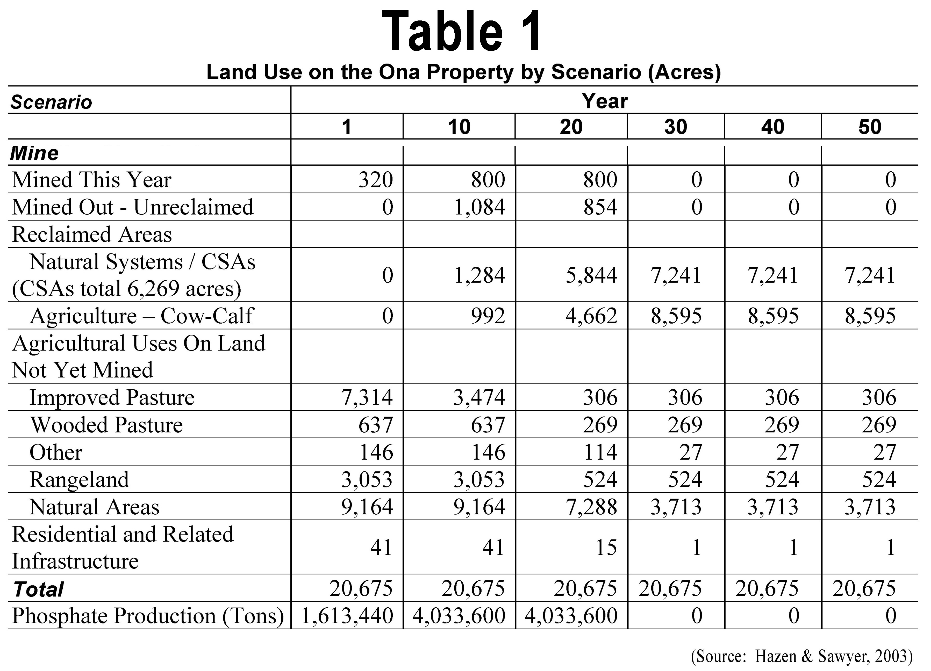

3PR additionally questions the adequacy of the environmental analyses in the FAEIS because independent, site-specific research (Hazen & Sawyer 2003) indicates that mining will ultimately be at the expense of viable agriculture, long-term economic growth, future development, protection of the environment, water resources and public health. Minorities and low-income residents are invested in their communities the same as other classes. No matter where they live in a jurisdiction (county) their lives will be negatively affected by phosphate strip mining. The economic profits of mining can never compensate for ecosystem destruction, or repair the damage to soils, aquifers, and geology. Only a minute fraction of the residents of Hardee and DeSoto are employed by mining, the vast majority of profits are directed to benefit external destinations and entities. To allow phosphate strip mining to move through a county, or in this case an entire region, leaving a wasteland in its wake, is not Environmental Justice. In the case of Hardee County, as explained previously, the far-reaching and diverse impacts associated with phosphate strip mining will disproportionately affect minorities and those of low-income. The Hazen & Sawyer economic analysis chart below shows that phosphate mining will ultimately be devastating to Hardee County’s local economy as compared to the “No Mining” scenario.

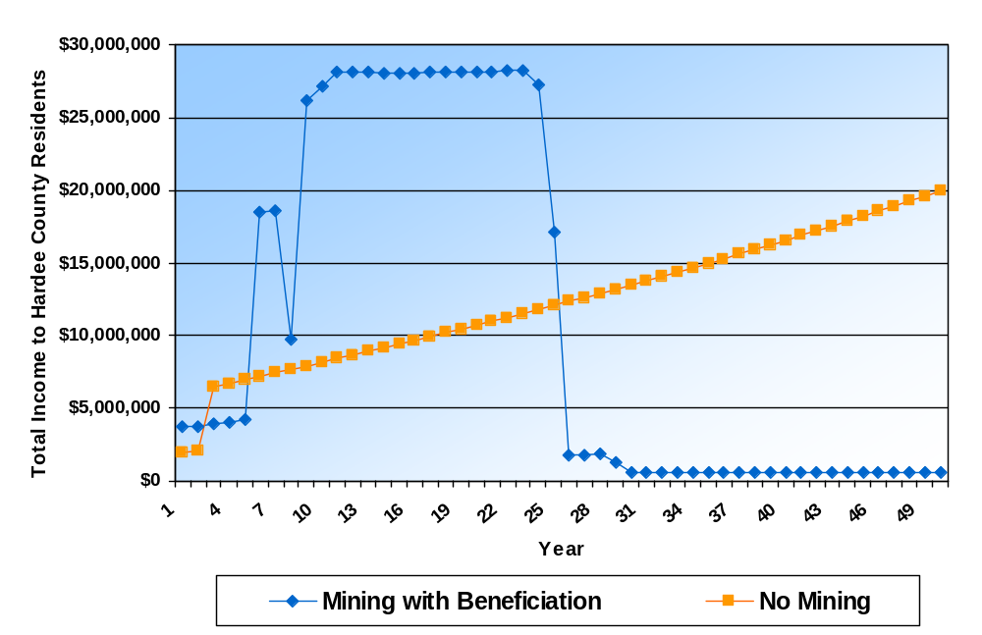

The majority of residents living within the southern half of the CFPD, mostly Hardee and DeSoto counties, either do not have a computer with Internet service, or do not have adequate Internet performance to effectively acquire and manage the documents involved. Not that they would actually be in a position to evaluate such large volumes of technical data and information. Disproportionately, the residents of these impoverished, less educated, mainly agricultural-based, strikingly lower socioeconomic jurisdictions, are much less able to become aware or acquire notice of federal actions, to analyze and understand the consequences of such actions, or effectively respond or comment. In many cases these residents do not possess an adequate level of education to comprehend the significance of the proposed action. This neglect is compounded by the fact that little or no effort has been made to specifically ensure that these special classes have been made aware of the scope, level of impacts, and long-term implications and consequences of the proposed, extensive, phosphate strip mining. In addition large percentages of these populations are minority classes, mainly Hispanic. Significant portions of the populations of Hardee and DeSoto counties do not read or speak English, or only marginally understand, read, or speak English as a second language. The DAEIS and FAEIS should have also been issued in a Spanish language version.
An exclusion of minorities, poorer classes of people, and less educated people has occurred through lack of consideration of their special circumstances in the development of the FAEIS, and in phosphate strip mining matters in general. This is evidenced by their lack of participation proportionate to their population shares in DeSoto and Hardee counties. Also, the minority classes in particular are not represented, or are poorly represented in local politics and government. Many do not hold jobs with industries that will pay them to attend public meetings, such as the phosphate industry does. Such matters represent class discrimination based on national origin, race/color and education, and are important "Environmental Justice" concerns not considered in the development of the FAEIS, or in the large permit applications currently being considered for approval which are intrinsically the subject and current focus of this federal action.
Because the minority and low-income classes, particularly those of Hispanic origin, represent the fastest growing segment of the populations of Hardee and DeSoto counties, Hispanic people will soon become heir to these counties, both socially and politically. Sadly, they are also destined to inherit the extreme liabilities and other negative legacies of area-wide phosphate strip mining. These generally include, but are not limited to, extensive clay waste disposal sites, wholesale ecosystem and wildlife habitat destruction, degradation and alteration of wetlands, creeks, streams and water resources, elevated radiation levels, and ongoing pollution and spills of various types from various sources. The FAEIS is inadequate and inaccurate in that it does not specifically provide planning considerations for this dramatic social change, or social phenomenon, in consideration of the community impacts and economic shifts associated with phosphate strip mining.
As previously indicated, many extreme environmental impacts, and many crucial environmental issues are directly involved in large-scale phosphate strip mining and its related industries. Much has been reported and published concerning the negative effects of such mining on minorities and low-income residents, and on their impoverished communities.
Unfortunately, because of the completely inadequate amount of time provided by the USACE/USEPA to obtain and comment on the contents of a 2794 page report, 3PR can only respond to a few of the many issues which have not been addressed, or adequately addressed. Also, because the amount of time allotted for review and comment was grossly insufficient, this too is inconsistent with ensuring "Environmental Justice". It is not merely a deficiency in providing for the special rights of the low-income residents, impoverished communities, and minorities, which are guaranteed through special consideration to those special classes, but communication of important issues and concerns, which in such communities requires a significant special effort because such residents have less education, financial means, free time, and also lack access to the technical resources needed to read, verify, and comment on such a voluminous and technically specialized document as the FAEIS.
Of additional significance and concern relating to the insufficient comment period allotted the FAEIS, is that the document contains a large number of very complex and technical alternatives, each of which would independently require substantial time and resources to evaluate. Even to verify and comment on a single significant issue, such as hydrologic impacts, may require months. The FAEIS is thus further inadequate and deficient in that it contains a highly excessive amount of technical information and industry conjecture, and is thus directly with the requirements of NEPA. In addition, and this is discussed further later, the FAEIS does not treat the geographic area involved as a single area-wide project, but includes many renditions of multiple subprojects, each of which must be analyzed separately.
Lisa F. Garcia, senior adviser to the EPA administrator for environmental justice, emphasized the importance of advancing environmental justice and the goals of Plan EJ 2014, "Far too often, and for far too long, low-income, minority and tribal communities have lived in the shadows of some of the worst pollution, holding back progress in the places where they raise their families and grow their businesses. Today's release of Plan EJ 2014 underscores Jackson's ongoing commitment to ensuring that all communities have access to clean air, water and land, and that all Americans have a voice in this environmental conversation."
The FAEIS is therefore completely inadequate. It requires reconsideration of all environmental issues, and introduction of additional, new, regionally specific environmental data, analyses relevant to addressing the well-known negative impacts of phosphate strip mining on low-income poverty stricken and high-minority communities and jurisdictions. In addition, the FAEIS is inaccurate because environmental analyses did not consider the particular and unique needs of minority populations and low-income populations as required by executive order. Changes and revisions are required throughout the FAEIS in order to correct this legal and moral deficiency.
* Recommendation:
A comprehensive Environmental Justice analysis should be performed for Hardee and DeSoto counties. The development of data and analyses should include a broad third-party (industry non-affiliated) effort to extensively involve and objectively educate the residents of these communities as to how their lives, jobs, properties, and other interests may be impacted by area-wide phosphate strip mining.

CUMULATIVE IMPACTS NOT CONSIDERED
* Substantive Comment:
3PR questions the accuracy of information and adequacy of environmental analyses contained throughout the FAEIS, and contends that it is deficient in describing and characterizing the "actual" current, historical, and projected negative effects of regional phosphate strip mining, both individually for the four proposed mines, and cumulatively for all mining, and the CFPD. 3PR asserts that the following mission statement and stated purpose of the FAEIS is not accomplished through the current (FAEIS).
"Based on the continued applications for expanded mining in the CFPD, the size of the project area, the CFPD characteristics, and the potential environmental impacts, both individually and cumulatively, of the proposed actions, the Corps will prepare an Areawide Environmental Impact Statement (FAEIS) in compliance with the National Environmental Policy Act (NEPA) to render a final decision on the permit applications."

Many important issues and negative impacts resulting from the individual and cumulative effects of large-scale phosphate strip mining are not identified or discussed in the FAEIS. And, essential "current" and "independent" data and analyses are omitted, or not referenced. The FAEIS does not include or consider important basic issues relating to large-scale destruction of ecosystems, the irreparable area-wide impacts to native soils and geology, the destruction of irreplaceable flora and fauna, the elimination of gene pools, or the reduction of biodiversity. The resources at risk have not been adequately or competently characterized or quantified, or, if so, only generally or vaguely, mainly through data supplied by the Applicants, and from generic sources. The region in question, CFPD, is "unique" geologically and floristically. It is isolated from east central Florida by the Lake Wales Ridge. The FAEIS is insufficient for the purposes of evaluating the discrete, direct, or cumulative and ongoing impacts of phosphate strip mining in west-central Florida, and in providing for the stated NEPA purpose of "Protection of the Environment". These significant issues and others are presented in more detail in the substantive comments in the following sections.
* Recommendation:
Many questions concerning the cumulative impacts of phosphate strip mining on ecosystem services must be answered before any further mining is considered:
- What are the relative impacts of the various mining and processing related activities upon ecosystem services?
- To what extent have various ecosystem services already been impaired by mining, and how is existing impairment and risk of future impairment distributed as a result of mining?
- To what extent are the different ecosystem services in the study area interrelated?
- How does damaging one ecosystem service influence the functioning of others?
- What proportion and spatial extent pattern of land (ecosystems and restorable areas) must remain undisturbed within the study (impact) area in order to sustain the delivery of essential ecosystem services?

"The human economy depends upon the services performed "for free" by ecosystems. The ecosystem services supplied annually are worth many trillions of dollars. Economic development that destroys habitats and impairs services create costs to humanity over the long term that may greatly exceed the short-term economic benefits or the development. These costs are generally hidden from traditional economic accounting, but are nonetheless real and are usually borne by society at large. Tragically, a short-term focus in land-use decisions often sets in motion potentially great costs to be borne by future generations" (Daily 1997).

LOSS OF BIODIVERSITY IGNORED
* Substantive Comment:
3PR vehemently objects to the inaccuracy of the information and inadequacy of the environmental analyses in the FAEIS. The USACE has not considered the extremely important issue relating to loss of regional biodiversity. Agency action(s) will therefore contribute greatly to the decline of biodiversity, and consequently ecosystems, in the Southwest Florida Flatwoods Ecoregion. The reductions and declines will also contribute significantly to losses globally. Biodiversity declines are not limited to increased rates of species extinction, but include losses of genetic and functional diversity across populations, communities and ecosystems (Chart 1).
The wide-ranging decline in biodiversity results largely from habitat modifications and destruction, increased rates of invasions by deliberately or accidentally introducing non-native species (such as cogongrass and the many non-indigenous weeds and other species encouraged by the disturbance and environment altering effects of phosphate strip mining) or over-exploitation (like area-wide phosphate strip mining) and human-caused impacts (Naeem 1999).
"At a global scale, even at the lowest estimated current extinction rate, about half of all species could be extinct within 100 years. Such an event would be similar in magnitude to the five mass extinction events in the 3.5 billion year history of life on earth." (Naeem 1999). In viewing the chart below it must be considered that "genetic" extinctions occur when a significant portion of a local gene pool is reduced or depleted, or when essential genetic traits necessary for reproduction and survival are reduced or weakened. Phosphate strip mining has already destroyed the native, locally-adapted gene pools of most regional species over much of west central Florida. A cumulative analysis of genetic erosion caused by the industry is needed.
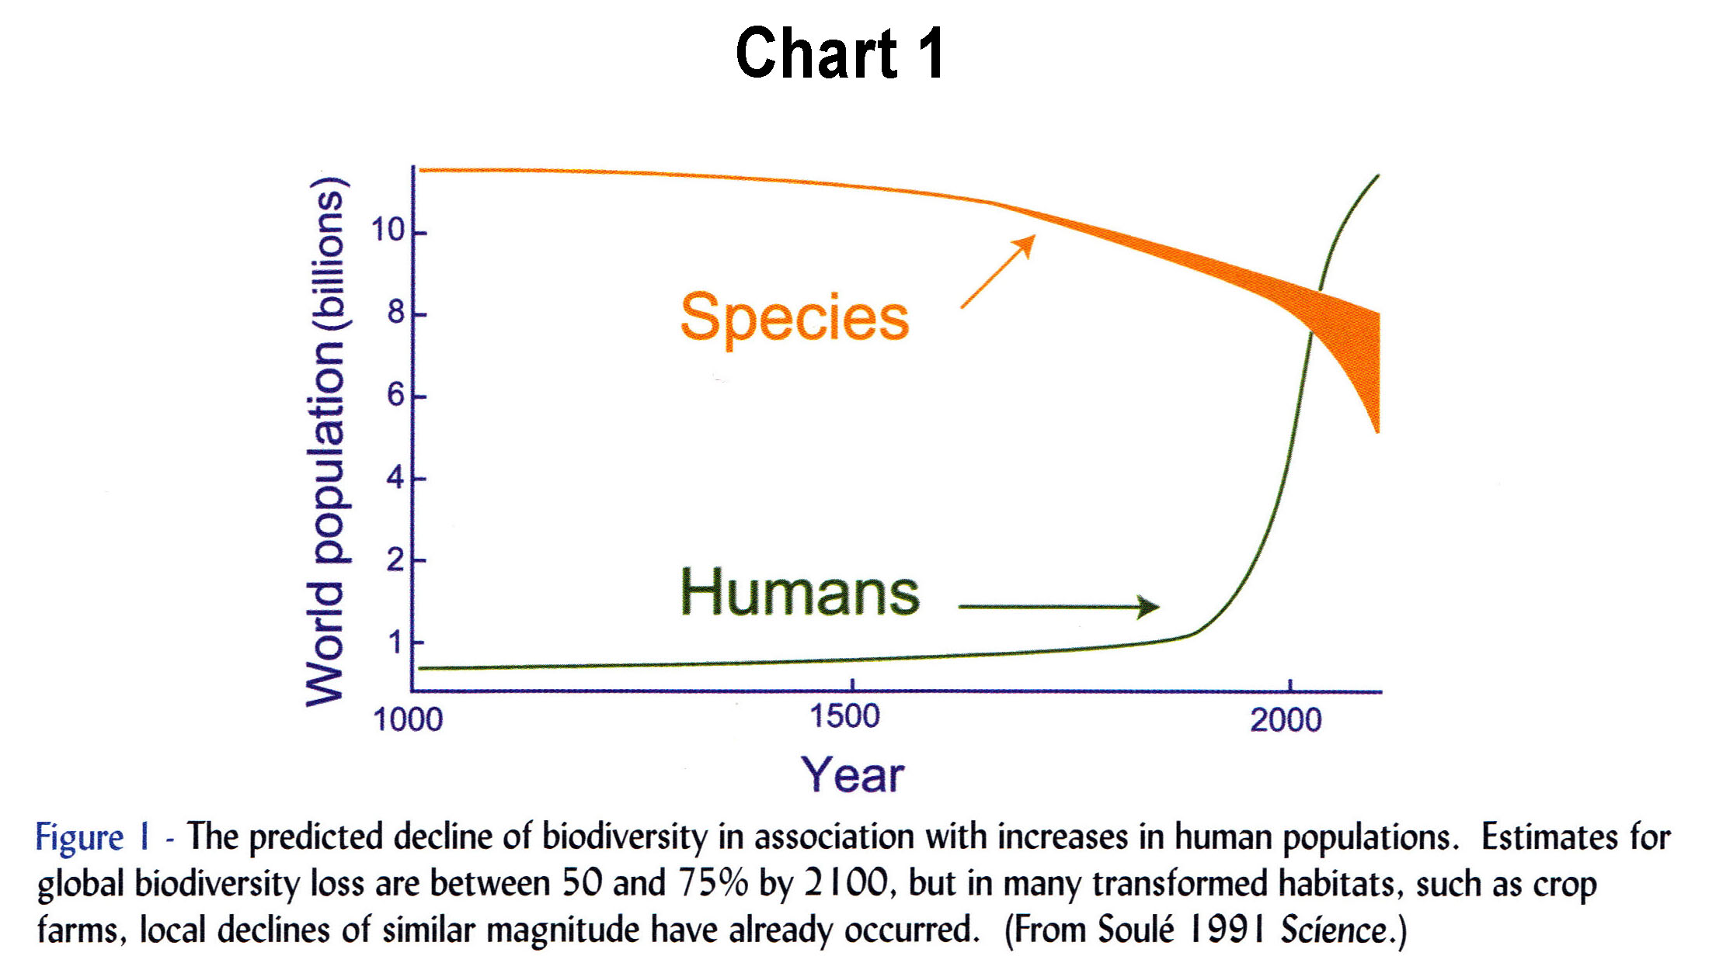

"Unprecedented changes are taking place in the ecosystems of the world." "Recent evidence demonstrates that both the magnitude and stability of ecosystem functioning are likely to be significantly altered by declines in local diversity, especially when genetic diversity reaches the low levels of managed ecosystems" (Naeem 1999).
- Human impacts on global biodiversity have been dramatic, resulting in unprecedented losses of global biodiversity at all levels, from genes and species to entire ecosystems.
- Local declines in biodiversity are even more dramatic than global declines.
- Many ecosystem processes are sensitive to declines in biodiversity.
- Changes in the identity and abundance of species in an ecosystem can be as important as changes in biodiversity in influencing ecosystem process.

The FAEIS, as written, will encourage an onslaught of unbridled phosphate strip mining, which will result in permanent large-scale gene pool loss and/or genetic erosion through irreplaceable destruction of many locally or regionally adapted plant and animal populations, and in the elimination of many of the remaining tracts of native ecosystem in the region. Most all of the ecosystems of the Southwestern Florida Flatwoods (Dry Prairie) Ecoregion will have been eliminated by phosphate strip mining, or its ecosystems will have been severely disrupted, compromised and/or genetically depleted. The secondary and tertiary impacts of this ecological disaster will extend into the surrounding counties and regions, and far beyond. Due to its vast scale and severity phosphate strip mining is clearly one of the largest single offenders of the environment and the human community in Southeastern United States.

OBJECTION TO FAEIS REVIEW TIME LIMIT
Substantive Comment:
3PR objects and questions the excessive length of the FAEIS, and to the completely insufficient 30-day time period allotted for review and comment. The set of documents which make up the FAEIS, including prior comments and appendices, totals 2,794 pages. The abbreviated review period is completely unreasonable and untenable for any person, any group or any agency. The length, unnecessary complexity, and lack of clear succinctness of the FAEIS, is inconsistent with NEPA which requires that an EIS not just "generate paperwork", but that it must "reduce paperwork and the accumulation of extraneous background data". NEPA requires such documents to be less than 150 pages long, or normally less than 300 pages for more complex proposals. The 2,794 page length of the FAEIS is grossly excessive, and greatly exceeds the maximum number of pages recommended, even without the appendices. Also, a tremendous amount of external information is referred to, or incorporated by reference, instead of being included in the FAEIS. In effect, its extreme length, complexity and convoluted construction precludes effect analysis and comment even if a considerably greater review period had been granted. The FAEIS therefore violates the public trust, greatly diminishes public participation and discourages public scrutiny.
The severe time limit restriction for the FAEIS review and comment has the effect of censuring and effectively precluding public involvement, even much more so for the minority populations that dominate the region of impact. The USACE should have mailed every resident a succinct description of the proposed action, in both English and Spanish, including simple summaries that explain the project and describe prior phosphate strip mining. This should have been done in terms the layperson can understand. A wide range of photos showing the impacts of phosphate mining from the air and ground, and a list showing all environmental impacts and concerns should have been included. Today's society learns mostly by visual means. The FAEIS does not communicate any meaningful of the reality of phosphate strip mining. The FAEIS contains no photos of strip mining which show the public what mining, its chemical processing and waste disposal do to the land and environment. Neither does it contain or list where access to educational videos and documentaries may be viewed. Under NEPA the public is entitled to be broadly and fully informed about phosphate strip mining so that communities will possess "real" information upon which to base their public involvement and their actions. In its current state, the FAEIS would be essentially meaningless to the overwhelming majority of residents in terms of describing the proposed phosphate strip mining and its real and potential impacts to the land, community and environment.
In addition, the USACE has simultaneously issued notice of four individual and distinct mine permit applications involving over 52,000 acres of land. These documents and related materials are individually voluminous and include many separate exhibits and appendices. They are incorporated by reference and repeatedly referred to in the FAEIS, and are therefore intrinsically a part of the FAEIS, although they havenot been included. The effect of overlapping the FAEIS review with such vast libraries is that only the most minimal comments are possible, and that the general public is further precluded from having the ability to participate and offer well-considered comments:

40 CFR 1500.1 Purpose
(c) Ultimately, of course, it is not better documents but better decisions that count. NEPA's purpose is not to generate paperwork--even excellent paperwork--but to foster excellent action.
40 CFR 1500.2 Policy
(b) Implement procedures to make the NEPA process more useful to decisionmakers and the public; to reduce paperwork and the accumulation of extraneous background data; and to emphasize real environmental issues and alternatives. Environmental impact statements shall be concise, clear, and to the point, and shall be supported by evidence that agencies have made the necessary environmental analyses.
40 CFR 1502.7 Page limits.
The text of final environmental impact statements (e.g., paragraphs (d) through (g) of Sec. 1502.10) shall normally be less than 150 pages and for proposals of unusual scope or complexity shall normally be less than 300 pages.

Concerned citizens, and interested parties and organizations, have therefore been completely overwhelmed by the amount of documentation contained in the FAEIS and by the scope of its ancillary documents, research publications, regulations and website materials which must also be collectively digested and considered in understanding and responding to the FAEIS; assuming that it was properly formulated with the intent of appropriately informing the public of these huge projects, which it was not!
Because of the immense, once-in-history importance of the FAEIS, and in consideration of the four expansive, ensuing phosphate strip mining projects, 3PR is compelled to continually and thoroughly articulate this significant issue, and further object to the unnecessary length, complexity, and utter deficiency of the FAEIS (included its related documents and sources). The public is entitled to a fair and liberal opportunity to thoroughly evaluate the FAEIS because "public scrutiny is essential to implementing NEPA", and because the resulting Area-wide EIS will in large part determine the destiny of an entire region and ultimately affect the lives of millions of people. As phosphate strip mining has done historically, it will most certainly leave a legacy of environmental and economic liability, in perpetuity, resulting from its diverse and comprehensive negative environmental impacts. This is true because phosphate strip mining is non-renewable and non-sustainable, and its extremely minimal contributions, in the form of jobs and tax base, only brief. It is a here-then-gone, purely exploitive industry, which leaves an extensively altered and often abandoned, or forgotten, alien landscape in its wake of total ruin. See Photos 1 through 7.
A thorough review of the FAEIS document alone, not including the time and resources needed to verify any of the data or analyses, would require many months. Advertising for and contracting professional consultants capable of performing a thorough review of such a vast and diverse region, involving such a huge number of severe cumulative impacts and other issues requires considerable time in itself. A 30-day comment timeframe may be acceptable for a very small, single project, such as boat dock or small marina, which does not involve any significant native ecosystems and water resources impacts, but is completely inadequate and unacceptable for an action involving a geographic area as great as that of the CFPD that includes such huge ranges of extreme environmental impacts, and requires the review of a report of such magnitude, complexity, length and poor quality as the FAEIS.
The FAEIS is a pseudo-technical document involving terminology and quasi data and analyses from the phosphate industry, its agencies and business allies and proponents. Its development has taken the Applicants, USACE, its cooperating agencies, CH2M-Hill (one of largest industry-support consulting firms of its kind), other consultants and advisors, other phosphate representatives and employees, and personnel from various sympathetic political agencies, over a year to develop. Even if the resources of private sector organizations and local government commenters were unlimited, it would be impossible for even a minimal review of the FAEIS in just 30 days. In order to perform a review and comment on such a voluminous and technical document, and to actually verify some of the data and analyses provided, a much greater span of time would be required. It would include time for the field verifications, essential investigations, and other analyses necessary to generally evaluate and objectively verify the thousands of statements of the FAEIS, as well as the actual extent, attributes and status of ecological/biological resources within the CFPD.

RELATED DOCUMENTS LARGE AND/OR INACCESSIBLE
* Substantive Comment:
In addition to the excessive length and complexity of the FAEIS, the document states that information has been taken from a number of other voluminous publications, either by incorporating them by reference, or by vaguely alluding to them, as in Chapter 1.7, "These documents have helped to inform the USACE as it developed this FAEIS on phosphate mining in the CFPD" (followed by Figure 1-10). At least 9 major document sets are referred to in this section. There is no mention of precisely what information or conclusions were adapted from these documents. Although the USACE may incorporate by reference, the inclusion of entire encyclopedic documents, without references to the specific information or sections used, is both unreasonable and untenable for anyone reviewing the FAEIS.
The FAEIS states that "A number of precedent NEPA documents and other regional planning studies contain information useful to this FAEIS. Brief summaries of some of the most relevant environmental documents are provided in the following paragraphs. These documents have helped to inform the USACE as it developed this FAEIS on phosphate mining in the CFPD". NEPA is the regulatory framework within which the FAEIS must be developed and must conform. It is not within the discretion of the USACE to merely consider NEPA "useful", "helpful", or "informing". Adherence to it provisions is required!
Also a number of the documents and publications are not cited in the Chapter 7 "References" section of the FAEIS. This deficiency makes locating these documents exceedingly difficult and time-consuming. Most of them can only be obtained in physical form from distant repositories, or from paid digital document services, or may not be conveniently available to the public at all. This deficiency further compounds problems reviewing the FAEIS because it greatly increases the time and resources needed for review and comment and, in many instances, precludes convenient objective verification on sections where information from these references may have been cited or somehow incorporated into the FAEIS.
A serious issue is that private research and possibly other documents have been submitted to the USACE by the Applicants, including scientific research, in-house reports or letters, or unpublished studies conducted by private concerns, some of which may have been presented in legal arguments relating to the interpretation of provisions for the development of the FAEIS, or the process through which it was to be developed, although not cited in the FAEIS. There is no reasonable means, other than continuous Freedom of Information Act (FOIA) requests for "any new documents", through which 3PR could officially become aware of these reports, or gain insight into the degree to which they may have been considered in the review and/or development of the FAEIS. Further, because many such documents are presumably being used and referred to by CH2M-HILL and other non-governmental parties working on the FAEIS, there is no official means for reviewers to obtain them. That is, they are not subject to the FOIA. Even if a FOIA request could produce these documents, the reviewers would first have to be aware of their existence, formulate and transmit the request, and then wait up to 20 days for a reply. By that time the review period has mostly or completely expired. In relation to this, representatives of the Applicant recently boasted that the DAIES/FAEIS development "is not an interactive process". Meaning, the public cannot find out what is being used as a basis for the documents, and can not ask or be asked about it contents, the issues, or the base information, studies, data, or analyses.
3PR therefore questions the adequacy of the FAEIS, and the accuracy of its information, in that it does not properly cite many documents, does not provide any information on an inestimable number of documents and information sources used "behind the scenes", and provides no access, or no convenient access. The FAEIS development process therefore circumvents NEPA "public scrutiny" requirement. The following documents cited in a 25-Apr-2010 "hand-delivered" letter from Deedra Allen (Mosaic) appear to be among the apparent plethora of mostly unpublicized, unavailable items:
Potential Future Mining Areas in the Central Florida Phosphate District, Environmental
Consulting, Technologies, Inc.

Water Quantity Issues Associated with Phosphate Mining, Dr. John E. Garlinger, Ardaman
Associates, Inc.

Stream Condition Assessments and Stream Reclamation in the Central Florida Phosphate
Mining District, Environmental Consulting & Technology, Inc.
Characterization of Forested Seepage Swamps on Mosaic Lands in the Bone Valley of West-Central Florida, Dr. Shirley Denton, Cardno ENTRIX.

Why we need to mine Phosphate Rock in the United States, Ken Nyiri, CRU.

Surface Water Quality Associated with Central Florida Phosphate Mining, Dr. Douglas Durbin, Cardno ENTRIX.

Comments and Corrections of the Peace River Cumulative Impact Study, Joshua W. House,
Mosaic Fertilizer LLC.

During our review of the DAEIS when 3PR asked for a copy of one the documents from its author, the request was politely refused by stating, "I'll have to get permission from our (phosphate mine) client". It would seem that the Applicant is not only in charge of the FAEIS process, but of the information and documents upon which it is purported based.
In short, the general public has no idea whatsoever as to the resources and base information employed in the development of either DAEIS or FAEIS.

FAEIS INAPPROPRIATE AND POOR QUALITY
* Substantive Comment:
In addition to all other issues commented on herein, 3PR has determined that a very large number of errors, omissions and internal inconsistencies exists in the FAEIS. These include, but are not limited to inconsistencies in various wetland acreages of wetlands to be dredged, mining and reclamation time periods, incomplete and inaccurate tables, large quantities of included irrelevant, erroneous, and misleading pro-phosphate-mining content which read like phosphate company sponsored newspaper and TV ads, grammatical and organization errors, and countless omissions of important data, analyses, tables, maps and exhibits readily available from public sources. Often highly significant issues and concerns are ignored, omitted, or summarily dismissed with little or no analysis or comment. The FAEIS is obviously, for many reasons, not a product which should have been presented to the public for review and comment. The USACE must consider the unnecessary expenditures of time and resources, and other impacts to the citizens, businesses, and other organizations which are concerned with phosphate strip mining, in releasing such an inappropriate proposal for public review and comment. The FAEIS should be concise, accurate, objective, and soundly supported by data and analysis developed and presented independent of the Applicants. NEPA requires that expert input be solicited from the public, but it was not, even though many regional experts and non-profit ecological research institutions were available!

PERMIT DURATIONS FAR TOO LONG
* Substantive Comment:
3PR objects to the issuing of phosphate strip mine permits (such as 404 CWA and other permits and approvals) that would be valid for periods greater than 5 years. (1) Phosphate strip mining and its related activities are very intensive industries that create large-scale and far-reaching impacts within short periods of time and which create even more dramatic and wide-spread impacts cumulatively. Granting long-term approvals of up to 30 years or more, and purporting to plan mining nearly 80 years into the future is completely absurd! These massive projects disturb very extensive tracts of land, destroy vast areas of native ecosystem and wildlife habitat, introduce invasive species on a massive scale, disrupt and eliminate regional agriculture, soils and water resources, and induce rapid changes in local communities and economies in profound, significant, and often irreversible ways. It is crucial that permits expire within reasonable periods of time so that federal, state, regional, and local governments, and especially local communities, may reevaluate such projects in accordance with society's constantly changing needs.
The durations of the permits of currently approved phosphate strip mines are unacceptable, especially when the extensive negative impacts are considered collectively, that is cumulatively. To approve four new mines of such extremely excessive size and durations is unconscionable. Considering the approximate 320,000 plus acres of past phosphate mining impacts, with existing mine permits considered collectively, then adding the four projects described in the FAEIS, the cumulative impact will be the utter desolation of much of eastern west-central Florida, plus potentially massive impacts to "downstream" jurisdictions and coastal communities at the receiving ends of the Myakka and Peace rivers, that is Charlotte, Lee, and Sarasota counties.
Issuing permits and approvals for phosphate strip mining for such extended durations represents a shocking injustice to society. Such long-term approvals preclude affected communities from being able to respond to changes in societal needs including, but not limited to, protection of public health and safety, changes in the economy, natural disasters and disaster response, increases in the need for local natural resources including food from traditional local agriculture. It is therefore essential that only the shortest possible permit durations be granted.
* Recommendation:
In no case should any phosphate strip mining permits be issued or granted for time periods exceeding 5 years. Even within this 5-year span, permit compliance and local community must be reviewed at least annually. Also, because phosphate strip mine "extensions" are actually "new" mining, all extensions must be permitted as individual phosphate strip mines. No projects which do not currently have permits should be approved until the cumulative historical impacts of phosphate strip mining in the CFPD, have been completely evaluated. Phosphate strip mining technologies could be developed which may allow some limited mining to take place in an environmentally acceptable manner, if possible. NEPA's mission is "Protection of the Environment". In no section of the FAEIS is this mission embraced in a forthright manner. In no section is there evidence that the USACE has attempted to consider public need and qualified, regionally relevant, 3rd party (non-industry) information, data and analysis. Also, a "genuine" cumulative analysis is needed in order to determine the additive impacts of past, present and future phosphate strip mining, chemical processing and product distribution and use.

IMPROPER PURPOSE AND NEED
* Substantive Comment:
3PR objects to the "purpose and need" as stated in the FAEIS. "The Applicants' purpose and need forms the basis for the alternatives analysis. The purpose and need for an Environmental Impact Statement is "Protection of the Environment" in federal actions. Nowhere is this NEPA directive found in the FAEIS. The FAEIS therefore completely obfuscates and fails to acknowledge the primary purpose and legal basis upon which it, by law, must be founded and developed.
The position taken by the USACE is inconsistent with federal law, and has the effect not only of promoting phosphate strip mining, but to virtually ensure and predetermine that alternatives proposed by the Applicants are approved (permitted). This position taken by the USACE effectively excludes Alternative-1 ("No Action" / "no permit"). It is clear that all of the other alternatives are merely additional scenarios acceptable to the Applicants. None were formulated by the 3rd party public at large. In actuality, NEPA requires that "the agency" propose the "alternatives, including the proposed action", not the Applicants. And, "the agency", is required to do this by "affirmatively soliciting comments from those persons or organizations which may be interested or affected".
40 CFR 1502.13 Purpose and need.
The statement shall briefly specify the underlying purpose and need to which the agency is responding in proposing the alternatives including the proposed action.

* Recommendation:
The "Purpose and Need" for the FAEIS should be changed to: “The purpose of the proposed action is "Protection of the Environment" via independent comprehensive analysis of the direct and cumulative environmental impacts of phosphate strip mining throughout the CFPD, while ensuring protection of all natural environmental assets, conservation of water and air, public health safety and welfare”.

MINING NOT A TEMPORARY IMPACT
* Substantive Comment:
Phosphate mining has often been misconstrued by the mining industry as a "temporary" disturbance of land. However, it is absurd to assert that a 30-plus year mining project is a "temporary" disturbance, or that large-scale removal, disturbance, mixing of native soils, and construction of massive, permanent CSAs and phosphogypsum stacks, maintenance corridors, ditches, berms, pipelines, and processing facilities, will result in anything other than the permanent destruction of native ecosystems, soils, communities, and future land use potentials, just as it has with all phosphate strip mining in the past. Mined land, whether in the process of being mined, whether reclaimed or not, is an impediment to wildlife and ecosystem function through habitat fragmentation, the creation of physical barriers (CSAs), altered hydrology, soil removal and other edaphic changes, and many other problems. Mined land fragments the few areas of habitat that remain and prohibits wildlife from moving within their home ranges. It thus isolates wildlife populations from the resources needed for their survival and reproduction. In addition, the disturbed, physically and chemically altered substrates left behind by mining, promote the spread of nuisance and/or exotic opportunistic plant species which immediately invade and dominate, excluding and/or precluding native species and habitats. Massive seed production and dispersal from these concentrated and vast mine land infestations infect adjacent ecosystems and regions well beyond, compromising their ecological integrity and causing great ecological harm and economic liability.
* Recommendation:
The diverse, extreme, and permanent impacts associated with phosphate strip mining must, for once, be admitted and considered honestly. A brief tour by air and ground though the phosphate mining district will dispel any myths concerning the level of impacts and destruction created by this industry. Seeing is knowing and believing. Upon experiencing this reality, one immediately realizes that hundreds-of-thousands of acres of wildlife habitat, farmland, and space for the human community have been utterly destroyed, and that the billboards, newspaper ads and TV ads repeatedly run by the industry are highly misleading. Questions regarding whether phosphate strip mining should take place must be decided in an academic environment, in full "sunshine" and with complete "transparency". Phosphate mining is a multinational industry/business which exists for profit. From the industry's perspective its mission is no doubt to increase efficiency and make more money. From page to page the FAEIS primary focus is to promote strip mining. Nowhere does it acknowledge or further the NEPA purpose, which is "Protection of the Environment". In fact, the NEPA purpose is not to be found in the document. It is apparent throughout the FAEIS that the overwhelming desire for mining efficiency and increased profits was the basis of decision-making and, consequently, has preemptively compromised its contents.

CUMULATIVE IMPACT ANALYSIS
* Substantive Comment:
3PR questions the adequacy of the environmental analyses and accuracy of the information in the FAEIS because it does not evaluate the ALL-IMPORTANT "cumulative" impacts which the phosphate strip mining and certain associated industries have inflicted on west-central Florida. In general, the FAEIS effectively avoids and obfuscates meaningful discussions and analyses relating to cumulative impacts.
A comprehensive cumulative analysis of all historical impacts must be a primary requirement and prerequisite before considering any new phosphate strip mining permits. The FAEIS states "The temporal scope of the cumulative impact analysis is based on the overall operational periods of the four proposed actions, plus any overlap with the operational period of the two reasonably foreseeable actions." This concept does not include the historical impacts of phosphate strip mining, which have been extremely extensive. The FAEIS does not therefore constitute a cumulative impact analysis. NEPA explicitly requires that cumulative impacts include "past", "present", and "future" actions regardless of their sources, scale or scope:
40 CFR 1508.7 Cumulative impact
Cumulative impact is the impact on the environment which results from the incremental impact of the action when added to other past, present, and reasonably foreseeable future actions regardless of what agency (Federal or non-Federal) or person undertakes such other actions. Cumulative impacts can result from individually minor but collectively significant actions taking place over a period of time.

The FAEIS does not accurately identify or quantify, as required by NEPA, all of the direct and indirect impacts resulting from past and on-going actions (prior to 1978). No maps, illustrations, analyses, or narratives adequately or sincerely consider the incredibly massive environmental disaster of historical and ongoing phosphate strip mining. NEPA requires that even "minor" impacts are cumulative because they become "collectively significant" over periods of time. Comprehensive analyses are needed in order to accurately determine the existing status of significant aquatic/hydrologic/biologic resources, which in turn, are necessary to determine the "real/actual" impacts of the proposed projects on the natural resources within the CFPD and other "downstream" regions at risk and which will obviously be affected. Further, because surface and ground waters are very vulnerable to incremental impacts, and because their historical cumulative impacts have been tremendous, it is absolutely essential that the USACE expand the temporal scope of the FAEIS so that it is consistent with the requirements of NEPA. The FAEIS must identify and analyze all direct and indirect past actions needed to accurately describe the direct, indirect and cumulative impacts that the four proposed phosphate strip mining projects may potentially have on existing and projected human resources. That is, the FAEIS must include a comprehensive evaluation of all known and potential environmental, social, physical and economic impacts of phosphate strip mining in west-central Florida, past, present and future.
An essential element of cumulative analysis involves the phosphate strip mining industry's tremendous generation of waste clays. Because waste clay disposal areas (CSAs) permanently reduce recharge of the surficial aquifer and lateral base-flows to adjacent streams in the regions they occupy, the FAEIS should be revised to identify, map and calculate the total acreage of clay settling areas to be constructed. Further, the total of post mining pits/ponds/lakes, which also significantly reduces stream and river flows to the estuaries, need to be identified and their impacts quantified. To this, add the millions of gallons per day in stream flows lost to the many sinkholes created, in part, by the consumptive use and withdrawals associated with phosphate strip mining. Very comprehensive and intensive analyses of the historical hydrology of the phosphate mining district are needed.
The information and analyses provided in the FAEIS does not fully identify or quantify the many adverse, permanent impacts caused by the approximate 320,000 acres of past mining in Florida (which may have occurred before the State’s Mandatory Reclamation Rule). This serious omission invalidates any conclusions assigned to cumulative impacts. Ironically, the FAEIS maintains that the analysis of cumulative impacts is one of the most important elements of an EIS, although the information in the document does not reflect this value.
Conspicuously missing from the FAEIS are photographs of the many aspects of phosphate strip mining. If selected honestly such photos would help show the public of the true impacts of phosphate strip mining and it consequences to their lives and future. Professionals who visit the phosphate mining district usually return with shocking photographs and environmental horror stories. In reviewing the FAEIS the question arises as to how much first hand, on-site experience the USACE "List of Preparers" actually has with west central Florida phosphate strip mines?
The current age is primarily a digital one. We live in a "visual" world. Literacy is at an all time low in central Florida, with the majority of graduates reading at or below 8-grade levels. Language is an additional barrier for Latinos (discussed elsewhere), which constitute the dominant sector of society in Hardee and Desoto counties. The FAEIS is devoid of adequate visual representation and communication necessary to inform and educate the general public about phosphate mining. Especially lacking are materials suitable to educate the proportionally high minority and low-income populations of Hardee and DeSoto counties, a significant portion of which exhibit low levels of educational attainment. The FAEIS is inconsistent with the requirements of NEPA because it fails to communicate through its exceedingly poor organization and lack of clarity and measurability, any regard for the educational limitations of regional ethnic residents, internal inconsistencies and improper content. The FAEIS reflects no attempt to accommodate the general public through adhering to the NEPA requirements of concise and meaningful content, encouragement of adequate public participation, and consideration of the special needs of low income and minorities.
* Recommendation:
Before any new phosphate strip mining permit applications are considered, it is scientifically essential and morally imperative that all mining, past, present, and proposed, be comprehensively evaluated in terms of its cumulative impacts to the human society as well as its environmental and economic liabilities. The analyses should include evaluations extending as far back in time as records or evidence exists. See the 3PR "Significant Environmental Issues" section, and other comments relating to the essential prerequisite of fully evaluating the cumulative impacts of phosphate strip mining.

ADDITIONAL HYDROLOGIC / EVAPOTRANSPIRATION IMPACTS
* Substantive Comment:
3PR questions the adequacy of the environmental analyses in the FAEIS because it fails to incorporate and respond to the considerable body of very broad-ranging, multi-disciplinary scientific research showing the significant negative hydrologic impacts which have resulted from phosphate strip mining in the past, which are presently occurring, and which are direly predicted for the future if additional permits are to be issued.
The primary land-altering and re-contouring activities of phosphate strip mining comprehensively destroy watersheds, the native surficial aquifer, and hydrology in general, greatly altering and compromising patterns of runoff and regionally altering recharge, including increased and induced recharge to the IAS and FAS through injection and karst formations.
The vast historical areas of dry prairie (flatwoods / pine-palmetto flatwoods) are removed along with their native soils, many of which included spodic horizons which restrict recharge or downward percolation and which is absolutely required for maintaining the seasonally high ground water levels needed to support the ecosystem. These native soils, which are essential to the self-sustaining existence of native plants and wildlife, are removed by the phosphate strip mining process and are replaced by unnatural Arents-Hydraquents-Neilhurst substrates. This results in profound impacts to local and regional hydrology by altering the amount of low-flow and pattern of low-flow, greatly altering recharge (inducing or reducing recharge, depending on various factors), increasing or reducing runoff (depending on various factors), and eliminating or comprehensively altering seepage regimes, runoff patterns and other hydrologic regimes.
One of the hydrologically significant aspects of removing and/or disrupting vast regions of native soils and replacing them with materials which exhibit vastly different physical and chemical properties, constructing many large CSAs, re-contouring much of the landscape, and also creating many open bodies of water where virtually none existed before, is that evapotranspiration (ET) rates and coefficients are altered over large areas.
A reevaluation of ET rates is needed which better establishes the moisture lost from the many open water bodies and inundated areas created by the phosphate strip mining industry, whether temporary, or permanent. A cumulative analysis of ET especially needed so that water lost may be determined for all past, present and future phosphate strip mining. Few open water bodies existed in the region prior to mining, but after mining the many pits and impoundments cause the loss by evaporation of tremendous volumes of water on a daily basis. Open bodies of water often have by far the highest ET rate.

DESTRUCTION OF A VERY LARGE NUMBER OF BASINS
Substantive Comment:
3PR further questions the reasonableness and fairness of the abbreviated FAEIS review and comment timeframe because of the importance of the extensive natural resources at risk, that is, slated to be permanently destroyed by phosphate strip mining. The CFPD includes a large portion of the diverse physical and hydrologic features, and extensive environmental and biotic assets of west-central Florida. As a single example, the CFPD includes vast areas in the headwaters of 7 major watersheds, and 269 drainage basins (Figure 1). Of the 269 basins, 195 are entirely included, approximately 30 are about "90%" included, and only about 44 are less than 90% included. Although not all of this region has been mined, or is planned to be mined, it is reasonable to assume that it will be mined at some time in the future. Certainly the phosphate industry would like to mine it, and because of its potential for mining, it must be included in any cumulative impact analysis. The four proposed phosphate strip mining permits will impart extremely large impacts within the southern half of the CFPD.
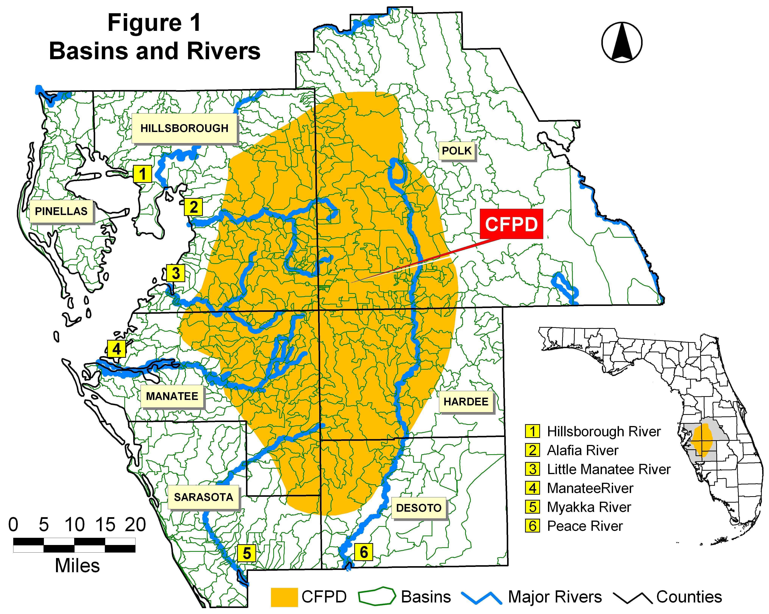

UNQUALIFIED ECOSYSTEM STUDIES
* Substantive Comment:
3PR questions the accuracy of information and the adequacy of the environmental analyses in the FAEIS because it does not include adequate assessments of native systems, or include competent site-specific (on-site) evaluations and ecosystem analyses of irreplaceable biosphere assets as is required by NEPA. West-central Florida, and in particular the xeric uplands, dry prairies, and certain other vegetative communities and ecosystems which occur within the CFPD, are known to support unique floras and ecologically specialized biota. Because these vegetative communities have not been adequately classified, and their ecological requirements are unknown, it is not possible consider their values and provide the proper protection required by NEPA. In Chapter 8 of the FAEIS, under "List of Preparers", no regional experts are listed, nor any experts qualified in the fields of ecology, systems ecology, zoology, plant ecology or botany. Of the specialist cited as preparers of the FAEIS, Steven Gong (CH2M-Hill, Project Manager) has a zoology degree from the University of Florida, and Tunch Orsoy, ( USACE, Ecology Lead) has a marine science degree from the University of South Florida. None of the officials or scientists listed as "preparers" possessed (or possess) regionally recognized expertise with the environs of the Southwestern Florida Flatwoods Ecoregion, nor have the authored any independent scientific studies relating to the ecosystems of this region. As commented on later, NEPA requires involved federal agencies to be sufficiently capable of independently evaluating an EIS, including the work done by others, and even though external consultants and assistance may have been retained for much of the work. Adherence to this federal requirement is clearly lacking in the FAEIS. Throughout the development of the FAEIS the USACE has rejected virtually all qualified scientific research and documentation offered by the scientific environmental community, but has included many in-house documents and position statements supplied by the Applicants.
The expansive and diverse natural landscapes of the CFPD, and regions slated for destruction by the four proposed permits and/or alternatives, all fall within the Southwestern Florida Flatwoods Ecoregion. This ecoregion is characterized by highly complex and regionally unique combinations of topography and hydrology, and very extensive globally unique ecosystems and regional wildlife food webs. Because the southern half of this region supports many xeric upland areas distinctly separated from other major ridges and uplands systems (particularly in Manatee County), its vegetative communities include unique endangered species. Several species thought to have been extinct in the region have been rediscovered in recent years, and additional unknown ("new") taxa are under scientific review. These attributes and important discoveries indicate a highly unique floristic region. A region that is being rapidly pushed towards extinction mainly by phosphate strip mining.
Additionally, research in molecular phylogenetics has recently discovered new genetically distinct taxa. Areas of native ecosystems within the four proposed phosphate strip mining proposals (including all alternatives), as well as potentially restorable lands which have reasonably intact native soils and geology, must be protected until comprehensive genetic studies can be conducted in these regions. There is high potential that additional genetically unique taxa will be discovered in this region.

USACE INSUFFICIENT CAPABILITY TO EVALUATE DATA AND ANALYSIS
* Substantive Comment:
3PR questions the accuracy of information in the FAEIS because the USACE project team as listed in the FAEIS does not individually or collectively possess the full in-house capability of developing a document which is technically sufficient and competent, or which would be necessary in order to evaluate the work of external consultants and sources, thereby ensuring NEPA compliance. The FAEIS is therefore inappropriate for ensuring the protection of important native ecosystems and other biota, including upland ecosystems and other related considerations. It is inconsistent with NEPA and the NEPA charter and purpose of "Protection of the Environment".
40 CFR 1507.2 Agency capability to comply
Each agency shall be capable (in terms of personnel and other resources) of complying with the requirements enumerated below. Such compliance may include use of other's resources, but the using agency shall itself have sufficient capability to evaluate what others do for it.

Procedures provided in the Environmental Impact Analysis Handbook explain that ecological impacts are predicted by "professional knowledge of plant and animal life and their habitat requirements, professional judgment of the biotic community's ability to withstand or respond to disturbance, professional experience with the impending changes and impacts, and results from similar studies, and common sense (a biologist who simply lists the names of organisms observed on the site - without an interpretation of key life histories, ecological interrelationships, and habitat requirements -- misses the primary intent of the environmental impact report" (Rau & Wooten 1980).

UNIQUE PHYSIOGRAPHY / GEOMORPHOLOGY
* Substantive Comment:
3PR questions the accuracy of the information and adequacy of the analyses in the FAEIS because values and attributes associated with unique physiography / geomorphology were not properly evaluated and considered. The important assets found in the biological, physical/geomorphologic, aesthetic, and geological uniqueness of the various physiographic regions found within the CFPD, and within the geographic extents of the four proposed phosphate strip mining projects (including the various alternatives), were all but ignored in the FAEIS. Especially lacking in the document was any evaluation of impacts and measurable guidance for protecting the important resources and attributes relating to physiography/geomorphology. Regional physiography/geomorphology is responsible for the character of the land and for the ecosystems, soils and hydrology found there.
The various physiographic / geomorphologic features of central Florida, including west-central Florida, are physically and environmentally unique. Many are regions of high biotic endemism and/or ecosystem specialization. The preparers of the FAEIS, as listed therein, are not qualified to evaluate these specialized features, regions, and areas of potentially high endemism. Because there is no evidence of the authors of the FAEIS having sufficient experience or expertise in west-central Florida ecosystems and regionally-specialized areas of biological sciences, the document is intrinsically flawed, inadequate, inaccurate and unqualified. Additionally, the statements and conclusions of the FAEIS in regard to ecosystem resources are unqualified in that no appropriate, adequate site-specific ecosystem evaluations were conducted by qualified regional biological research institutions, or qualified regional experts, using modern biological and ecological techniques and resources. NEPA requires that environmental components be properly evaluated so that the best possible decisions may be made. The data and analyses which are needed for the protection of ecosystems, specialized vegetative associations and biota are highly site specific. Species lists and general descriptions do not provide the levels of ecological understanding necessary to evaluate important NEPA conservation decisions and requirements.
Aesthetic value is a highly important attribute of physiography/geomorphology. Ridges, valleys, plains and inclines, together with the forest, hammocks, prairies and other native land covers they foster impart unique regional character and features which are important to the self-identities of people, communities and regions. The FAEIS ignores or omits consideration of the fact that phosphate strip mining completely destroys regional character and transmutates regional aesthetics into an uglified landscape of gigantic, elevated clay waste disposal sites and seeping, oozing, noxious weed-infested wastelands. Communities have tremendous pride and often generational sentiment associated with the physical and environmental character of the areas they live in. Phosphate strip mining is therefore very damaging to the psychological health of the communities involved, not to mention property values.

PHOSPHATE STRIP MINING IMPACTS 5 MAJOR RIVERS
* Substantive Comment:
The region within the CFPD provides the primary sources and flows of clean, life-giving water to the numerous bays, estuaries, and inlets, both large and small, along the west Florida coast. Comprehensively destroying the vast native ecosystems in this area, and disrupting native soils and geology, will adversely impact the fisheries, marine ecosystems, essential estuary systems, wildlife sanctuaries, property values, including waterfront properties, businesses, and other coastal and "downstream" physical and environmental assets, as well as the quality of life in the most densely populated regions of west-central Florida, which are located near the Gulf Coast and along rivers and waterways, mainly in Lee, Charlotte and Sarasota counties.
The CFPD is the source of 5 major rivers and includes part of the drainage basins of 2 others (Hillsborough River and Withlacoochee River), 1 minor river (Braden River), approximately 150 named creeks and streams, and large number of unnamed tributaries and small streams or water courses (Figure 2).
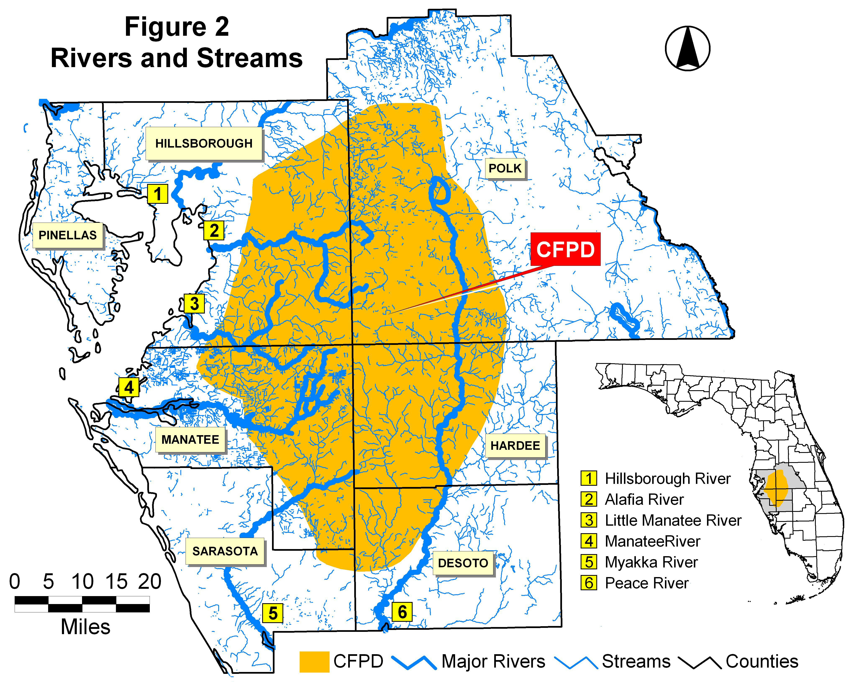

The southern half of the CFPD in the Southwestern Florida Flatwoods Ecoregion supports one of the most diverse ecosystem complexes remaining in central and south Florida. This rare wildlife habitat represents the bulk of the little remaining high-quality wilderness in west-central Florida. It is one of the last great repositories of Florida wilderness, and the most invaluable, self-renewing, essential and irreplaceable upstream assets upon which coastal fisheries, rookeries, and marine spawning grounds from Hillsborough County southwards to southern Lee County utterly depend. It provides primary "ecosystem services", that is, offers essential environmental sustenance for humans, animals and plant life in west-central Florida.
Because open public access to most of the lands within the CFPD has not been available, many of its great tracts of native land in Manatee, Hardee, Desoto, and Sarasota counties have not been adequately explored or zoologically and floristically characterized. No comprehensive searches have been conducted for species which may be "unknown to science". Even so, private scientists have made major discoveries including the discovery of several new plant species as well as several species formerly considered extinct in the region. It is clear that the FAEIS does not address the astounding diversity and concentrations of wildlife which exists in this region. Although not reported, or not accurately reported by the phosphate industry, limited local government surveys and observations have revealed ecosystems supporting a remarkable abundance of animal life as well as diverse and pristine natural plant communities. A significant number of species found in the areas to be mined were not previously know to occur in the region. In addition to endangered flora and fauna occurring in the native ecosystems, very large populations of deer, gopher tortoise, snakes, other reptiles, turkeys, and numerous birds and other animals are abundant. Some of the native vegetative communities found within the CFPD may represent the last of their kind in west-central Florida. That is, no site-specific, current, relevant studies were conducted by independent scientists and used as a basis for development of the FAEIS in fulfilling its NEPA mandate of "Protection of the Environment".
As previously stated, the vast geographic footprint of the CFPD extends across many unique landscapes, ecosystems, and physiographic features. These physiographic features/regions, generally depicted in Figure 3 (based on, White 1970), are the result of distinct, and mostly independent, natural histories. Each is characterized by a unique set of soils, geology and geomorphology. As a result of unique natural histories and other regionally specific attributes, and because of the isolating factors and pressure they apply, each region supports distinct elements of flora and fauna, and distinctly different ecosystems than found elsewhere in the world.
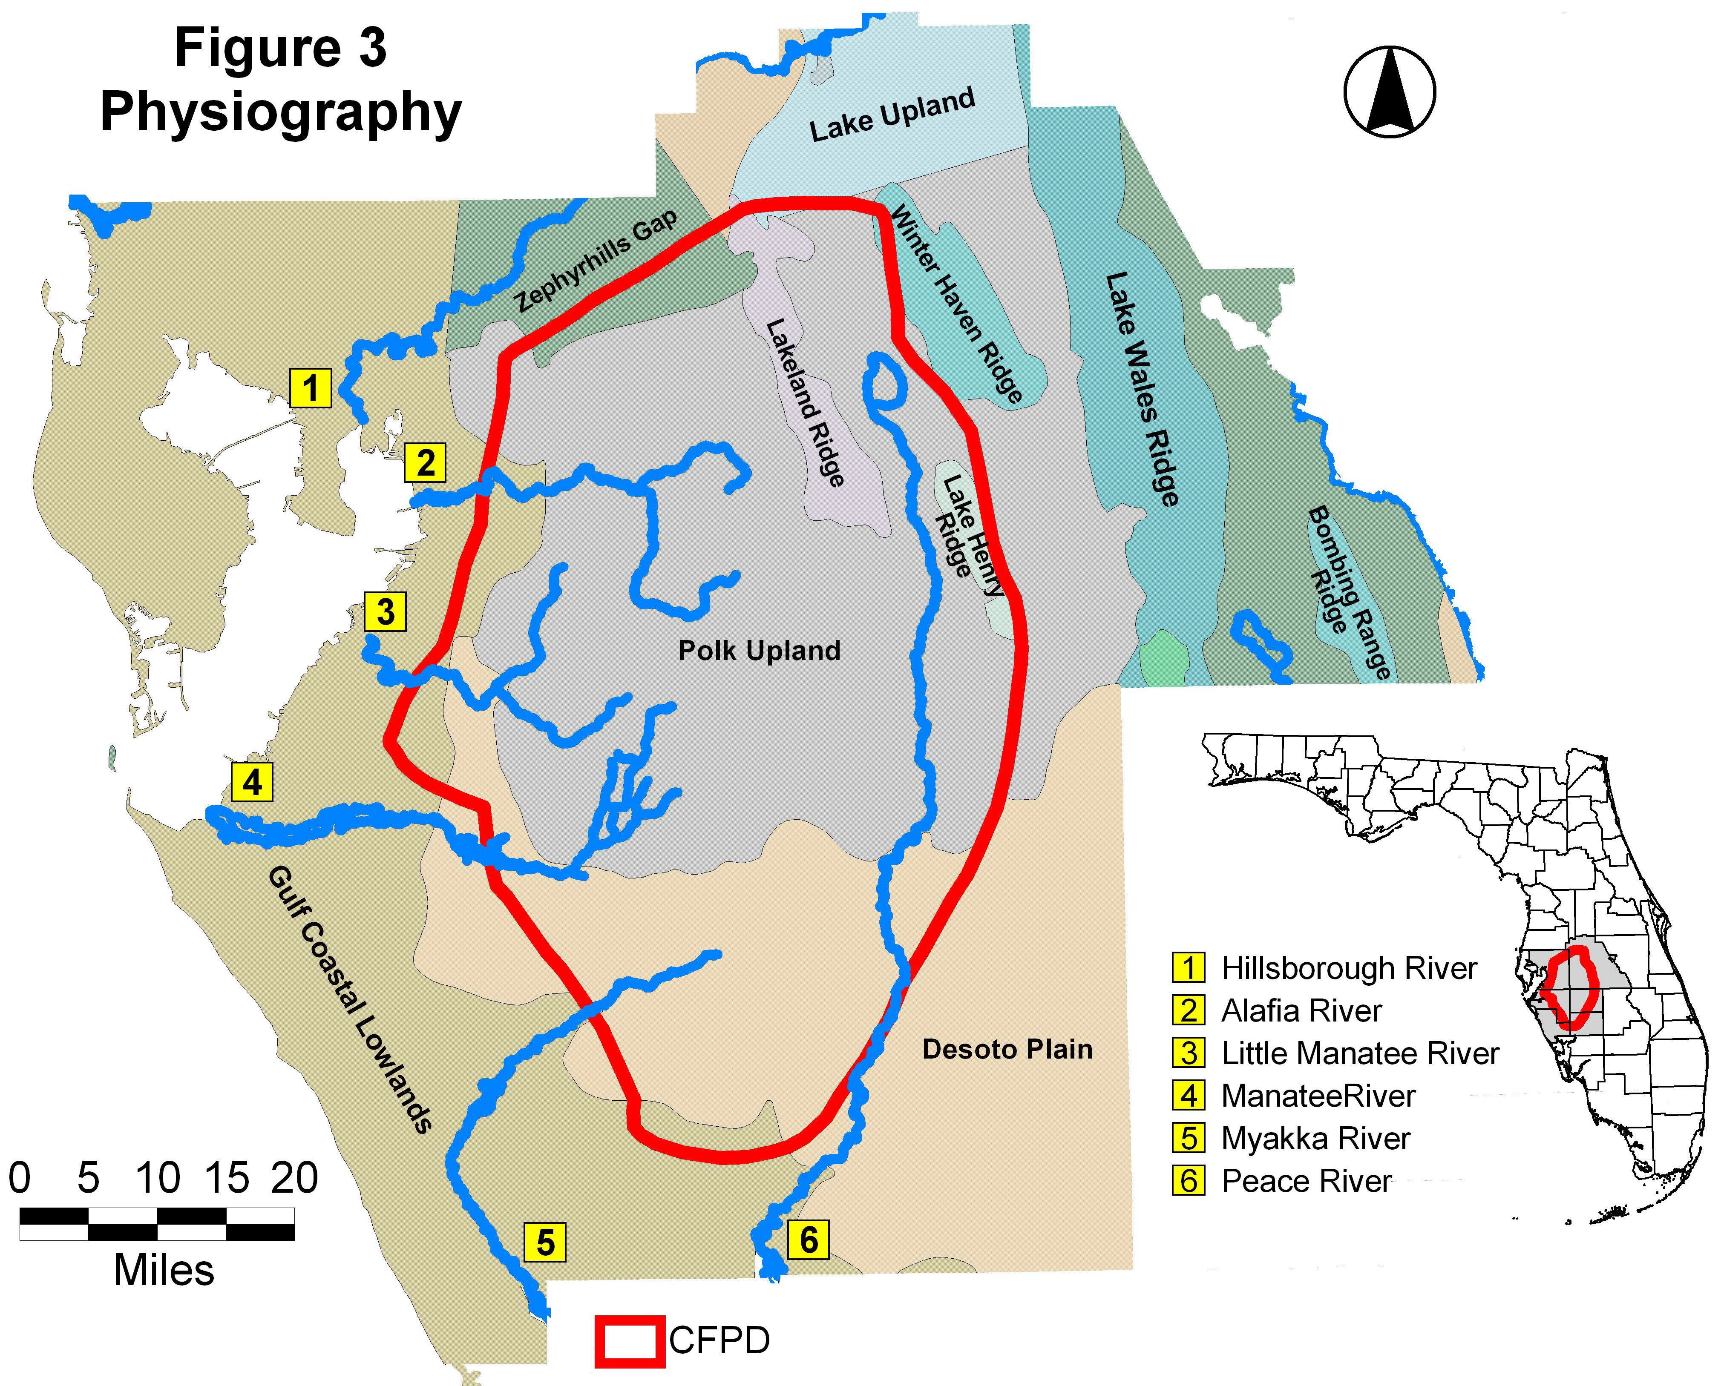

LACK OF CONSIDERATION FOR ENDEMISM AND GENETIC DIVERSITY
* Substantive Comment:
3PR questions the adequacy of the environmental analyses and the accuracy of the information provided in the FAEIS because it does not adequately or accurately evaluate or consider the fact that phosphate strip mining has destroyed much of the central Polk Upland, and is currently destroying some of the last vestiges of the Lake Henry Ridge, a unique geomorphologic feature with only small fragments of it original native ecosystem remaining. Also not adequately addressed in the FAEIS, are the xeric uplands and xeric upland systems of western Hardee and eastern Manatee counties. These environs are essentially unknown in the scientific literature, are of great interest to science, and of great importance to environmental conservation in Florida.
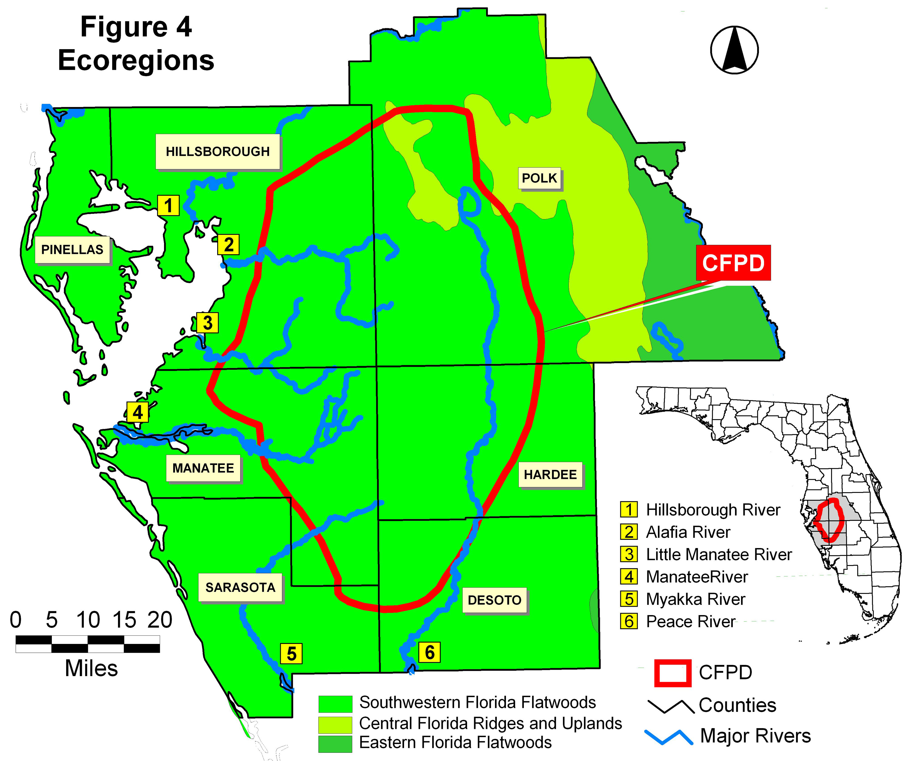

Many important wildlife areas have been completely eliminated by phosphate strip mining and other land uses. No trace remains of entire biotic systems which once existed before phosphate mining. The FAEIS is inadequate and inaccurate in that, in the context of unique ecosystems and endemism, there is no discussion of, or consideration for, the unique geomorphology within the CFPD impact area, nor is there a discussion of the "biogeography" of the endemic and/or listed plant and animal species in these distinct, unique regions. The terms "geomorphology", "biogeography", "endemism", "endemic", "genetic", "genetic diversity", and "critical habitat" (except in the glossary), do not appear anywhere in the FAEIS. The FAEIS does contain some discussion of physiography (i.e., "physiographic" regions), but not in the context of plant and animal endemism, specialization of ecosystems, regional aesthetic character and value, and certainly not in terms of the NEPA EIS requirement of "Protection of the Environment".
Conspicuously omitted or absent from the FAEIS are investigations and discussions of plant and animal endemism. Objectively verifiable, site-specific, comprehensive ecological surveys should have been prepared specifically for the FAEIS by third parties, or recognized regional experts.

SPECIAL ECOSYSTEM ANALYSES NEEDED
* Substantive Comment:
3PR questions the accuracy of the information and the adequacy of the environmental analyses in the FAEIS because it does not provide information on many areas within the CFPD and within the four proposed mine sites. If the remaining fractions of natural ecosystems and vegetative and wildlife communities are not protected through the FAEIS, a monumental ecological and environmental catastrophe will result for west-central Florida. Planning to provide "Protection of the Environment" as required by NEPA is not possible without adequate data and analysis. The FAEIS is therefore invalid.
* Recommendation:
The USACE should consult with the Natural Resources Flight of the US Air Force Range at Avon Park for the purposes of developing plans for conducting comprehensive ecosystem analyses in the regions containing the four proposed mine permits (including the various alternatives) and throughout the remaining natural areas of the CFPD. These base studies are essential for competent and objective review of phosphate strip mining applications, including the cumulative impacts which they would potentially contribute. The studies fully analyze and provide a classification system for regional vegetative communities within regional ecosystems by correlating native flora components to their essential ecological, edaphic, geologic, topographic, hydrologic, and climatic requirements. At a minimum, ecosystem classification base studies, necessary for further analyses, should be of similar design and include the same level of analysis as those conducted by the Natural Resources Flight of the US Air Force Range at Avon Park (Orzell & Bridges 2006). The cumulative effects of multiple stressors should also be analyzed for the extant ecosystem and biota of the CFPD.

FAEIS GENERALLY INAPPROPRIATE
The FAEIS is insufficient and inappropriate in its range of content. It includes many sections of irrelevant, superfluous and unnecessary content. Federal law required the FAEIS be clear, concise and condensed. The USACE has resisted and effectively avoided site-specific, relevant, qualified, third-party scientific research, including a number of land-mark studies. It appears to be based primarily on representation advanced by the Applicants, or information which furthers their corporate objective of high-profit mining without concern for "Protection of the Environment", which is the NEPA purpose. There is virtually no suggestion of meaningful native ecosystem protection or conservation, whether wetland or upland, most of the natural environment is simply to be destroyed.
To restate this, the FAEIS is inappropriate in that it mostly avoids the "Purpose" for issuing an Environmental Impact Statement under NEPA, which is "Protection of the Environment". 3PR perceives that the FAEIS disproportionately favors the desires and positions of the Applicants throughout: which is to strip mine nearly every available acre! NEPA requires that the focus of the FAEIS "shall" be based on "significant environmental issues and alternatives", not on furthering or ensuring the private economic goals the Applicants.
The "Assessing Environmental Impact" section of The Environmental Impact Analysis Handbook (Rau & Wooten 1980) identifies several deficiencies in biotic impact assessment reporting which should be avoided:
(1) "Evasion of possible impacts and lack of their assessment."
(2) "Omission of pertinent information necessary for unbiased evaluation of impacts."
(3) "Inadequate descriptions of adverse impacts."
(4) "A plethora of biotic data or information without interpretation or correlation with possible impacts."

The FAEIS is inadequate and inaccurate it clearly suffers from the above listed deficiencies. 3PR specifically addresses these deficiencies and provides evidence and documentation of their existence and deleterious effects on the FAEIS throughout its comments contained herein.
The FAEIS "omits" any competent, current discussion of radioactivity and elevated radiation levels relating to phosphate strip mining, including potential threats to human health and safety, plants, animals (particularly birds), agriculture, smokers, and to the general environment. It "omits" discussion of the extensive infestations of the noxious species known commonly as "Cogongrass" which is and will continue to have profound and wide-spread impacts on the environment and economy of west-central Florida, particularly in and around areas of the phosphate industry's "reclaimed" lands. It "omits" important research relevant to "Protection of the Environment" within the CFPD, As well as proper evaluations and characterization of ecosystems and biota (see quotes in next paragraph) which are important to examine in order to ensure public health and safety. It is "inadequate" in that through its omissions, and generally throughout its narratives, it does not clearly and completely describe the potential adverse impacts to the environment. In fact, these impacts should be clearly and prominently tabulated so that the lay person may fully comprehend and understand, because such is a primary purpose and requirement of NEPA through public involvement, public scrutiny, and Environmental Justice. Further, the FAEIS is filled with a "plethora" of data and information, much of which is not accompanied by clear correlations to the possible or probable negative impacts of phosphate strip mining on the environment, which is the NEPA purpose. The FAEIS is therefore unacceptable and inappropriate in these regards.
The process of preparing the FAEIS should have involved the development of high-quality, site-specific, independently developed and objectively verifiable data, which should have been immediately made available for public scrutiny and certification. In terms of ecosystems and biota it is necessary that the FAEIS provide "an evaluation of the key plant and animal species, to give an ecological perspective of important species present, and to evaluate the biota in a regional context. This observation comes from direct observation and study on the site" (Rau & Wooten 1980). As explained in this section of 3PR's comments, and as detailed in others, the FAEIS does not provide an adequate "evaluation of the key plant (species)" because it is not based on current site-specific data and direct observation of the study area (the CFPD, including all permit alternatives), it does not competently provide relevant discussions as to the conservation of specialized, rare, protected, or important flora. It does not discuss the important and relevant aspects of plant endemism, and does not consider the protection of biodiversity and genetic diversity. The FAEIS is therefore inadequate and incomplete in this regard. Note: It seems important that these issues be addressed at public forums where regional experts have been invited to participate. NEPA requires that contributions to the Environmental Impact Statement process be "solicited". An obvious deficiency in the FAEIS is a lack of knowledge and understanding concerning the environs (mainly the Flora of the southern half of the CFPD). This is because the USACE made no effort to "solicit" the involvement of regional "expert" scientists or research institutions, and not even "solicit" the involvement of the Natural Resources Flight of the Avon Park Air Force Range which has tremendous experience in similar ecosystems such as dry prairie and scrub.
Because of the extremely inadequate review/comment period allotted, 3PR's comments will represent only a small fraction of the many important concerns and disputable issues of the FAEIS. As expressed in detail in previous narratives, it is clear that no individual or organization would be capable of evaluating the huge amounts of data, analyses, information, external documents, and references, and respond to a reasonable number of the issues and concerns under such time constraints. 3PR therefore continues to object on this point.

SIGNIFICANT ENVIRONMENTAL ISSUES
* Substantive Comment:
3PR asserts that the FAEIS is inadequate and inaccurate in accomplishing the legal intent and purpose of NEPA because numerous crucial environmental issues relating to phosphate strip mining are either entirely omitted, or not adequately or accurately considered in the FAEIS. Nowhere are these important concerns meaningfully considered, either individually, collectively, or cumulatively (even though the FAEIS purportedly considers cumulative impacts). A large body of highly relevant, readily available scientific literature has not been incorporated into the FAEIS, and has been omitted from the references section. Important issues include, but are not limited to (and in no particular order of ranking):
- Radioactivity and increased radiation in phosphate mines, reclaimed lands and waste disposal sites which potentially presents a myriad of risks to humans, animals, plants and the environment.
- Radioactive Lead-210 and Polonium-210 fallout emanating from mined land and mine wastes, and its negative consequences for public health.
- Region-wide destruction of native ecosystems and vegetative communities caused by the direct destruction their specific native soils and geology by strip mining. Of particular concern are the native vegetative communities of the Southwestern Florida Flatwoods Ecoregion which occurs in a region of highly specialized and very complex soils, geology and hydrology. These flatwoods soils can not be reconstruction, therefore
- Large-scale destruction of critical habitat for endangered and threatened plants and animals, including those listed by federal, state, regional, local and international agencies and organizations. And, the destruction of critical habitat for newly discovered species which have not yet been listed.
- Extensive regional habitat fragmentation creating broad gaps between habitat or ecosystem fragments.
- Vast infestations of cogongrass and other invasive, noxious, or weedy plants which dominate the disturbed, non-native, unnatural substrates left after mining. Infestations of cogongrass preclude colonization by native species.
- Large-scale, permanent loss of genetic diversity through direct destruction of large tracts of native ecosystems, including the cumulative consequences of such losses.
- Complete eventual destruction of numerous drainage basins by the four proposed phosphate strip mines, and eventually the cumulative destruction of as many as 195 entire natural drainage basins in the CFPD.
- Area-wide deforestation and its regional and state-wide impacts to the environment.
- Lack of consideration for the protection of newly discovered/described biota.
- Creation of extensive above-ground clay waste disposal facilities (misnomered as "clay settling areas", CSAs, by the phosphate industry"), which create permanent barriers to terrestrial wildlife, require perpetual management, preclude future development, present tremendous future land use planning obstacles, and offer only perpetual, untenable environmental liabilities.
- Injuries and deaths associated with mining-related activities, or ancillary to the industry.
- Extensive loss of economically viable, self-sustaining agricultural lands, and the concomitant destruction of Hardee County's rural agricultural heritage and traditions.
- Large-scale impairment and physical obstacles to west-central Florida's transportation systems and future urban planning potentials.
- Extensive secondary pollution via wide-scale contamination of surface waters and aquifers with phosphate chemical fertilizers, such as the well-documented contamination of groundwater along the Lake Wales Ridge which, in concert with other chemical contaminants, continues to be a growing economic and environmental liability. And, pollution of the Florida Everglades, Florida Bay, the Great Barrier Reef of Australia, and may other ecosystems and important water resources around the world.
- Degradation of regional aesthetics, land character and communities.
- Large-scale reduction of essential wilderness lands needed for non-game wildlife and ecologically-related recreational activities.
- The inappropriateness of allowing large-scale mitigation in exchange for the destruction of natural ecosystems.
- The inappropriateness of offsite mitigation in exchange for the destruction of natural on-site ecosystems, which represents a 100% net loss of habitat at the project sites.
- Loss of over 100,000 acres of potential living space, water resources, and the potential for agricultural products which could accommodate future growth and support millions of people.
- Loss of future jobs and tax bases due to destruction of living space, water resource degradation and other contamination.
- Historical loss of the potential for jobs, growth and development, and tax base due to the phosphate industry's tendency toward long-term land ownership.
- The phosphate industries long history of effluent spills, chemical spills and releases, both large-scale and small-scale, into wetlands, waterways, soils, groundwater, air, and into the general environment, both locally and into other regions. These include, but are not limited to, discharges which travel down the Peace River, Myakka River, and Horse Creek towards Charlotte, Lee, and Sarasota counties on the Gulf Coast of Florida (as an example, see pictorial of the 2002 Homeland Spill beginning with Photo 1) and spills from processing plants and waste disposal sites including, but not limited to, spills into Tampa Bay. Three of the countless example are as follows:
(a) "Piney Point, the shuttered phosphate plant that once threatened to flood Tampa Bay with contaminated waste, is leaking again, and state officials are once again rushing to stop a potential disaster. Meanwhile, millions of gallons of potentially polluted water are flushing into the bay."
(b) "In late 1997 acidic process water from a phosphogypsum stack spilled into the Alafia (River), causing a massive fish kill and damage to the river's aquatic life and ecosystem."
(c) Mid 2002- Homeland Mine Spill: Effluent Discharge into the Peace River, Polk County. Phosphate waste clay laden effluent discharged into the river for several days before an approximately 30-foot wide breach in an earthen dam/impoundment/containment could be repaired. The disaster was apparently caused by improper maintenance (abandonment) followed by the effects of heavy rains. The spill "silted" the Peace River for miles, fish were killed, and the floor of the adjacent wetland floodplain forest was silted with phosphate waste clay and other strip mining waste materials

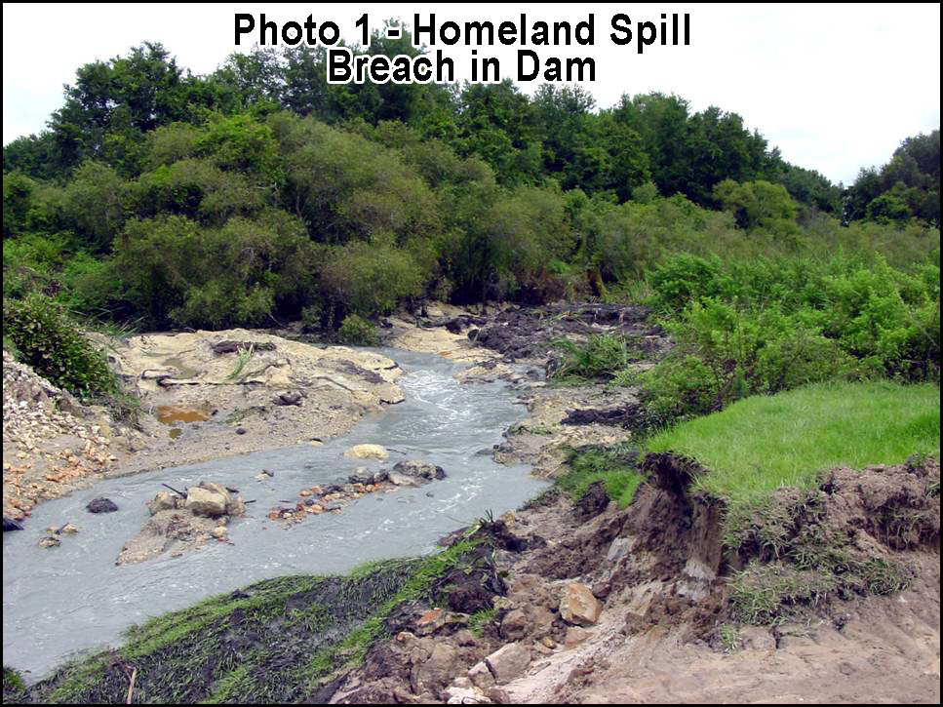

Except for the select few who have visited active/inactive phosphate strip mines, or have per chance flown over such devastated regions in a plane or helicopter, the general public has no conception as to the degree and magnitude of the impacts, permanency, or potential for associated long-term liabilities and human health risks. The extensive alterations to the Florida landscape which have already occurred within the CFPD are among the most prominent collection of land disturbance features visible from space. In consideration of this, there is no doubt that the advertising conducted for the scoping meetings and the narratives, figures, and exhibits of the FAEIS, were/are inadequate to educate the general public concerning the magnitude and impacts of strip mining in west-central Florida. A very large effort, much broader in scope and intensity, should have been made to educate and engage the general public on the very profound issue of regional-scale phosphate strip mining, chemical processing, and area-wide waste dumping (CSAs, Gyp Stacks and Reclaimed Land). Involvement in the initial scoping meetings for the FAEIS was therefore improperly selective and restrictive, and constitutes a general public injustice and lack of environmental justice.
Although at least one scoping meeting reportedly hosted over 100 attendees, a large percentage of those present were, intrinsically, representatives of the phosphate industry and various assortments of government officials, agency personnel and assistants. The public has not been adequately noticed and appropriately educated as to the extent, value, complexity, and irreplaceably of the natural resources destined to be destroyed by phosphate strip mining. Neither have they been appropriately informed in clear terms, meaningful to laypersons, as to the vast array of regional and global consequences of destroying a large percentage of west-central Florida merely for the short-term economic gain of external interests.

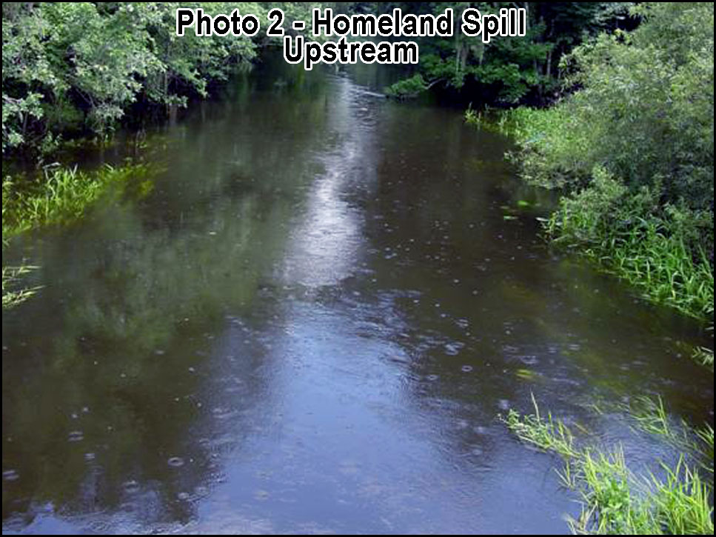

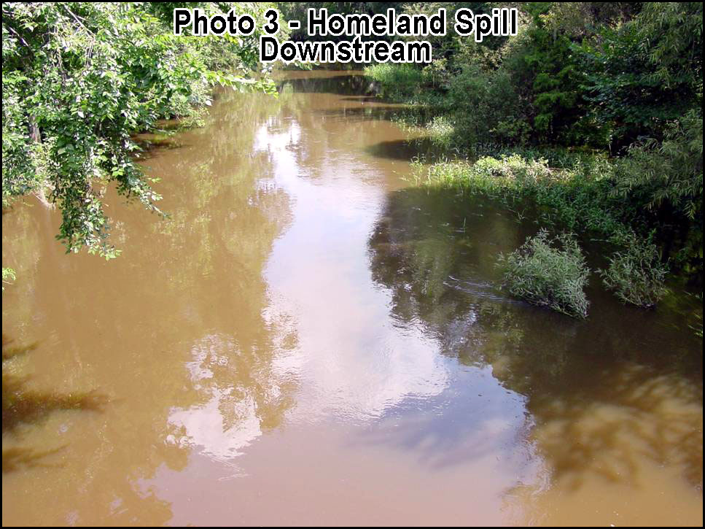

The FAEIS focuses almost exclusively on fulfilling the primary economic strategy of the phosphate industry, which has been, and continues to be, to mine every available acre, without regard for protecting the irreplaceable subtropical ecosystems and extensive water resources which it destroys, and without assuming responsibility for the long-term liabilities which fall on local communities after mining is completed. Phosphate strip mining results in far-reaching and pervasive impacts, on a titanic scale, such as contamination of surface waters and groundwater. Avoided in the FAEIS are competent evaluations of ecological resources and forthright discussions and proposals for "Protection of the Environment", which is the sole purpose of NEPA as set forth in 40 CFR 1500.1.
It is not possible to estimate the number of spills which have occurred within the CFPD, or their negative impacts both internally on mine lands, and to external properties, ecosystems and water resources. Monitoring is direly lacking, and spills seem seldom reported, even less often are they documented, or well-documented, as is the example provided in the previous three photos. Even if spills are reported, the state is highly resistant to documenting them, and even more unwilling to enforce regulations.
* Recommendation:
The FAEIS includes no discussion of the problem of ongoing spills on previously mined land and at active mines. Comprehensive fulltime monitoring and auditing of phosphate strip mines (past and present) and its related industries is critically needed in order to find and respond to the many spills and ongoing discharges in a timely manner. Adequate staff, resources and industry funding need to be guaranteed. The lack of public access and transparency into industry-owned lands precludes adequate monitoring and necessary oversight, which should be provided only by objective 3rd parties.

FAEIS ERRONEOUS AND BIASED STATEMENTS
* Substantive Comment:
The FAEIS should be rewritten to contain only scientifically supported descriptions of environmental resources and potential impacts. Some representations made in the document, such as inferring that mining will actually improve the site, are erroneous and greatly erode the credibility of FAEIS. Additionally, a very significant body of valuable "independent" scientific research exists which was not utilized or cited in the FAEIS.

FAEIS NOT SCIENTIFICALLY QUALIFIED
* Substantive Comment:
3PR questions the adequacy of environmental analyses and accuracy of the information upon which the FAEIS was based because regional environmental experts and regionally relevant biological and ecological research were not utilized and, in fact, were resisted by the USACE. Of the citations in listed in the Chapter 7 "Reference" section of the FAEIS, only a few are research from mainstream scientific journals, and most these not relevant to the CFPD or the four proposed phosphate strip mine sites. A complete environmental literature review should have been conducted, and regionally relevant research should have been sought out and incorporated in the decision-making process as required by NEPA. That is, NEPA requires that information be actively solicited from the public and be of the highest possible quality and relevance. Research upon which the FAEIS was based should have included, but not been limited to, that published by prominent institutions conducting research in conservation biology in central Florida, such as the Archbold Biological Station, the University of Central Florida, the Natural Resources Flight of the Avon Park Bombing Range, Tall Timbers Research Station, and independent, 3rd party scientists who are recognized as experts in the region. The FAEIS is inconsistent with NEPA because the USACE did not solicit appropriate public involvement and refused the introduction of important scientific information. The USACE rejected attempts to submit relevant environmental research and bona fide site-specific, 3rd part research. Additionally, the USACE ignored most every important published study relevant to the environmental impacts of phosphate strip mining on the human, physical and biological environments of west central Florida. Consideration of these studies would need to be considered in order to accomplish the NEPA purpose of "Protection of the Environment".
40 CFR 1506.6 Public Involvement
Agencies shall:
(d) Solicit appropriate information from the public.

Most of the so-called "References" (Chapter 7) are completely unqualified as they are not openly published works which have been subjected to public scrutiny and peer review, but mostly "sponsor funded" or in-house documents, personal communications and memoranda. The public, including 3PR, is entitled to the data and analysis upon which the FAEIS is based. Much of this information has not been provided, nor is it anywhere available. NEPA (40 CFR 1500.1 Purpose) requires that "Information must be of high quality" and that "accurate scientific analysis, expert agency comments and public scrutiny are essential to implementing NEPA", "Most important, NEPA documents must concentrate on the issues that are truly significant to the action in question, rather than amassing needless detail." These requirements are "Binding on all Federal agencies for implementing the procedural provisions of the National Environmental Policy Act." "The NEPA process is intended to help public officials make decisions that are based on understanding of environmental consequences, and take actions that protect, restore, and enhance the environment." Nowhere in the FAEIS are "Protection of the Environment", "understanding of environmental consequences", and the taking of "actions that protect, restore, and enhance the environment" addressed or considered with any measure of priority or concern.
At a minimum, the FAEIS should have included a comprehensive literature search, reviews, and independent biological evaluations and characterizations of ecosystems, vegetative communities, and other biota occurring within the CFPD (Palmer et al 2005). Without comprehensive and qualified public information there can be no analysis, and therefore no cumulative impact study. A comprehensive cumulative impact assessment must be based on high levels of scientific data and analyses, developed from research conducted within the project area (CFPD) by independent, regionally-experienced, well-known, third-part scientists, plus a comprehensive and independent treatment of each important biological, wildlife, and ecosystem concern. And, as previously indicated, information must be solicited from the public, and all information must be made available and presented to the public so that it may be subjected to public scrutiny. The USACE did not adhere to this NEPA requirement, as is clearly evidenced in the Chapter 7 "References" and throughout the FAEIS.
Instead of independent evaluations, the content of the FAEIS relies very heavily on representations and unpublished in-house correspondence provided by the Applicants, phosphate industry consultants, contractors, attorneys and agents, and other phosphate strip mining proponents such as The Phosphate Council. This is a conflict of interest. It is highly improper, and serves along with other problems to invalidate the FAEIS.
The FAEIS and cumulative impact assessment should specifically include, but not be limited to, comprehensive evaluations and analyses conducted by qualified scientists, who have extensive experience in central Florida, and who are independent of the phosphate strip mining industry. The following is a list of phosphate strip mining impacts which were not addressed, or not meaningfully considered in the FAEIS:
- Cumulative and compound negative effects of permanently destroying tens-of-thousands of acres of native soils crucial for the production of traditional types of local crops and foods, which are indispensable for the continuance of economically viable and flexible traditional agriculture, and which are also essential for the existence of native regional ecosystems including native vegetation associations.
- Increased vulnerability to contamination of the IAS and FAS potentially caused by removal of the overlying SAS, and removal of the vital, irreparable, inscrutably complex and ecologically delicate upper soil layers and horizons, including, but not limited to, the spodic horizons of many dry prairie (flatwoods, pine-palmetto flatwoods) soils.
- Destruction of tens-of-thousands of acres of native wildlife habitat; hundreds-of-thousands cumulatively.
- Increased Radium-226 and other radiological/radionuclide contamination in birds, plants and other biota.
- Destruction of many thousands of acres of diverse, complex natural wetlands and waterfowl habitat.
- Regional alteration of aquifers, surface water flows and low-flow.
- Creation of tens of thousands of acres of surface disturbance and altering soils, resulting in large-scale ruderal conditions which promote endless and permanent infestations of noxious weeds and/or undesirable species, or disproportionate concentrations thereof, such as cogongrass, which is exceedingly difficult and expensive to eradicate (that is, cannot be effectively eradicated) and which poses severe invasion threats to surrounding lands.
- Greatly increased evaporation loss potentially relating to the extensive areas of open water associated with clay waste disposal and settling/storage areas (CSAs), dewatering processes, water management, and exposed surface waters in mine pits. That is, creating manifold areas of open water which lose moisture at a very high rate.
- Excessive use and degradation of groundwater during the mining process.
- Contamination from astronomical quantities of chemical processing reagents that end up in reclaimed lands, the environment and phosphate products.
- Climatic change resulting from regional deforestation, re-contouring, and hydrological alterations, and the extensive and essentially treeless, depauperate landscapes of so-called reclaimed lands.
- Health and environmental risks associated with increased radioactivity, especially radioactive fallout and contamination of crops.
- Universal aesthetic degradation of the region and destruction of regional character and rural traditions, including traditional agriculture.

The FAEIS is mostly unsupported by relevant data, analysis, and documentation. It lacks specificity and measurability throughout, and is generally unqualified because of inadequate, non-regionally-specific data and analyses, and "preparers" who lack adequate experience with the ecosystem and biota of west-central Florida. It does not provide adequate evaluations of the vast and irreplaceable natural resources proposed to be destroyed by mining, conducted by objective, politically neutral, third-party researchers. Because the base information and analysis of the FAEIS is wholly inadequate for the purposes of characterizing and understanding the resources at risk, the FAEIS is intrinsically flawed and does not comply with the NEPA purpose of "Protection of the Environment".

INADEQUATE PUBLIC NOTICE AND EDUCATION
* Substantive Comment:
3PR questions the adequacy of the FAEIS development process, because it does not adequately solicit public input and participation. Regionally recognized, "independent" biological and conservation research institutions and wildlife experts were not sought out for their knowledge. And, the introduction of relevant scientific information was flatly discouraged - rejected by the USACE without explanation, comment, or acknowledgement. The USACE AEIS public meetings were not widely advertised in ways that would adequately, accurately, and appropriately characterize the tremendous scope and importance of the proposal and its potential for long-term negative impacts to human society and the environment. Public notices and advertising did not adequately or appropriately characterize phosphate strip mining and the potential it has demonstrated historically for adverse impacts to the environment and human society. Additionally, the FAEIS development/process efforts did not adequately and broadly inform the public, with concise descriptions, photos, multimedia and TV as to the environmental and land use realities of previously-mined properties. No reasonable effort was made to inform the general public concerning phosphate strip mining, to depict or characterize their operations and activities in any meaningful way, or to make residents aware of important issues relating to previously mined lands, current mining operations, or the huge four mine projects currently proposed. An effective and comprehensive educational process is therefore needed in order for the general public is to gain a reasonable level of understanding, and conceptualize the magnitude and potential for negative impacts which phosphate strip mining will have on their communities. Tours of the landscape surrounding Mulberry and Ft. Meade, and the phosphate industrial processing district along SR-60 between Bartow and Mulberry are very educational and enlightening, as the condition of this region provides foreshadows of the impacts and effects of future phosphate strip mining on human communities and the environment.
Although the FAEIS and four proposed mining operations will result in impacts to approximately 50,000 acres of intact land, involving 6 counties, and 2 watersheds (which include an additional 2 counties), only very limited advertising was provided to the public, and with no "real" characterization of the extreme scale of the proposed projects and magnitude of impacts to the environment and human society.

SCOPE AND DETAIL OF FAEIS INSUFFICIENT
* Substantive Comment:
As stated previously, the FAEIS is highly insufficient in scope and level of analysis. It is insufficient: (1) In terms of its evaluations of ecosystems, biota and biodiversity, including the analysis of the cumulative effects of area-wide ecosystem destruction; (2) In terms of Environmental Justice; (3) In terms of gross omission of scientific research, analyses, and qualified, published, objective, third-party research; and (4) In terms of its utter lack of consideration for important public health and safety concerns; (5) In terms of its lack of consideration for increased radioactivity and radioactive fallout; (6) and in absence of discussion of the environmental and economic consequences of the wide-spread infestations of noxious, weedy, and/or non-native vegetation on mined land.
The FAEIS states "The USACE’s decision will be to either issue, issue with modifications, or deny Department of the Army permits for the proposed actions. The FAEIS (FAEIS) is intended to be sufficient in scope to address federal, state, and local requirements and environmental issues concerning the Proposed Action and permit reviews."

It is demonstrated throughout 3PR's comments that the FAEIS is insufficient in scope and qualified scientific basis as required by NEPA. Federal, state and local requirements and environmental issues are universally omitted, or all but ignored.

FAEIS PREDETERMINES APPROVAL THROUGHOUT
* Substantive Comment:
Throughout the FAEIS, the USACE predetermines or assumes approval of the four phosphate strip mining project. This invalidates the FAEIS because interested parties are compelled to comment on issues which clearly, by the tone and verbiage of the document, will not affect final decisions, conditions, or approvals.

INAPPROPRIATE FAEIS CONTENT / “MINING EFFICIENCY ADVANCES”
* Substantive Comment:
3PR questions the need for much of the pro forma information and bulk contained within the FAEIS. As previously detailed, this is inconsistent with the requirements of NEPA. Many sections, such as “Mining Efficiency Advances,” do not further the understanding of the impacts of phosphate strip mining. Even so, improvements in phosphate strip mining technologies have merely served to increase the destructiveness of the industry by more completely obliterating native ecosystems, and by increasing the volume of toxic wastes and other environmentally damaging results. As the industry has become more "efficient" in extracting its products, damage and suffering of communities and the environment is concomitantly increased.
* Recommendation:
Comprehensive studies need to be conducted in order to determine the amount of residential and commercial development which has occurred on the phosphate lands (including on CSA's) which have been mined during the last 20 years. The results of such studies would no doubt reveal the "true" economic and social potentials of properties in the post-mine post-reclamation landscape scenario. Mine ownership precluded large areas of land from being developed during the recent economic boom. Likewise, future phosphate strip mining will continue to physically and environmentally obstruct residential and commercial growth in central Florida. See Hazen & Sawyer (2004).

INADEQUATE PUBLIC EDUCATION AND INVOLVEMENT
* Substantive Comment:
3PR questions the adequacy of the environmental analyses contained in the FAEIS because the NEPA "Public Involvement" requirements were not fulfilled. This represents a special concern because, as detailed in previous sections of 3PR's comments, significant areas within the CFPD are dominated by low-income and/or minorities, dictating the need for special public involvement considerations. The sections of NEPA non-compliance include:
40 CFR 1506.6 Public involvement.
Agencies shall:
(b) .In the case of an action with effects primarily of local concern the notice may include:
(v) Notice through other local media.
(vi) Notice to potentially interested community organizations including small business associations.
(vii) Publication in newsletters that may be expected to reach potentially interested persons.
(viii) Direct mailing to owners and occupants of nearby or affected property.
(d) Solicit appropriate information from the public.

3PR is not aware of any utilization of the predominant television channels viewed locally within the CFPD, notices to churches within the CFPD, minority businesses and business associations within the CFPD, direct mailings to owners and occupants "nearby", but external to, the CFPD, or "affected" properties within or external to the CFPD.
The effects of area-wide phosphate strip mining extend far beyond the boundaries of the individual mine project, or the CFPD, and the public involvement process should have been greatly expanded and much more comprehensive. Again, low-income and minority populations, including non-English speaking, are entitled to an especially strong effort to educate them concerning the negative impacts that area-wide phosphate strip mining will have on their communities, livelihoods, land values, and future opportunities. Proportionate to the amount of land utilized and impacted, phosphate strip mining creates very few fulltime jobs for the local residents where mining takes place. And, the jobs are merely temporary, until mining is completed and the land is exhausted.

RANGE OF ALTERNATIVES IMPROPER AND INCONSISTENT
* Substantive Comment:
3PR questions the adequacy of the environmental analyses in the FAEIS because the presentation and discussion of alternatives is internally inconsistent and avoids certain considerations relating to cumulative impacts, and cumulative impact analysis. The analyses of the alternatives would be more logically conducted according to each class of alternative, as in: "No Action", proposed, foreseeable, and potential.
3PR primarily questions this section because, except for Alternative-1 ("No Action" / "no permit"), none of the alternatives significantly protect ecosystems, wetlands, water resources, soils, climate, geology, human environment, public health, the rights of the majority of residents, or the needs and rights of future residents. The purpose of NEPA, which is "Protection of the Environment", the "Congressional Declaration of Purpose", which in part is to "encourage productive and enjoyable harmony between man and his environment; to promote efforts which will prevent or eliminate damage to the environment and biosphere", and "Environmental Justice", which is necessary to protect those who are most certainly not able to well represent themselves, are nowhere adequately addressed in the FAEIS.
3PR questions Alternative-1 ("No Action" / "no permit") because, as discussed in a previous comment, this alternative potentially allows many of the most severe impacts of phosphate mining to continue with approval. This is inconsistent with the NEPA purpose of "Protection of the Environment".
3PR questions the validity and intent of the FAEIS as a tool which should further the interests of mankind, but which does not. The document presents voluminous amounts of generic data, including many excerpts from public documents, most of which are either biased in favor of unrestricted phosphate strip mining, or otherwise inappropriate or unnecessary.
3PR contends that "Alternative-1 ("No Mining") is the only acceptable alternative. It is the only alternative which offers any protection or concern for the environment as required by NEPA. Even this alternative will result in very extensive negative impacts through continued phosphate strip mining as the industry completes its currently permitted projects.
3PR questions the validity of all alternatives presented in the FAEIS because they very obviously were not developed objectively and openly in the public interest. The alternatives are not reasonable in terms of their total impacts on the environment and society, especially their impacts on low-income and minority communities.

AFFECTED ENVIRONMENT ANALYSIS GROSSLY INSUFFICIENT
* Substantive Comment:
3PR questions the adequacy of the environmental analyses in the FAEIS because Chapter 3.0 "Affected Environment" is entirely inconsistent with the requirements of NEPA.
40 CFR 1502.15 Affected environment.
"The environmental impact statement shall succinctly describe the environment of the area(s) to be affected or created by the alternatives under consideration. The descriptions shall be no longer than is necessary to understand the effects of the alternatives. Data and analyses in a statement shall be commensurate with the importance of the impact, with less important material summarized, consolidated, or simply referenced. Agencies shall avoid useless bulk in statements and shall concentrate effort and attention on important issues. Verbose descriptions of the affected environment are themselves no measure of the adequacy of an environmental impact statement."

Nowhere is the "environment" of the CFPD and the four proposed phosphate strip mine projects "succinctly" described in ways which would allow a reviewer to "understand the effects of the alternatives". And, as detailed in the other comments of 3PR, the level and quality of data and analyses are definitely not "commensurate with the importance of the impact".
As with all Chapters of the FAEIS, this section is difficult to follow and evaluate because of such erroneous statements as "The CFPD study area is characterized by prevailing flat terrain. Minimal aesthetic impact concerns are anticipated for any proposed new phosphate mines so long as adequate berms and setbacks or buffers are maintained." The CFPD contains most of the Polk Upland, which is the largest upland physiographic province in central Florida, and is characterized as "uplands", "ridges" and "slopes". Positioned within this vast upland region, which has many broadly rolling hills, and riverine/palustrine valleys and ravines, are the even higher hills of the topographically contrasting Lakeland Ridge and Lake Henry Ridge, as well as several unnamed ridges and extensive intermittent xeric upland areas, such as is found throughout western Manatee County, and along the banks of the Peace River and major creeks. A more appropriate statement for the FAEIS, which is "succinctly" accurate, would be "Phosphate strip mining destroys the historical aesthetic character of each community and region it mines by excavating the hills and valleys, and replacing them with new contours surrounding massively tall, geographically extensive, rectangular waste clay dams and impoundments containing inestimable volumes of contaminants." See Photo 6.
Much of FAEIS is composed mainly of "useless bulk" and its statements are generally inadequate and inappropriate in properly responding to NEPA requirement because they do not responsibly characterize and evaluate the "Affected Environment" in a "succinct" manner. Also, they are very frequently contradictory.
The Applicants have publicly stated that development of the FAEIS "is not" an interactive process. 3PR can only guess how they may have come by this misconception. However, they are correct in the sense that the development of the FAEIS "has not been an interactive process!” The general public and non-industry interested parties have not been allowed input into the "process". Of all of the scientific studies, research materials and expert contributions made at by non-phosphate-industry concerns at public meetings, none (as far as 3PR is aware) has been incorporated into the document, or even official acknowledged.

SOILS ESSENTIAL TO NATIVE ECOSYSTEMS AND HYDROLOGY IGNORED
* Substantive Comment:
3PR questions the accuracy of information and adequacy of the environmental analyses in the FAEIS because it does not consider the fact that phosphate strip mining destroys environmentally sensitive native soils. Such soils are essential to the existence of native ecosystems including, but not limited to, dry prairies (pine/palmetto/wiregrass flatwoods soils). Phosphate strip mining results in the replacement of these invaluable resources with non-native substrates composed of ore processing wastes to which native vegetation and thus native ecosystems are not adapted, and which can never again support natural, self-sustaining native plant and animal communities. This issue/impact is of paramount importance. It is not addressed in the FAEIS. Omission of protection of native soils and ecosystems renders the FAEIS invalid. NEPA requires, as a first measure, "Protection of the Environment". NEPA is the federal act which must guide the FAEIS. NEPA requirements are "Binding on all Federal agencies for implementing the procedural provisions of the National Environmental Policy Act
The most important, and by far the most predominant natural (native) soils found on unmined phosphate-company-owned lands in Hardee County belong to the "poorly drained" drainage class, "B/D" hydrologic group (USDA 2012b). Because of very recent changes in the engineering criteria for hydrologic groups, extensive areas of B/D soils have been re-designated or redefined, as A/D hydrologic group. Both B/D and many A/D soils in Hardee County include the following types: Basinger fine sand, Bradenton loamy fine sand, Farmton fine sand, Felda fine sand - frequently flooded, Felda fine sand, Immokalee fine sand, Myakka fine sand, Pomona fine sand, Wauchula fine sand mapped by the NRCS. The crucial importance of protecting the integrity of these unique native soils, which are essential to mesic and seasonally wet native upland ecosystems, is discussed further in several other 3PR comments.
Phosphate strip mining extensively alters the physical, chemical, and hydrologic properties of surficial aquifers and water tables. It is well documented that native upland ecosystems and vegetative communities are precisely adapted and require these special natural attributes (Orzell & Bridges 2006) (Cole et al 1994) (Huck 1987). Natural native ecosystems and their specific vegetative communities are therefore precluded from re-establishment as a result of the native soil destruction caused by phosphate strip mining, phosphate processing waste disposal, and so-called reclamation.
* Recommendation:
The effects of converting vast areas of native soils to unnatural post-mining Arents-Hydraquents-Neilhurst substrates, which cannot support native upland ecosystems, including "dry prairie, pine/palmetto flatwoods" vegetative communities, are devastating to vast areas of the natural environment. These essential ecological assets must be thoroughly analyzed and assessed, providing special attention to the cumulative negative impacts which area-wide phosphate strip mining has imparted, and will impart, on the regional ecology, native biota, genetic diversity (genetic erosion), natural hydrology, and critical bio-hydrologic regimes of the Southwestern Florida Flatwoods Ecoregion. The aerial extent of each native soil type must be correlated to the amount of each native vegetative community which has been lost, and would be lost if phosphate strip mining is allowed to continue. Each native vegetative community must be fully characterized as in Orzell & Bridges (2006) because little is known of ecosystem structure in the regions west of the Lake Wales Ridge, and because numerous plant species have been recently discovered in that region which were formerly unknown to science, and which are planned to be proposed for federal listing. Evaluations must be conducted for each alternative, and for lands which have already been mined, so that negative environmental impacts may be evaluated separately, and then cumulatively.
* Substantive Comment:
Additionally, destruction of native soils, especially those supporting, or formerly supporting, dry prairie, pine/palmetto flatwoods, precludes traditional agriculture, both private and commercial agribusiness. The agricultural infrastructure within west central Florida is based on nearly 100 years of technology developed specifically to farm on native soils.

COORDINATION AND CONSISTENCY WITH LOCAL AGENCIES LACKING
* Substantive Comment:
Additionally, 3PR questions the adequacy of the environmental analyses and accuracy of the information in the FAEIS because NEPA requires coordination and consistency with the laws and future planning strategies of state and local governments.
PART 1506--OTHER REQUIREMENTS OF NEPA
Sec. 1506.2 Elimination of duplication with State and local procedures.

(b) Agencies shall cooperate with State and local agencies to the fullest extent possible to reduce duplication between NEPA and State and local requirements ... such cooperation shall to the fullest extent possible include:

- Joint planning processes.
- Joint environmental research and studies.
- Joint public hearings (except where otherwise provided by statute).
- Joint environmental assessments.

(d) To better integrate environmental impact statements into State or local planning processes, statements shall discuss any inconsistency of a proposed action with any approved State or local plan and laws (whether or not federally sanctioned). Where an inconsistency exists, the statement should describe the extent to which the agency would reconcile its proposed action with the plan or law.

As detailed elsewhere in 3PR's comments, throughout the FAEIS there is little evidence of any effort to comply with NEPA, including any significant coordination with state and local agencies in terms of ensuring consistency with their laws, regulations, or adopted land use or agency policy plans. In comparing the policies of the State Comprehensive Plan, Central Florida Regional Policy Plan and Local Comprehensive Plans of the counties being impacted by phosphate strip mining, many inconsistencies and direct NEPA conflicts are found. Examples where the FAEIS is inconsistent with the State Comprehensive Plan are as follows:
State Comprehensive Plan

Florida Statues: 187.201(5)(b)1 Goal: An environment which supports a healthy population and which does not cause illness.

Florida Statues: 187.201(5)(b)1.2 Policy a: The state should assure a safe and healthful environment through monitoring and regulating activities which impact the quality of the state's air, water, and food.

Florida Statues: 187.201(7)(a) Goal: Florida shall assure the availability of an adequate supply of water for all competing uses deemed reasonable and beneficial and shall maintain the functions of natural systems and the overall present level of surface and ground water quality. Florida shall improve and restore the quality of waters not presently meeting water quality standards.

Florida Statues: 187.201(7)(b) Policy 2: Identify and protect the functions of water recharge areas and provide incentives for their conservation.

Florida Statues: 187.201(7)(b) Policy 4: Protect and use natural water systems in lieu of structural alternatives and restore modified systems.

Florida Statues: 187.201(7)(b) Policy 5: Ensure that new development is compatible with existing local and regional water supplies.

Florida Statues: 187.201(7)(b) Policy 6: Establish minimum seasonal flows and levels for surface watercourses with primary consideration given to the protection of natural resources, especially marine, estuarine, and aquatic ecosystems.

Florida Statues: 187.201(7)(b) Policy 7: Discourage the channelization, diversion, or damming of natural riverine systems.

Florida Statues: 187.201(7)(b) Policy 8: Encourage the development of a strict floodplain management program by state and local governments designed to preserve hydrologically significant wetlands and other natural floodplain features.

Florida Statues: 187.201(7)(b) Policy 9: Protect aquifers from depletion and contamination through appropriate regulatory programs and through incentives.

Florida Statues: 187.201(7)(b) Policy 10: Protect surface and groundwater quality and quantity in the state.

Florida Statues: 187.201(7)(b) Policy 14: Reserve from use that water necessary to support essential nonwithdrawal demands, including navigation, recreation, and the protection of fish and wildlife.

Florida Statues: 187.201(9)(a) Goal: Florida shall protect and acquire unique natural habitats and ecological systems, such as wetlands, tropical hardwood hammocks, palm hammocks, and virgin longleaf pine forests, and restore degraded natural systems to a functional condition.

Florida Statues: 187.201(9)(b) Policy 1: Conserve forests, wetlands, fish, marine life, and wildlife to maintain their environmental, economic, aesthetic, and recreational values.

Florida Statues: 187.201(9)(b) Policy 3: Prohibit the destruction of endangered species and protect their habitats.

Florida Statues: 187.201(9)(b) Policy 4: Establish an integrated regulatory program to assure the survival of endangered and threatened species within the state.

Florida Statues: 187.201(9)(b) Policy 7: Protect and restore the ecological functions of wetlands systems to ensure their long-term environmental, economic, and recreational value.

Florida Statues: 187.201(13)(b) Policy 5: Prohibit resource extraction which will result in an adverse effect on environmentally sensitive areas of the state which cannot be restored.

Florida Statues: 187.201(13)(b) Policy 6: Minimize the effects of resource extraction upon ground and surface waters.

Florida Statues: 187.201(13)(b) Policy 7: Protect human health from radiological or other adverse impacts associated with resource extraction.

Florida Statues: 187.201(13)(b) Policy 8: Reduce the adverse impacts of waste disposal associated with resource extraction.

Florida Statues: 187.201(22)(b) Policy 9: Conserve soil resources to maintain the economic value of land for agricultural pursuits and to prevent sedimentation in state waters. 187.201(22)(b) Policy 9: Conserve soil resources to maintain the economic value of land for agricultural pursuits and to prevent sedimentation in state waters.

Reading through the above list of Florida Statues, it is clear that the FAEIS is in no way consistent with any of them. These statutes were clearly adopted to provide "Protection of the Environment". These statutes are consistent with and further NEPA, but the FAEIS does not! The statutes strongly support and echo many of 3PR's concerns involving the protection of natural function of wetlands, soils and agriculture, and ensuring an environment that promotes public health and safety, and protecting the public against the many negative impacts, hazards and health risks of polluting and destructive industries such as phosphate strip mining, ore processing and product use. Under NEPA these statutes (as well as regional and local laws) must be considered by all federal agencies, including, but not limited to, the USACE, USEPA and USFWS.
There are very large numbers of state, regional and local laws, and other regulations, with which the FAEIS is not consistent as required by NEPA. The USACE has failed to appropriately coordinate with the State of Florida. 3PR also questions the degree to which the USACE specially and specifically cooperated with local governments as required by NEPA. The FAEIS does not contain any evidence of meaningful coordination with affected local governments.

WILDLIFE COMMENTS NOT RELEVANT OR REASONABLE
* Substantive Comment:
3PR questions the adequacy of the environmental analyses and the accuracy of the information in the FAEIS because certain statements such as under 3.3.62 are not reasonable, and are irrelevant and inappropriate. It is not reasonable or rational for the USACE to compare so-called "reclaimed" phosphate strip mines to the qualities of native/natural Florida ecosystems. Improperly using excerpts from short-term, narrow studies to suggest that "reclaimed" phosphate strip mines are in any way comparable, or even partly mitigate for impacts to native ecosystems, is not rational or defensible. Isolated artificial habitat facades, reclamation demonstration projects which required great expense to create and/or maintain, and temporary influxes of wildlife attracted to new water resources, where none existed before, are not indicative of a functioning or stable ecosystem, nor do they provide significant value. Such areas may actually represent hazards and risks to wildlife. Further, the area-wide destruction of native upland and wetland ecosystems by the phosphate strip mining industry results mainly in vast, seemingly endless regions of noxious weed infestations which preclude/exclude native plant and animal communities, and that promote ecological imbalances. 3PR objects to these out-of-context excerpts and conjecture of paid industry consultants and contractors which permeate the FAEIS. The FAEIS should have been based primarily on peer-reviewed 3rd-party research relevant to the region and the types of impacts caused by phosphate strip mining, phosphate processing, phosphate processing waste disposal, and the transport and use of phosphate mining products and wastes. All information upon which the FAEIS was supposedly based should have been made available for public scrutiny prior to, and throughout the process, as required by NEPA. However, it was not.
Plant and animal species are products of their respective natural environments. Except for certain generalist species, most native (indigenous) plants and animals are utterly dependent on specific native ecosystems. Many birds and some mammals and reptiles are mobile to varying degrees. Some generalists may utilize man-altered sites from time to time, especially when they are forced to do, or are abnormally attracted to do so (as aquatic/wading birds may be attracted to water areas), or when they happen into a vast region of destruction and have no other alternative. Some species may occasionally breed in non-native areas, even though this is not their natural/normal biological or ecological behavior. This sometimes happens because of destruction of their natural habitat and breeding areas, but usually on a small scale, or only in localized situations. "By altering the character of the environment, human beings bring about changes in the behavior patterns of within and between species so that most species are unsuccessful. However, the few that are successful reproduce quickly sometimes in explosive fashion" (Rau & Wooten 1980). The animals which remain are pioneer-type animals that tolerate changes in food types, shelter, and have only limited relationships with other organisms. Usually these population explosions are short-lived, and the disturbance which released the excess resources then fosters a rampant growth of exotic or vegetation. The end result is permanent ecological damage. That is, these population explosions which brought about disturbance and artificial opportunities actually represent evidence of impending environmental doom, and inevitably lead to ecological collapse, disaster, or at a minimum, ultimate reduction in stable species richness and species evenness as compared to natural reference systems. When their natural native habitat is being destroyed on a tractless scale in neighboring areas by phosphate strip mining and by other types of development, many species will be forced to move into any available land, natural or unnatural, which is not actively being mined.
Several important issues and concerns exist in relation to mined/reclaimed land. The natural ecosystems which are completely destroyed by mining, along with their highly specific and essential soils and geology, are replaced by rocky/marl/sand/clay/etc substrates, many by the highly variable and inconsistent conglomerate Arents-Hydraquents-Neilhurst. No indigenous plant species are adapted to these soils, therefore no native ecosystems can be supported or establish self-sustaining populations of animals. Arents-Hydraquents-Neilhurst rapidly encourages dense infestation of noxious plants and weeds, mainly cogongrass, and supports only certain generalist animals, including pest species such as rodents and temporary or guest species. This unnatural situation introduces primary succession. "Primary succession occurs in an area where life has not existed before, such as on bare rocks, tallus slopes (which are unconsolidated slopes, land slides, embankments, etc.), sand bars, and sand dunes" (Rau & Wooten 1980). However, because of the absence of natural soils, the succession on reclaimed phosphate mine land quickly moves towards domination by noxious and undesirable species. In no way will these lands ultimately succeed into natural ecosystems comparable to any natural reference systems.
Lands impacted by phosphate strip mining and reclamation represent "bare" lands and are therefore in a mode of primary succession. "Secondary succession occurs on bare sites previously vegetated" (Rau & Wooten 1980), but this assumes that unnatural changes to soils and geology have not occurred, and that such areas can be recolonized from intact external floral and faunal sources. Therefore, few, if any, native plant species naturally colonize these mined and reclaimed upland areas. Normally, native "pioneer species" would first colonize such areas. However, and quite the contrary in the case of phosphate lands, many such unnatural areas are immediately colonized by noxious plant species, weedy species, foreign species, and other undesirable plants which play little, if any, normal ecological role in native ecosystems, or in ecosystem services, and typically provide few "real" resources to native wildlife. Some species, such as cogongrass, completely preclude the reintroduction of native plant and animal communities. Such infested lands present serious, essentially untenable, ongoing management and eradication liabilities.
The Environmental Impact Analysis Handbook (Rau & Wooten 1980), which is widely used by federal agencies as a guide for developing environmental impact statements (e.g., by the Bureau of Land Management), concludes that "Unfortunately, we are finding that some of our most complex environmental problems are the result of environmental and ecological backlash. As a general rule we find that artificial projects and technological additions lead to the simplification of natural systems. This reductionism results in losses in biological efficiency, diversity, balance, and self-sufficiency of the biological community, and concomitant increases in pest species of plants and animals as escapees and weeds” Much of phosphate strip mine reclamation fits this dismal characterization precisely, especially after a few years, or after a few years without maintenance, which is in essence very expensive artificial "life support". "Managed" biological systems, including "reclaimed" lands, and systems infested with noxious or non-native species, represent the lowest level of biodiversity, genetic diversity, species richness, species evenness, and ecosystem services. For all intents and purposes the native communities of these areas have been completely extirpated and are the native wildlife effectively extinct (Naeem 1997). Also, such boundless eradication of native ecosystems by phosphate strip mining substantially reduces genetic diversity for the entire region, negatively impacting ecosystems and food webs far beyond, even into other states, countries, and globally.
"Alteration or removal of natural vegetation has been the primary cause of habitat destruction, reduction in native plants and animals, and species extinctions. Any proposed project that will alter or remove the native vegetation must consider the impacts ... " (Rau & Wooten 1980). The following represent some, but not all, of the significant adverse impacts and important issues identified by Rau & Wooten in relation to land clearing, draining and filling, changing watercourses, construction of dams and reservoirs, roads, and industrial use:
- Habitat destruction - ADVERSE
- Loss of shelter and food - ADVERSE
- Loss of native plants and animals - ADVERSE
- Reduced species diversity - ADVERSE
- Enhances site for invasion of noxious and weed plants and animals - ADVERSE
- Creates conditions suitable for rodent outbreaks - ADVERSE
- Increased edge effect - ADVERSE
- Loss of climax species (in the case of forested habitats) - ADVERSE
- Changes in migratory patterns of birds and wildlife - ADVERSE
- Interference with migratory routes or normal movement of animals (in the case of roads) - ADVERSE

3PR questions the adequacy of the environmental analyses and accuracy of the information in the FAEIS because it does not provide "accurate scientific analysis", "expert agency comments", but relies disproportionately on representations made by the Applicants. Representations made by the Applicants intrinsically further their own needs and desire for maximum profit, and consequently are in direct conflict with the NEPA purpose of "Protection of the Environment". The fact that the Applicants interact with the USACE without public involvement, public scrutiny, or transparency, is a concern of the utmost seriousness as it precludes compliance with the provision of NEPA, that is, is contrary to the NEPA goal and purpose of "Protection of the Environment".
3PR considers that the FAEIS process has been inadequate in effectively soliciting, advertising, and recruiting the independent expert assistance and judgments which are necessary in order to ensure adequate "public scrutiny". NEPA requires that "Agencies shall: Solicit appropriate information from the public". The FAEIS is therefore not founded on "decisions that are based on understanding of environmental consequences, and take actions that protect, restore, and enhance the environment." NEPA required that "Environmental impact statements shall be concise, clear, and to the point, and shall be supported by evidence that agencies have made the necessary environmental analyses." Many sections of the FAEIS present no clear point, are not measurable, or merely regurgitate pro forma generic narratives, and are supported by data and analyses. The FAEIS "Radiation" section is one example of many.
Even if the soils and geology of the natural ecosystems which phosphate mining destroys were somehow preserved, or somehow avoid the impacts of phosphate strip mining, local gene pools would have been destroyed by clearing away natural vegetative communities, thus creating severe regional genetic erosion, which causes the essential adaptations (genes/genetics) that have taken millennia to develop to be permanently lost! Genetic erosion occurs because each individual organism has many unique genes which are lost if it dies without reproducing. Genetic erosion and other gene pool problems are compounded and accelerated by habitat fragmentation. Without even considering the hundreds of thousands of acres of mined lands in Florida, the habitats of many plants and animals, including but not limited to listed species, are forced into smaller and smaller areas of fragmented habitat, interspersed with human settlements and farmland, making it much more difficult to naturally interact with others of their kind for reproduction. Many therefore die off without having a chance to reproduce, and thus are unable to pass on their unique and often regionally adapted genes to living populations. In its wholesale evisceration of habitat phosphate strip mining thus destroys genetic diversity and creates genetic erosion on a regional scale, possibly completely eliminating entire locally adapted plant genomes (landraces, locally adapted varieties, or ecotypes). It has been well established, that the only effective and self-sustaining species protection, which is actually gene pool protection, involves the protection and management of sufficiently large tracts of native ecosystems.
Also, because phosphate lands have been held in ownership for such long time periods, much (or the majority) of the surrounding ecosystems have already been reduced by other land uses such as agriculture, residential housing, and business/commercial uses. Therefore, as a result of phosphate strip mining, many of the last remaining locally adapted gene pools of important plant and animal populations, and even the genetics of entire metapopulations, will be greatly reduced, or possibly entirely lost. This represents a very serious, "once in history" issue of regional concern. The permitting of additional phosphate strip mining will devastate the genetic diversity necessary to support the remainder of the Southwestern Florida Flatwoods Ecoregion, and server to help erode the overall ecological health of the biosphere. The dire consequences of this situation are that there will be no ecologically appropriate, regionally-adapted, adequately diverse genetic sources which could be used for re-colonization or secondary succession, if such were even possible, which it is not. "If the Earth has lost its savor, from where forth shall it be salted?"
3PR questions the adequacy of environmental analyses and accuracy of information in the FAEIS because it neglects to consider the negative impacts and effects of phosphate strip mining on bio-diversity and the essential and necessary protection of genetic diversity within west-central Florida, and beyond (as these impacts affect surrounding regions and the biosphere), and because it does not consider the strongly related issue concerning the specific soil and geologic requirements of the native/natural upland ecosystems within the CFPD.
It is a widely known ecological principal, and an exceedingly common phenomenon, that disturbed areas, and newly inundated areas, promote the colonization and rapid reproduction of various wildlife due to the presence of artificially and temporarily expanded resources. These short-term increases include space, water, nutrients (some native uplands in central Florida are actually low-nutrient systems which are precisely adapted to very specific acidic soils), soil de-compaction and aeration, increased light, greatly reduced or entirely eliminated competition, and the concomitant explosion of insects, larva, sprouting seeds, and small and thalloid plants which provide additional plentiful food sources for larger species. Almost any flooded area will quickly acquire and produce large amounts of wildlife for a limited amount of time.
Because the phosphate industry and related uses are almost continuously destroying ecosystems and creating pits, dams, vast enclosures of inundated waste clays, other wet areas, and creating the disturbed and somewhat alien substrates of open mine land, including "reclaimed land", which are often laden with nutrients and greatly differ in chemical and physical properties as compared to the natural soils required to support native ecosystems, ecological imbalances are continuously and dynamically taking place. These extreme impacts temporarily provide abnormal levels of "freed" resources. Because animals are forced into these areas from other regions of ecosystems being destroyed, and because animals flying over and moving through will seek out any available sustenance, active and recent phosphate mining continuously sponsors numerous examples of these unnatural, and environmentally unhealthy "population boom" phenomena. A sudden or temporary abundance of certain types of wildlife, more than in natural systems, is invariably an indication of an ecological imbalance from a natural disaster, an atypical event, or artificially induced problem. Therefore, the short-term bird and wildlife studies such as those cited here by the Applicants are irrelevant, and completely out of context from studies of mature systems, whether native or non-native. Ecosystems out of balance represent a serious concern, and most definitely are not an indication of ecological health. To suggest the latter is absurd.
Many mined lands eventually become overgrown with weedy and noxious plant species (such as cogongrass) and do not succeed to vegetative communities which experience natural or naturally compatible ecological succession. Such infested regions represent ecological and agricultural deserts. It would be very enlightening for the USACE's FAEIS authors to take a broad and unrestrained tour of recently reclaimed and formerly reclaimed or abandoned phosphate lands.
The potential for long-term stability and health of the native environment is not measured based on mobile animal species, but on the diversity and stability of plant communities upon which they depend. Ecosystems are self-contained and self-maintaining. "Natural ecosystems are invariably richer in species and more stable than those artificially developed, due to their many interdependencies and interrelationships" (Rau & Wooten 1980). Such natural systems draw in life-supporting materials from great distances. However, in non-natural areas, which are artificial, the interdependencies are missing. These areas are therefore not self-sustaining. Energy and materials are not recycled efficiently and constant maintenance is required. Phosphate strip mining sites and so-called reclaimed land represent severe examples of being "artificial" because of extreme alterations to soils and geology, which preclude recovery to any natural state with species richness, species evenness, and self-sustainability comparable to intact reference systems.
Additionally, the primary vegetative cover of a very large number of acres of "reclaimed" phosphate strip mines is dominated by the invasive species cogongrass (Imperata cylindrica), which forms irrevocable monocultures over these vast ruderal landscapes. More thorough comments regarding cogongrass are presented in a separate comment.

RADIUM-226 IN BIRDS, WILDLIFE, AND PLANTS
* Substantive Comment:
3PR strongly objects and questions the accuracy of the information, the adequacy of the environmental analysis, and indeed the validity of the FAEIS because of the fact that the well-known problem of generally elevated low-level radiation and the assimilation of Radium-226 in wildlife and plants are not treated with any degree of concern or compassion. The scientific studies and publications of government, prestigious research institutions, universities, and others warn of this potential health and safety issue which faces the environment and human population alike. Even conservative authors caution that "we assume that low doses also cause human health effects to a directly proportional, but smaller degree" (FIPR 1986).
Of great concern, and a very significant wildlife impact of phosphate strip mining, is that birds are attracted to clay waste ponds, mine cuts and wetlands which were created either intentionally, or unintentionally, on or near mined lands, or where discharges have taken place, or are taking place. Research indicates that these areas act as radiation poisoning stations for wildlife because the radioactive isotope Radium-226 (which reportedly has a half-life of 1601 years) has been shown to accumulate in the bones of fish and birds feeding in these areas, particularly in the clay waste ponds referred to by the Applicants in this section. It was reported that "the average bone concentration in waterfowl from settling ponds in central Florida was about 4 times the recommended maximum for humans" (O'Meara 1986). This issue is reinforced by additional research which concluded that "As a result of mining and processing operations, most of the radioelements accumulate in the waste clays. Radium and thorium also are present in the gypsum stacks and uranium is present in the acid products and fertilizer" (O'Meara 1986). Runoff and leachate from phosphate processing sources into ditches, wetlands and other areas which may be utilized by plants, animals, or humans, may be of further concern as indicated by the conclusion that the EPA "... does not allow the use of central Florida gypsum. Material from central Florida generally contains about twenty-five pCi/g" (Osmond et al 1984). "Radium-226, a bone-seeking alpha-emitting carcinogen which is at least 20 times as harmful as strontium-90, is blown in the wind, washed by the rain, and leached into the waterways from the tailings piles, where it re-concentrates by factors of thousands in aquatic plants and by factors of hundreds in land plants. It has a half-life of 1,600 years" (CCNR). "A large proportion of the radioelements in phosphate ore ends up in the clay" (Osmond et al 1984).
The photo below depicts only a small fraction of land which was once subtropical Florida, rich with native wildlife habitat, but after phosphate mining, now a wasteland of water-filled pits and waste disposal.
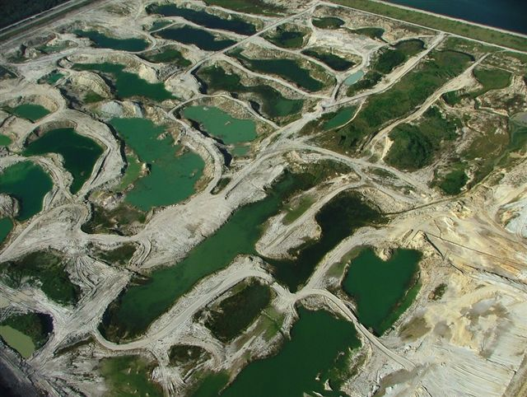

3PR questions the accuracy of information and the adequacy of environmental analyses in the FAEIS where elevated levels of low-level ionizing radiation are concerned because nowhere is this mining-induced phenomenon treated with the proper concern, especially considering the very real potential for such radiation to negatively impact human health, nor does it analyze these documented concerns in regard to overall "Protection of the Environment", which is the stated purpose of NEPA. The FAEIS merely "brushes over" the radiation issue, providing an abbreviated pro forma narrative that avoids all of the available research, even that of FIPR, which explicitly provides evidence of the threat. Especially lacking is consideration of the issue of Lead-210 and Polonium-210 fallout.
As for Radon-222, "When radon undergoes radioactive breakdown, it decays into other radioactive elements called radon daughters, or progeny. Radon daughters are solids, not gases, and stick to surfaces such as dust particles in the air. If contaminated dust is inhaled, these particles can adhere to the airways of the lungs. As these radioactive dust particles break down further, they release small bursts of energy which can damage lung tissue and therefore increase the risk of developing lung cancer. In general, the risk increases as the level of radon and the length of exposure increases." (MASS 2012).
There ever-increasing body of research which confirms that even small increases in low-level ionizing radiation increase the risk of cancer and disease. Krestinian 2007, indicates that:
"Based on 1836 solid cancer cases with 446 588 person years accrued over 47 years of follow-up, solid cancer incidence rates were found to increase with dose and about 3% of the cases were attributable to radiation exposure. The ERR was 1.0/Gy (P = 0.004 95% CI (0.3; 1.9) in a linear dose-response model. There was no significant non-linearity in the dose response and no indication of effect modification by gender, ethnicity, attained age or age at first exposure."

"The Techa River cohort provides strong evidence that low-dose, low-dose rate exposures lead to significant increases in solid cancer risks that appear to be linear in dose. The results do not suggest that risks associated with low-dose rate exposures are less than those seen following acute exposures such as were received by atomic bomb survivors."

The USACE has consistently ignored all important research relevant to the issue of increased radiation and the threats which it may pose. Research conducted on mined lands consistently reports increased radiation threats and elevated concentrations of radionuclides which have been brought to or near the surface by mining, waste disposal and so-called reclamation. Guidry et al (1990), in another example of such research, found that:
"In general, lands containing waste clays or sand-phosphate "debris" tend to have the highest levels of radiation, ,followed by lands reclaimed generally with overburden and sand, next followed by mineralized unmined lands, and finally nonmineralized lands."

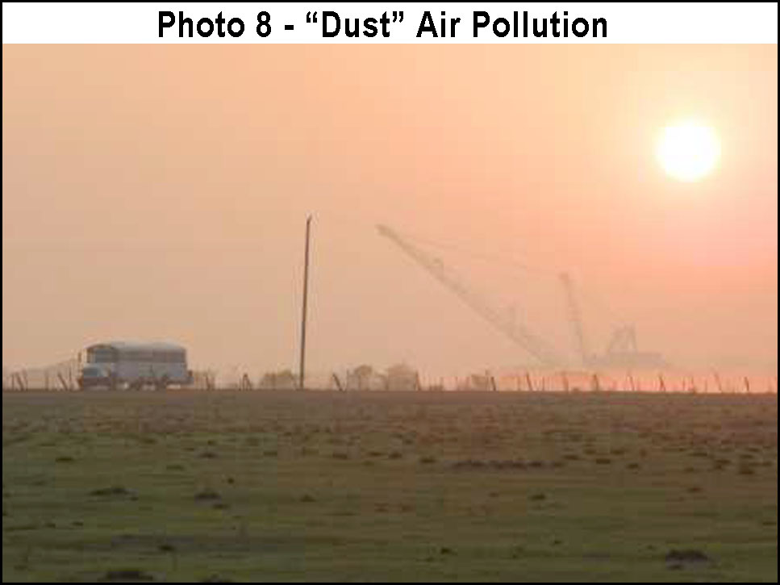

Table 2 shows the decay chain starting with Uranium-238. The chart is very helpful in understanding the relationships between the radioactive elements, their various isotopes and half lives.

Prior to phosphate strip mining there very few permanent or open bodies of water within the CFPD (except in the northern half along the major ridges). The creation of many acres of open water, or frequently near permanently inundated areas as result of phosphate strip mining may have greatly compound the issue of radium in birds, fish, aquatic plants, and other wildlife. This may present a particular problem for other animals, including animals from distant regions, which consume such radioactive phosphate mine wildlife because they are attracted to the many wet and submerged areas resulting from the extensive excavations and waste disposal (CSAs) associated with mining. The apparent foundation of this problem is the accumulation of radiation in aquatic plants, especially small, thalloid, floating species eaten by water foul, which grow quickly in the higher nutrient waters associated with mined lands and vast waste disposal sites (CSAs). It is also reported that radioactive isotopes travel with phosphate fertilizers and are taken up by tobacco and other agricultural plants (Watson 1983)[see other comments for more discussion on this].
The presence of such elevated concentrations of Radium-226 in wildlife, particularly in mobile wildlife such as birds, is of great concern. Elevated radiation in the phosphate strip mining district in general, represents a very large and highly significant issue which has not been adequately addressed in the FAEIS. 3PR therefore questions the accuracy of information and adequacy of the environmental analysis in the FAEIS because it does not consider this important health and safety issue which has the potential to negatively affect the human population and the precious and irreplaceable plants and animals of Florida. Additionally, this readily available research, as well as considerable other published research, is not cited in the Chapter 7 references of the FAEIS.

MORE ON INCREASED RADIOACTIVITY AND RADIATION CONTAMINATION
* Substantive Comment:
3PR questions the accuracy of information and adequacy of the environmental analyses in the FAEIS because not only does phosphate strip mining destroy the potential for future farming, but increased radioactivity, including increased background radiation, exposure to a variety of radionuclides, and Lead-210 and Polonium-210 fallout which contaminates crops, are cause for concern. Increased radiation is generally a concern on mined and so-called reclaimed land, mining wastes dumps such as CSA's and phosphogypsum "stacks". Additional concern arises with the potential for such radionuclides and radiation to escape or be transported, via various transport mechanisms to surrounding lands and communities, and to distant lands. Use of radioactive phosphogypsum and phosphate slag on agriculture lands is another concern. And last, but not least, is the serious concern of radioactive isotopes in phosphate fertilizer products.
The FAEIS statement that "The process of 'toe spoiling' the matrix leach zone to reduce the future exposure from this source on the reclaimed land to or below pre-mining levels" is not scientifically documented or referenced. A comprehensive, highly detailed study needs to be conducted in order to determine radiological risks on mined land, at waste disposal sites, in phosphate products, and beyond. In this same discussion, the FAEIS acknowledges the serious risk of Radon-222 gas, but does not discuss the exposure threat of this radionuclide to mine workers, especially those working where ore is being extracted, transported, or stockpiled. Logic would dictate that this and several other radiation risks would be much greater for those working for long periods at active mines. Examination of the decay chart below, which begins with Radon-222, suggest that the threat for mine workers may be very significantly amplified because mine workers are not only exposed to much higher levels of the Radon-222 and its daughters/progeny Polonium-210 (super radioactive and toxic) and Lead-210, but to the shorted-live radioactive progeny:
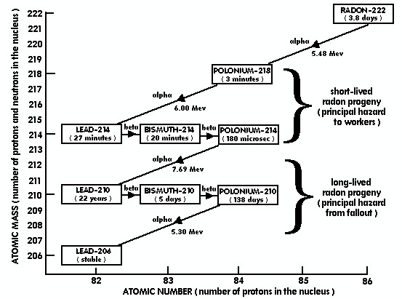

Additionally, there is no consideration for the problem of additive levels of risk, like smoking and/or being a mine worker, and/or synergistic effects such as additional exposure to ore processing ("flotation") reagents and/or phosphate plant separation chemicals, and/or increased or compound risk due to genetic predisposition. Considerable public research, including peer-reviewed medical research and other scientific publications are readily available which indicate that increased radiation and various types of exposure to radionuclides present serious public health and environmental concerns. Many of these publications relate directly to phosphate strip mining and processing. Several of these important studies are well-known and highly respected. The USACE has omitted virtually all of this research from the FAEIS and has not acknowledged the existence of such. Only very general statements concerning radiation are presented by the USACE, and even these highly contestable, are not offered with any compassion or direction for the protection of public health and the environment.

* Substantive Comment:
Brushing over the topic of radiation and radioactive isotope contamination, in the same way that so many other environmental and health issues have been discarded in the FAEIS, demonstrates that the USACE has little regard for environmental and public health concerns. The proposed phosphate strip mining impact area is massive. Increased cancer rates in the "phosphate region" have been unequivocally established in the medical literature. There are many examples in the FAEIS where readily available research has been ignored where unfavorable to the Applicant's goal of "mining everything ". Not the least of these includes: Research showing the contamination of plants and wading birds with Radium-226; Research warning not to eat leafy vegetables grown on reclaimed land due to Lead-210 and Polonium-210 fallout; Research showing increased cancer risks in the mining region; and, research pointing to phosphate fertilizers as a potential primary source of Lead-210 and Polonium-210 fallout on tobacco resulting in lung cancer in smokers, and much more scientific research showing the need to protect ecosystems. A number of these extremely important research studies are well known by the Applicants, FIPR, and undoubtedly by the USACE. They are openly available in public libraries, government databases and internet repositories. It is incomprehensible that these important publications, essential to the protection of public health and the environment, have been summarily excluded from the FAEIS by the USACE, without discussion, comment, or even acknowledgement.

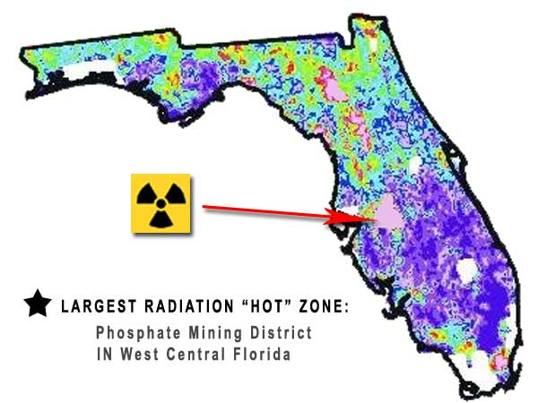

* Substantive Comment:
3PR questions the accuracy of information and adequacy of the environmental analyses in the FAEIS because serious omissions exists which serve to invalidate the FAEIS. One such omission is the absence of consideration for the negative environmental impacts of phosphate industry products. The wide-spread pollution resulting from phosphate chemical processing and the use and/or storage of phosphate fertilizers and processing wastes in agriculture, create serious impacts which are a direct end result of phosphate mining approvals and phosphate strip mining. The very reason for phosphate strip mining is to produce products for profit. Such products include primary goods plus any wastes that can be sold for profit or, used to offset costs. Industries such as the phosphate strip mining industry also find value in disposing of the wastes of other industries. Often wastes are marketed, or disposed of through other industries which incorporate them into their products, or mix them with their own waste streams.

* Substantive Comment:
3PR questions the accuracy of information and adequacy of the environmental analyses in the FAEIS because there is insufficient consideration of the negative impacts of phosphate mining wastes and phosphate products. The production of phosphate products is the sole reason for mining. Phosphogypsum is one such waste product. This byproduct of phosphate ore processing is apparently so radioactive that in 1992 the USEPA was compelled to ban it as an ingredient in Portland cement used in the construction of roads. Even so, it is still applied to farmlands. The problem with applying phosphate fertilizers and phosphate processing wastes to vegetable crops, farmlands and pastures, is that the radioactive isotopes in these substances are not very soluble and tend to build up in the land and environment, resulting in ever-increasing radioactivity with every application, and an increasing potential and risk to migrate off-site, extending the range of the contamination. This is a major concern which is understandably downplayed by the Applicants in the FAEIS; especially considering that the Applicants have clearly been dictating the contents and course of the FAEIS, and doing so privately without public interaction or oversight. Additionally, there are major discrepancies having to do with actual concentrations of radionuclides and radioactivity in certain phosphate-related substrates, ore processing wastes and related materials. The FAEIS offers no documented scientific data and analysis for its meager comments, which mainly constitute generalized information and biased conjecture.
The public is entitled to a very thorough literature review and comprehensive on-site analysis of the entire phosphate strip mining radiation and radioactive isotope phenomenon, for the entire CFPD, for all past, current and future mining and mining-related products. Before any mining is allowed to proceed, an extremely thorough risk analysis is essential. A considerable body of research exists which indicates that such elevated radioactivity/radiation presents very serious public health concerns. In fact, scientific research currently suggest that Lead-210 and Polonium-210 fallout from phosphate fertilizers may be a significant contributing cause of lung cancer among smokers. Scientists have determined that tobacco contaminated with Lead-210 and Polonium-210 fallout from phosphate fertilizers applied to the fields may be partly or mainly responsible for the hundreds-of-thousands of deaths of smokers, and not necessarily caused by the tobacco itself, that is, "smoked" tobacco.
Issues surrounding phosphate mining and product-related radiation, radioactive isotopes (radionuclides) are further discussed elsewhere in 3PR's comments. However, no such discussions are contained in the FAEIS. The FAEIS is therefore invalid because it in no way appropriately addresses the protection of public health against the impacts of phosphate strip mining, ore processing, and use of phosphate mining related products.
* Substantive Comment:
3PR questions the accuracy of information and adequacy of the environmental analyses in the FAEIS because the following excerpts from published research clearly demonstrate the existence of significant radiological risks, although they have not been considered in the FAEIS, or even cited in its references section. Numerous other relevant, published research is also available which does not appear in the FAEIS:

* WATSON 1983, by Oak Ridge National Lab:
"An important and relevant conclusion is that "For most food items and tobacco, aerosol deposition seems to be the principal mode of Lead-210 and Polonium-210 entry. This feature is of particular concern for leafy vegetables. As a result, only fruit-bearing crops such as citrus, berries, and cane fruits should be grown on phosphate-reclaimed land."

* Tidd 2008, by Journal of the Royal Society of Medicine:
"Smokers are killed by alpha-radiation, whatever its origin. Arguably, a significant part of this mortality is a result of Po-210 in tobacco."
"Po-210 is relatively long-lived fallout from the decay of radon in the atmosphere close to tobacco plants. This in turn comes from the decay of uranium-contaminated calcium phosphate fertilizer used on tobacco fields. Sub-microscopic particles of Po-210 in the air are trapped on sticky hairs on the leaves of tobacco plants. These hairs are very hydrophobic, and once trapped the radioactivity does not wash off in the rain".
"Uranium has a very long half-life and will accumulate in the soil with repeated applications of fertilizer. As a result, modern cigarettes may contain higher levels of Po-210 than those measured 40 years ago."

* Osmond et al 1984, by Dept. of Geology, Florida State University:
"A large proportion of the radioelements in phosphate ore ends up in the clay even before the adsorption process hypothesized above. We calculate that approximately 45% of the uranium and radium, and 55% of the thorium in the original matrix is in the clays that are removed by the washing process. In the gypsum residue resulting from further treatment stages are found 3% of the uranium, 30% of the radium, and 35% of the thorium of the original matrix. Less than 10% of the radium and thorium end up in fertilizer and chemical products, but as much as 30% of the uranium does".

* Lyman 1985, in the Journal of the American Medical Association (JAMA):
"Radiation exposure, including the ingestion of radium, has been causally associated with leukemia in man. Groundwater samples from 27 counties on or near Florida phosphate lands were found to exceed 5 pCi/L total radium in 12.4% of measurements. The incidence of leukemia was greater in those counties with high levels of radium contamination (>10% of the samples contaminated) than in those with low levels of contamination. Rank correlation coefficients of 0.56 and 0.45 were observed between the radium contamination level and the incidence of total leukemia and acute myeloid leukemia, respectively".
This paper, and several others, specifically report markedly increased incidences of cancer, and generally elevated cancer risks caused by human exposure to Radium-226 contaminated groundwater. Numerous other published research reports elevated low-level radiation associated with various sources within the CFPD, particularly on mined land and at waste clay disposal sites. The Lyman studies, all important land-mark research, were published in JAMA, the most prestigious, peer-reviewed medical journal in the world.

* Canadian Coalition for Nuclear Responsibility 2013:
"Lead-210 and Polonium-210 contamination in tobacco emanates from the phosphate fertilizers used to accelerate plant growth which emit Radon-222 gas that decays and creates "fallout" of these two radionuclides on tobacco crops."
"Radon gas is also given off by phosphate fertilizers (since phosphate ores are rich in uranium). When tobacco crops are so fertilized, radon gas accumulates under the thick canopy of tobacco leaves, and tiny dust particles impregnated with radon daughters adhere to the sticky, resinous hairs on the underside of each leaf. When harvested, the tobacco contains high concentrations of radioactive Lead-210 and Polonium-210. Cigarette smokers breathe these radon daughters into their lungs with every inhalation."
"Some of these radioactive particles lodge in the lungs of smokers, as confirmed by autopsies. Others enter the bloodstream along with oxygen and carbon monoxide. Radioactive deposits of this kind have been found in plaque removed from sclerotic arteries. Many researchers now believe these excessive concentrations of radon daughters are responsible for most of the 135,000 deaths each year in the U.S. from lung cancer, strokes and heart disease which the American Medical Association attributes to smoking."
So-called "reclaimed" phosphate strip mines, other waste disposal, other phosphate lands, and lands fertilized with radioactive phosphate fertilizers may never again grow completely safe crops. The half-life of Radium-226 (which is the source of Radon-222, and ultimately its lethal Lead and Polonium progeny) is 1600 years! Such radioactive land will continue to contaminate both local crops and far away crops for thousands of years. A myriad of other radioactive materials also present in these lands contributes even more to the problem. Some of these decay ultimately to Radium, continually replenishing the Radon-Lead-Polonium problem. Additionally, it has been shown that the Lead and Polonium fallout from phosphate fertilizers increases over times as additional fertilizer application are added to the land. It is believed that this is responsible for elevated incidences of some types of cancer over time.

* Stockwell et al 1988, in the American Journal of Epidemiology:
This research was a case-control study that included 25,398 cases of lung cancer among Florida residents. It was conducted to determine if residency in the central Florida phosphate mining region was associated with an increased risk of lung cancer. A twofold increase in lung cancer risk was observed among male nonsmokers who lived in the study area. Risks were elevated for all major lung cancer cell types.

* Edwards 2013, for the Canadian Coalition for Nuclear Responsibility:
"Radium-226, a bone-seeking alpha-emitting carcinogen which is at least 20 times as harmful as strontium-90, is blown in the wind, washed by the rain, and leached into the waterways from the tailings piles, where it re-concentrates by factors of thousands in aquatic plants and by factors of hundreds in land plants. It has a half-life of 1,600 years."

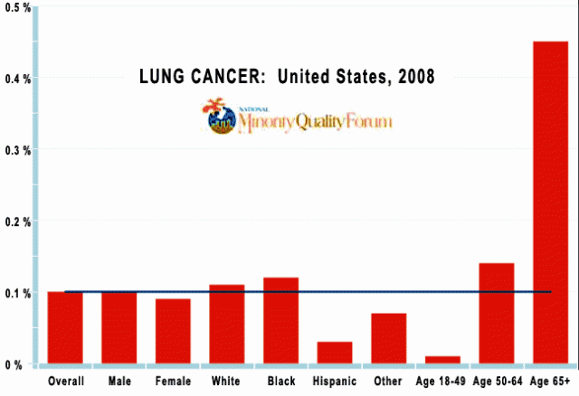

* O'Meara, T. et al 1986, for the Florida Institute for Phosphate Research:
"The average bone concentration in waterfowl from settling ponds in central Florida was about 4 times the recommended maximum for humans". This issue is reinforced by additional research which concluded that "As a result of mining and processing operations, most of the radioelements accumulate in the waste clays. Radium and thorium also are present in the gypsum stacks and uranium is present in the acid products and fertilizer". Runoff and leachate from phosphate processing sources into ditches, wetlands, and other areas which may be utilized by plants, animals and humans, may also be a concern as indicated by the conclusion that the EPA "does not allow the use of central Florida gypsum. Material from central Florida generally contains about twenty-five pCi/g". However, other government sources indicated radioactivity up to 25 times greater than this value.
Nowhere is the mining-induced phenomenon of increased low-level radiation treated with the proper concern by government agencies and the phosphate industry, especially so considering the potential for such radiation to negatively impact human health. The FAEIS does not include analysis of these documented concerns in regard to overall "Protection of the Environment", which is the stated purpose of NEPA.

The chart above indicates that the onset of lung cancer occurs mainly late in life. Residents being exposed when they are young, and during their working years, will not realize the disease until near or beyond retirement age.
* Substantive Comment:
3PR questions the accuracy of information and adequacy of the environmental analyses in the FAEIS because the USACE has not thoroughly investigated and analyzed radiological threats. The scant information provided in the FAEIS is uninformative, not based on the current state of scientific literature and, in so doing, potentially jeopardizes public over a vast region. NEPA requires that statements in the FAEIS be based on the best possible data and analysis, and that it be subjected to public scrutiny. NEPA also requires that information be solicited from the public. In addition, NEPA requires that the USACE "shall discuss at appropriate points in the final statement any responsible opposing view which was not adequately discussed in the draft statement and shall indicate the agency's response to the issues raised." The FAEIS is invalid because it avoids these and most all other NEPA requirements throughout its 2,794 pages.
Because the issue of increased radiation risks permeates many aspects of the FAEIS and four proposed mine projects, it is necessarily repeated in several sections of 3PR's comments.

PROTECTION OF CHILDREN FROM ENVIRONMENTAL HEALTH RISKS & SAFETY RISKS.
* Substantive Comment:
3PR questions the accuracy of information and adequacy of the environmental analyses in the FAEIS because the USACE has not thoroughly investigated and analyzed health and safety risks posed to children, and has not provided for their special protection as required by "Executive Order 13045: Protection Of Children From Environmental Health Risks And Safety Risks".
1-101. A growing body of scientific knowledge demonstrates that children may suffer disproportionately from environmental health risks and safety risks. These risks arise because: children's neurological, immunological, digestive, and other bodily systems are still developing; children eat more food, drink more fluids, and breathe more air in proportion to their body weight than adults; children's size and weight may diminish their protection from standard safety features; and children's behavior patterns may make them more susceptible to accidents because they are less able to protect themselves. Therefore, to the extent permitted by law and appropriate, and consistent with the agency's mission, each Federal agency:

(a) shall make it a high priority to identify and assess environmental health risks and safety risks that may disproportionately affect children; and (b) shall ensure that its policies, programs, activities, and standards address disproportionate risks to children that result from environmental health risks or safety risks.

2-203. "Environmental health risks and safety risks" mean risks to health or to safety that are attributable to products or substances that the child is likely to come in contact with or ingest (such as the air we breath, the food we eat, the water we drink or use for recreation, the soil we live on, and the products we use or are exposed to).

As detailed elsewhere herein, the phosphate strip mining and chemical processing industry introduces astronomical volumes of toxic, corrosive, mutagenic and suspected carcinogenic chemical wastes into the environment and its products. The industry is also responsible for increasing exposure to radiological threats in the form of increased radiation and increased exposure to radionuclides, both in the environment, in its products, and crops. Additional threats to children include spills and discharges of polluted effluents into rivers and streams, dust and air-borne contaminants, and gaseous or vaporous releases, and increased Lead-210 and Polonium-210 fallout from Radium-226, and Radium-226 uptake by vegetables, potentially increasing the risk of cancer and other disease or medical problems, and contaminating certain food which children consume, like leafy vegetables (Watson 1983; Bettencourt 1988).
Recent land-mark, peer-reviewed scientific/medical research indicates increased threats and risks to children from ionizing radiation.

"After adjustment for sex, attained age, and birth year, the MDS risk was significantly greater in those exposed when young." (Iwanaga et al 2011)

"However, there was emerging evidence from the present data that exposure as a child may increase risks of cancer of the body of the uterus. Elevated risks were seen for all of the five broadly classified histological groups considered, including squamous cell carcinoma, adenocarcinoma, other epithelial cancers, sarcomas and other non-epithelial cancers. Although the data were limited, there was a significant radiation-associated increase in the risk of cancer occurring in adolescence and young adulthood." (Preston 2007).

Also, the effect of chemical and pollutant exposure to the young have been well-documented and scientifically established for many decades.
Decisions today will dictate how environmental pollution and damage affect children (and the young) in their middle and later years. Phosphate mining, mining related activities and products created billions of tons of toxic and radioactive solid wastes, release millions of tons of chemical (reagent) wastes into the environment each year (Patel 2001), cause contamination (or chemical and/or radiological increases) in farmlands and food, contaminate water resources (drinking/swimming/bathing water/recreational/irrigation) via spills and various mechanisms, and introduce many other threats and risks which may have the potential to disproportionately affect children because their neurological, immunological, digestive, and other bodily systems, or behavioral attributes, are more susceptible.
The USACE has ignored the many threats and health risks to which children have been shown to be disproportionately more susceptible. The only mention of "Children" by the USACE in the 2,794 page FAEIS is as follows. It should be noted that the terms "schools" and "daycares" do not appear in Chapter 4.9, and are not used by the USACE anywhere in the FAEIS:
"Compliance with EO 13045 is documented in Chapter 4.9 of the Final AEIS, Land Use, which discusses the lack of special population land uses such as schools and daycares near the Applicants’ Preferred Alternatives."

Because of the complete lack of consideration for the protection of children, and absences of analysis of the specific problems previously identified, and established in the scientific literature, the FAEIS is inadequate and invalid.

WATER RESOURCES
* Substantive Comment:
Throughout the FAEIS scientific data developed by the federal government, SWFWMD, and published in scientific journals are cited. Immediately afterwards erroneous or arbitrary statements are then presented by the Applicants (or from the industry perspective), presumably in refutation or rebuttal. However, either the statements made by the Applicants are unreferenced, or cite an internal letter or document from the phosphate industry, such as The Phosphate Council. The representations are thus completely undocumented, and not subjected to public scrutiny as required by NEPA. The USACE should not entertain such conjecture and unqualified statements, or any information from those with obvious or suspected conflicts of interests. For example:
Page 3-63 states: "The case of Kissengen Springs is well documented. Kissengen Spring was a major spring which once contributed an average of 20 million gallons per day (mgd) of flow to the Peace River Basin in Polk County (Metz and Cimitile, 2010). USGS indicated that phosphate mining use of FAS wells for water supply was a contributing factor to the regional FAS drawdown that resulted in the cessation of flow from this spring (Metz and Lewelling, 2009)."
Page 3-65 states: "Garlanger (2002) estimated that groundwater pumping supporting phosphate mining contributed less than 10 percent of the drawdown that occurred at a particular affected spring (Kissengen Springs) and that other man-made withdrawals contributed to the rest of the effect."
The fact that Kissengen Springs was destroyed by the phosphate strip mining industry is extremely well documented. At that time in history very few people lived at Bartow, and there were very few agricultural water users because irrigated agriculture was rare. There were no "other man-made withdrawals" from the FAS. Irrefutable evidence of this disaster remains to this day in the form of a legacy of utter environmental destruction which was caused by phosphate strip mining along both banks of the Peace River from well above Bartow, through the defunct Kissengen Springs, south to Hardee County. USGS and SWFWMD publications indicate that the consumptive use of water from the FAS greatly lowered the potentiometric surface and contributed to the formation of collapse sink holes along the Peace River which drain away most of the river's flow, even to this day. Also, it was not only massive consumptive use which ruined Kissengen Springs, but the complete alteration of the surrounding surface water management system, SAS. It is also well documented that these impacts caused Kissengen Springs to fill in with clay. This is one of many prime examples illustrating how the phosphate strip mining industry has destroyed, or contributed to the destruction of resources which were tremendously valuable to the economy, environment and society at large. Today, Bartow is a very small town. It is the original county seat for Polk County, but because of phosphate strip mining early in its history, its growth was arrested and Lakeland became the county's major city instead. Mulberry, Ft. Meade, and now the City of Bowling Green have suffered an even a worse fate. Next in line will be the communities of Wauchula, Ona and Zolfo Springs.
* Recommendation:
The objectiveness, credibility and appropriateness of the comments and references which are included in an FAEIS should be more carefully considered. One of the main problems is that documentation/information is presented from government or scientific sources in one paragraph or on one page and then opposite statements are presented in/on the next which apparently emanate from industry-related sources. This is a recurring theme throughout the FAEIS. The USACE should only include data, information and analyses which it is willing to attest to as being the best possible scientific evidence, the most honest, objective and untainted available, and that which has been subjected to public scrutiny as required by NEPA! An Environmental Impact Statement is a very important instrument designed to guide the permitting of large projects ensuring "Protection of the Environment". The document should not be used as a platform for presenting debate, opposing views, or absurd arguments. Often, 3PR could not identify the position of the USACE in relation to important issues. Usually, only discussion, data, and results are presented, but without an affirmative conclusion and agency accepted determination. NEPA requires that the information in the FAEIS be clear and succinct, and based upon the most credible scientific foundations. The FAEIS does not meet any of these criteria, or any other NEPA requirements relating to "Protection of the Environment".

WATER QUALITY - NONPOINT POLLUTION
* Substantive Comment:
3PR questions the accuracy of the information and adequacy of the environmental analyses in the FAEIS because it does not recognize the significance of the degree and extent of pollution generated by the phosphate strip mining, including, but not limited to, nonpoint pollution involving elevated nutrients and contaminants from runoff and spills, and as a direct result of the phosphate industry from the use of chemical phosphate fertilizers for lawns, agriculture, golf courses, etc.
Nonpoint pollution is considered to "the major source of water pollution in the U.S. today". (Carpenter 1998). Eutrophication is currently the most widespread water quality problem in the country. Restoration of eutrophic water requires reduction in the contaminants. The most important barriers to the control of nonpoint nutrient pollution are social, political, and institutional.

IMPORTANCE OF UPPER SAS OMITTED: (HYDROLOGY OF NATIVE SOILS)
* Substantive Comment:
3PR questions the accuracy of the information and adequacy of the environmental analyses of the FAEIS because significant issues relating to the SAS were not evaluated. All aquifers are impacted by phosphate strip mining, but the SAS is usually completely removed. Phosphate strip mining utterly disrupts natural geology and hydrology, removes native soils including their ecologically essential, "unique" physical, chemical, and hydrologic properties, and replaces them with Arents-Hydraquents-Neilhurst substrates. Arents-Hydraquents-Neilhurst substrates is composed of unnatural waste tailings, left over overburden, or other unused substrates discarded as a result of phosphate strip mining and processing. Arents-Hydraquents-Neilhurst substrates exhibit entirely different and environmentally extreme properties as compared to native soils (USDA. 1990; 2012a; 2012b). Other 3PR comments also address this issue.
Arents are moderately well drained to excessively well drained, discarded overburden, left over from the strip mining process, that exhibit a consistently alkaline pH. Hydraquents, called "slickens", are up to 85% clay and exhibit a high (alkaline) pH, and Neilhurst, which is excessively drained and usually composed mostly of sand with other inclusions. These unnatural substrates are intrinsically physically and chemically variable, and can be randomly homogeneous or heterogeneous in formulation. All are incompatible with the native soils and hydrology and natural ecology of native ecosystems and vegetation associations.
In addition to creating landscapes dominated by substrates which cannot support natural upland ecosystems, the removal or alteration of the SAS also causes hydrologic changes, including aboveground and belowground alterations in flows and levels. Such alterations negatively impact all types of wetlands, including herbaceous marshes, bay heads and swamps, hardwood swamps, cypress swamps, seeps, etc. Man-made "reclaimed" wetlands seldom provide the same hydrologic functions as natural wetlands, exhibit altered hydroperiods, do not support equivalent species richness, often require continuous maintenance due to noxious or nuisance vegetation, are "out of context" with natural ecosystems, and are therefore of little ecological value. Such artificial systems may also present unusual environmental and physical risks to birds and other biota, including, but not limited to, Radium-226 contamination (as discussed elsewhere in 3PR's comments).

WETLANDS AND STREAMS NOT RESTORABLE
* Substantive Comment:
3PR questions the adequacy of the environmental analyses in the FAEIS because it does not consider the irreplaceable values of natural wetlands systems, or the essential role of native soils relative to ecosystem function and hydrology. Evaluations of the important dynamics of surface water, groundwater and soil interaction are completely omitted. And, the FAEIS does not appropriately recognize and consider: (1) the regional (CFPD) and statewide cumulative impacts of area-wide destruction of entire classes of native wetlands, such as isolated wetlands, and the concomitant loss of genetic diversity and long-term loss of habitat for dependent animals and other biota; (2) the fact that wetlands systems are complex and may have taken hundred or even thousands of years to develop, and that the phosphate industry does not have the technology (presuming it could exist), the resources, or the will to properly construct and manage, in perpetuity (or until stable and self-sustaining) hundreds of isolated wetlands, many miles of creeks, streams and tributaries; and, (3) that the processes required for wetlands to establish, stabilize, and begin to efficiently remove nutrients requires time — a long time in the case of forested wetlands, and this with constant maintenance.
The phosphate industry's track record of restoring the natural environment is dismal. In most phosphate strip mining operations the natural surficial aquifer system (SAS) is completely or mostly removed. The SAS is the unconsolidated zone or strata important in formation of seepage slopes and seep springs in Florida. It is generally of little or limited interest to most hydrologists due to small discharge or diffuse nature of seepage, but invaluable to the residents of rural areas such as Hardee, DeSoto, and western Manatee counties because SAS wells are the primary source of drinking water, household water, and often irrigation water for these regions. There are many unanswered public health questions, both chemically and radiological, having to do with consuming water from shallow wells located on or near land formerly strip mined. There are also unanswered questions regarding the economic impact of mitigating these concerns, especially in the low-income and minority communities which dominate these regions.
* Recommendation:
An independent scientific committee should be established to comprehensively and exhaustively evaluate the impacts which phosphate strip mining causes, and has caused, to native soils, natural aquifers, wetlands, native ecosystems, regional aesthetics, and public health. Nowhere in the FAEIS are these impacts or natural resources properly evaluated, cumulatively evaluated, or their values genuinely considered as required by NEPA. The FAEIS, throughout, is directly inconsistent with NEPA's legally authorized mission and "Basic National Charter" of "Protection of the Environment". The protection of ecosystems and ecosystem services is essential for the protection of all aspects of Florida's precious water resources, and for the protection public health, the economy and human society.

WELLS IMPACTED BY MINING
* Substantive Comment:
3PR questions the accuracy of the information and the adequacy of environmental analyses in the FAEIS because there is insufficient discussion of the impact of phosphate strip mining on wells which are on or near phosphate strip mines. A significant issue is that existing wells are not analyzed, discussed, or even identified in the FAEIS. Local residents near phosphate strip mining areas sometimes complain of "dry" wells. This is not surprising because phosphate strip mining not only removes entire aquifer systems, but completely alters surface water management systems, totally changing runoff, recharge, low-flow, evaporation and transpiration patterns. Mining operations remove or alter regional aquifers and is responsible for massive consumptive use of well-water over wide areas. Such alterations have profound effects on groundwater and aquifer levels which also affect surrounding lands.
* Recommendation:
The FAEIS should very comprehensively analyze all aspects of the existing and potential negative impacts that the water wells used in mining operations have on local and regional water resources. Data and analyses are needed for: (1) the effects of mining-related consumptive use; (2) the enhanced potential for aquifer contamination (particularly of the surficial and intermediate aquifers) via well transport and induced recharge from major geologic alterations; (3) the physical and hydrologic alteration of aquifers which impedes or alters their natural functions and negatively impacts dependent biotic systems; (4) the economic impacts associated with mitigating aquifer damage, and; (5) the contamination or other alteration of aquifers which contribute to public health concerns. Third-party, objective studies are needed. Currently, the FAEIS merely reflect the statements and desires of the Applicants, and does not offer any credible, research-supported discussion of these problems. The Chapter 7 "References" consist mostly of in-house documents and internal communications provided by the Applicant, which have not been made available to the public, and which have therefore not been subjected to public scrutiny as required by NEPA. Also, none of the references involve information that was actively "solicited" from the public as required by NEPA.

WATER DEMANDS VERSUS WETLAND HYDROLOGY AND ECOLOGY
* Substantive Comment:
3PR questions the validity of certain combinations of alternatives presented in the FAEIS because some combinations of alternatives appear to allow 50 to 80 or more miles of stream alteration (difficult to precisely determine). If allowed, this would be devastating to the regional environment and water resources, including serious impacts and effects on the "downstream" jurisdictions of Charlotte, Lee and Sarasota counties. The vast majority of Florida's population lives near the coasts. Coastal areas rely to a great extent on inland sources of water and inland ecosystem services. As sea levels rapidly rise for the next 50 years due to global warming (climate change), brackish invasion and saltwater intrusion will increase, and coastal populations will simultaneously be retreating inland and increasing in density. The spring of 2012 resulted in all-time record high temperatures far in excess of even the most dire global warming (climate change) predictions. Winters are getting much warmer, much quicker than expected, and evapotranspiration rates are increasing concomitantly, disproportionately so because less and less vegetation is dying back in the winter, and transpiration is therefore continuing as central Florida winters, on average, become warmer and warmer. It is essential to protect the natural ecosystems and water resources in order to support future increases in human occupation. Phosphate strip mining must not be allowed to mine and destroy these irreplaceable ecosystem services.
Mining requires the use of prodigious volumes of water. Mined lands greatly alter surface water management systems, and create many large open bodies of water which lose moisture much more quickly than native ecosystems and other pre-mine land covers. Open water typically exhibits the highest evaporation rate of all land covers (Table 3). These and other hydrologic impacts of phosphate strip mining are hugely damaging to the future of west-central Florida and southwest Florida. These concerns are not appropriately considered in the FAEIS.
The FAEIS does not provide analysis of dry-season and wet-season meteorological/hydrologic cycles and influences. These are all-important factors in modeling and predicting hydrologic systems. The FAEIS makes no mention of the importance of consequences of La Niña - El Niño cycles and the projected effects and impacts of global warming (climate change) on weather patterns, severity of storms including increased potential for floods and high winds, increased evapotranspiration rates, particularly in the winter, and other predicted impacts. The narrative relating to global warming (climate change) in the FAEIS are insufficient considering the paramount importance of the issue in all future planning.
The Peace River Manasota Regional Water Supply Authority (PRMRWSA) possesses a high level of regional scientific expertise in managing water resources. They are also the single most important agency providing water to several large populations in southwest central Florida. Although the PRMRWSA was referenced in several sections of the FAEIS, it does not appear as though adequate involvement has not been solicited from this agency. NEPA requires appropriate information be solicited from the public. Certainly the PRMRWSA possesses relevant information, data, and analyses which should have been more thoroughly considered in formulating the FAEIS where potential impacts to the water resources of south-central Florida (Charlotte, DeSoto, Lee and Sarasota counties) are concerned.

WATER USE, "DOWNSTREAM" USERS, AND CHARLOTTE HARBOR
* Substantive Comment:
3PR questions the adequacy of the environmental analyses in the FAEIS because nowhere are the total water uses and water availability impacts of phosphate strip mining analyzed in order to assure that the need for new public water sources will not be created. Photos 4, 5, and 6 represent strong evidence that phosphate strip mining completely alters runoff, recharge, storage, evapotranspiration, low flow, and ultimately climate. Of monumental concern is that the Applicants are proposing to use massive-scale engineering to control the flows of rivers, creeks, and tributaries. These stupendous systems will completely alter the ability of watersheds to deliver water to communities, urban areas, business, and industry downstream in Charlotte, Lee and Sarasota counties. The regional environment will be totally altered. Whereas, before mining, these systems were self-sustaining and auto-regulating, they were much more predictable and not subject to human error, miscalculation or abandonment. Who will maintain these complex, tremendously extensive artificial systems? Most affected by these region-wide hydrologic, geologic, and ecological modifications, will be the "downstream" counties of Charlotte, Lee and Sarasota counties. The water supplies of these downstream users will become "artificially" controlled by upstream interests. The limitless liability of this misguided regional destruction of water resources will fall on the human communities of the region, mostly on Charlotte, Lee and Sarasota counties because of the "deep pocket" principal.
Not only are there great environmental costs associated with disrupting the water resources of an entire region, but ongoing tremendous economic costs as well. These virtually unlimited financial burdens will fall on the taxpayers. They will also inherit the countless unforeseen or miscalculated disasters and other problems, which have routinely occurred in association with phosphate strip mines, their waste dumps and so-called reclaimed land. Intrinsically, based on the existing approved mine permits, the current four proposals, and future proposals, which will no doubt involve more extensive mining further south, east and west, these problems will be inherited by the same "downstream" jurisdictions. Any problems or interruptions in water supply or decreases in water quality will inherently affect these counties disproportionately because they support the greatest human populations, they have the greatest need for resources in order to grow, and because they are on the "receiving" end of the phosphate mining disaster. That is, Charlotte, Lee and Sarasota counties have the greatest need for water now, and will have an ever-increasing need for stable water supplies in the future. Further, man-made systems of the magnitude constructed by the phosphate industry present inestimable numbers of large-scale risks, including spills and discharges, unpredictable interruptions of water flows, or excessive increases in flows. And within the near future, massive coastal populations will have to move inland due to SLR. This coupled with normal population growth will create a tremendous need for land and water resources inlands. However, phosphate lands will be far too disrupted and contaminated (CSAs, chemical reagents, radiation, etc) to provide human space.
Artificial systems are much more subject to failure from natural and man-made disasters. Global warming (climate change) promises increasing numbers of ever more severe storms, including "super" storms. Long-term mining permits eliminate the flexibility to continuously modify plans to accommodate every-changing weather patterns and other rapidly shifting environment factors.
3PR questions the adequacy of the environmental analyses in the FAEIS because many of the aforementioned significant issues and risks have not been properly assessed, and therefore have the potential to negatively affect water quantity and quality for a very large region of west-central Florida, as well as adjacent "downstream" counties, thereby endangering reliable sustainability of human society and the environment. Conspicuously absent from the FAEIS are data and analyses which demonstrate that the phosphate industry possesses the resources, ability, planning, and will, to respond to the many natural, man-made and accidental disasters, and engineering miscalculations which will occur as a result of artificially reengineering the physical and ecological environment of an entire region. Also obvious is that the FAEIS distinctly avoids addressing "worst case" scenarios. In fact, the FAEIS promotes these scenarios by presumptuously assuming in inevitability of permit approval throughout. The Alafia River spill, Peace River at Homeland spill, Archie Creek spill, White Springs spill, Piney Point, and many many other incidents, documented and undocumented, are evidence of the phosphates industry's inability to limit or control the environmental disasters that emanate from its properties. 3PR also takes exception to statements in the FAEIS which suggest that the phosphate industry has not recently had major spills. The Homeland spill, which FDEP fought hard not to acknowledge or report, is well documented, even with video of the actual event and extensive damage it imparted to the upper Peace River and Peace River floodplain. This incident, which is no doubt one of many to occur and not be officially recorded, is described elsewhere in 3PR's comments.
* Recommendation:
Comprehensive analyses are needed in order to quantify the total water resource impacts of the proposed phosphate strip mines, including a full historical review of water use and water resource impacts previously caused by mining in the CFPD and beyond. Because surface water, aquifers and ground water, and water quality are directly related, these entities should not be analyzed independently, and as such cannot effectively be discussed separately. Area-wide studies are needed which include cumulative analyses of all historical water-related impacts. This is necessary in order to provide an adequate understanding of the full environmental consequences of phosphate strip mining on water resources, both within the CFPD, and to external regions including "downstream" coastal counties. Elements of the studies should include "independent" evaluations of water quality, quantity, and the distribution of water availability for human use and for the environment, including, but not limited to, analysis of: consumptive use, increased evapotranspiration (ET), effects of the removal of native soils and ecosystems, effects of re-contouring and alteration of surface water management systems, spills and discharges, FAS impacts, IAS impacts, SAS impacts, wetland hydroperiod, flows and levels of rivers and streams, dams and impoundments including CSAs and the creation of new open water or inundated areas. These studies must include factoring for all aspects of global warming (climate change) impacts, including atmospheric, hydrologic, ecologic and human cultural/social/economic. None of these issues are treated adequately in the FAEIS. The FAEIS does not provide adequate analyses to make important decisions regarding the water impacts imparted by tens-of-thousands of acres of new phosphate strip mining. The main problem with the FAEIS, is that it is mainly the product of the Applicant, and therefore strongly biased. 3PR will not consider the FAEIS valid until it has been developed in an open forum, broadly soliciting and ACCEPTING publicly provided information, and until it has undergone adequate public scrutiny during the process, which so far it has not.
The foreground in Photo 5 below represents a very small fraction (about 1/4000th) of what has already been destroyed by phosphate strip mining operations in west-central Florida. It portrays a very bleak future indeed for the southern half of the CFPD. Such desolation completely undermines the future needs of human society.

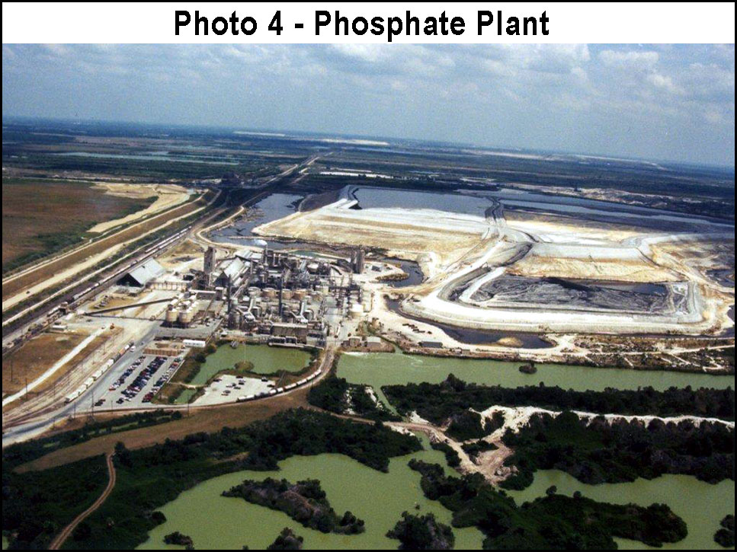

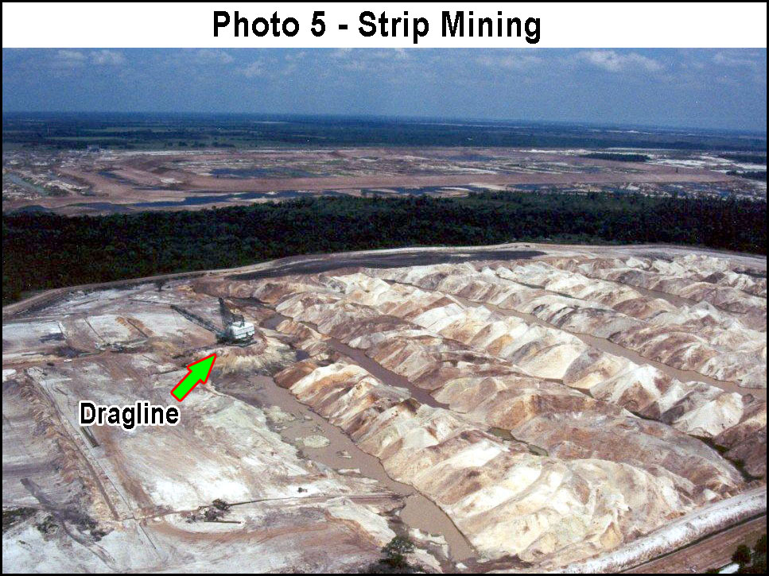

MINING'S HISTORY OF SPILLS, DISCHARGES, AND POLLUTION
* Substantive Comment:
3PR questions the adequacy of the environmental analyses in the FAEIS because it does not consider the phosphate industries history of accidental discharges and their inability to control them once they occur, as was the case with virtually every known major spill, and an inestimable number of "unknown" spills which have not been recorded due to the lack of adequate monitoring/auditing of the vast expanses of mined land and ancillary or secondary industry, or simply because reporting them was resisted by one party or another; often FDEP. See Photos 1 and 2.
Leaking, seeping, gurgling discharges of effluents from mined lands are common, and are an ongoing problem with the massively altered landscapes created by the phosphate strip mining industry and its ancillary (or secondary, tertiary) chemical processing industries and product manufactures. As commented earlier, large spills have occurred that have continuing for extended periods before being detected. Even so, they could not be controlled and were relegated to run their course. The Hardee County Mining Department's video of the latter stages of one such spill at Homeland exemplifies the unstoppability of even moderately large or significant phosphate land spills, and the futility of humans attempting to mitigate their impacts. The primary problem of spills emanates from the degree to which landscapes have been altered, the disposal of large volumes of waste clays and other discarded materials (sand, overburden, etc), and the problem of monitoring and auditing such vast, often difficult to access, expanses of property. It has to do with the fact that it extremely difficult to predict the behavior of altered landscapes, waste dumps (CSA's and reclaimed lands), and artificial surface water management systems, especially in the "real" environment (as opposed to "paper" engineering) where weather patterns and other influences are not predictable. See Photos 4, 5, and 6.
At phosphate mines and mined land, the term "spill" is typically used in the context of pollutants or unwanted substances leaving mines or mined land. Spills which occur internally may not be considered spills at all, and usually go on without remark, unnoticed, and unreported, even though new land is being contaminated or compromised in some way.
* Recommendation:
(1) A comprehensive investigation and evaluation of the phosphate industry's history and record in relation to accidental discharges of effluents and other potential pollutants into surface waters, wetlands, and aquifers is critically needed. Studies are needed which investigate the history of both "off-site" and "on-site" spills. The AIES should: (2) Evaluate the history and ability of government enforcing agencies to satisfactorily monitor, detect, and respond to spills and other discharges. Currently there extremely little oversight, as is evidenced by the fact that private or external parties often report spills. (3) Conduct research to evaluate the long-term liabilities associated with phosphogypsum disposal and radioactive "gyp stack" closure in relation to impacts to water quality and the economy, including who will ultimate pay for their maintenance and perpetual environmental impacts. (4) Conduct a survey of current and past phosphate strip mines to locate ongoing discharges into internal ecological areas, and to offsite properties, including ditches, drains, canals, and conveyances on road right-of-ways which drain into wetlands, rivers, streams, or other offsite areas. Review Photos 1 through 6, to understand a small fraction of the intractable problems which can in no way be expressed in words!
Photo 6 below depicts a waste clay disposal site (CSA) (or other massive containment). A great many already of these gargantuan structures occupy and greatly impair the west-central Florida landscape. Many phosphate strip mining impacts present permanent liabilities to the environment and economy, and create effectively immovable barriers to the future planning needs of an expanding human society; a society which has diverse and every-changing needs for space, potable water, green space, safe recreation, and a clean and healthy natural environment.

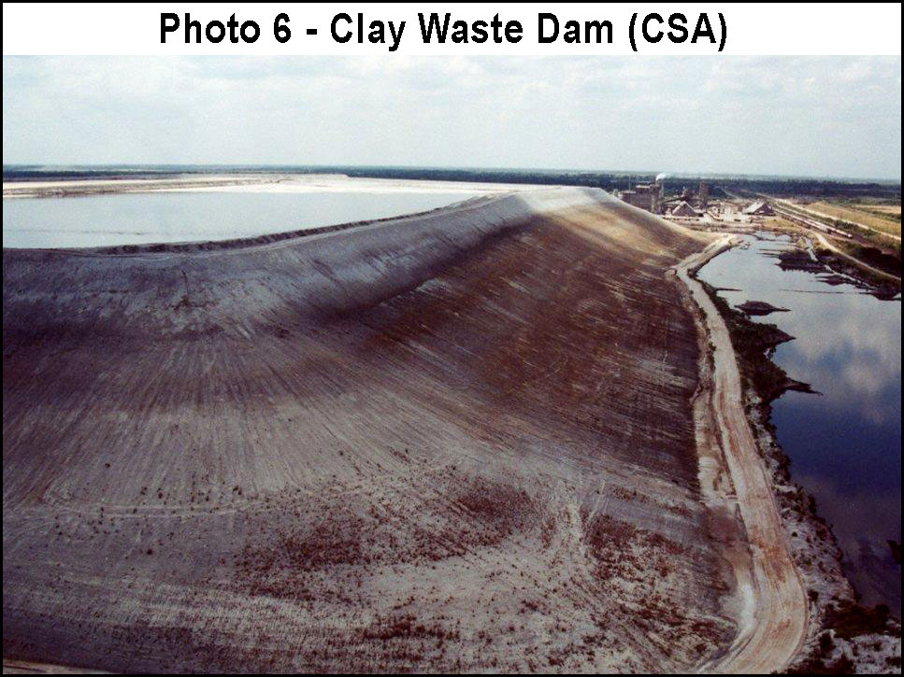

HEAVY METAL CONTAMINATION
* Substantive Comment:
3PR questions the adequacy of the environmental analyses and the accuracy of information because nowhere in the FAEIS is the important concern of extensive heavy metal contamination appropriately addressed. Throughout the FAEIS, there is virtually no concern for "Protection of the Environment" or public health. Heavy metal contamination from phosphate strip mining, processing, and product distribution and use, are well-documented impacts of the industry.
"Phosphate deposits contain significant amounts of naturally occurring heavy metals. Mining leaves tremendous volumes of wastes containing elevated levels of cadmium, lead, nickel, copper, chromium, vanadium, mercury, nickel, thorium and uranium. Unless carefully managed, these waste products can leach heavy metals into groundwater or nearby estuaries. Uptake of these substances by plants and marine life can lead to concentration of toxic heavy metals and radionuclides in food products" (Mortved & Beaton 1995; Gnandi et al 2006; Brigden et al 2002; Wikipedia 2013a)[see references near end of 3PR comments]. Cadmium, in particular is very toxic, and a heavy metal of serious concern to public health (Godt 2006).

PROCESSING REAGENTS ("CHEMICALS") IN THE ENVIRONMENT
* Substantive Comment:
3PR questions the adequacy of the environmental analyses and the accuracy of information because the highly significant issue concerning the use of "reagents" in phosphate processing is not adequately examined. The non-mechanical steps in phosphate ore extraction and product production consume incredibly vast quantities of low-grade chemicals, mainly thick petroleum residues, kerosene, amines and fatty acids, but also other toxic and/or corrosive substances. Thus vast quantities of chemical reagents used by the industry in ore processing and product production end up in the environment, mainly in so-called "reclaimed land", and to some degree in phosphate-related products. These chemicals are known to contaminate soils, water resources, and water supplies, affect the functions of the physical environment, and damage ecosystems and biota on a vast scale.
As an example, "The Florida phosphate industry consumes about 150 million tons a year of fuel oil in the forms of No.5 oil or kerosene" (Zhang 2008). That's 150,000,000 tons, not pounds! The magnitude and impacts to the environment associated with such fantastic amounts of such toxic chemicals is inconceivable! Several FIPR papers focus on the need to reduce consumption of reagents in order to reduce concentrate production costs. However, the issue is not how to increase profits for the phosphate industry. The use of such reagents appears to be increasing. "Fuel Oil" is only one of many chemicals, used on a massive scale by the industry, which find their way into the environment.
No.5 oil is primarily a "residue" from petroleum distillation/refinement, and a very serious environmental contaminant. It is essentially a waste or low-value product of the oil industry, and because it has not been refined it contains numerous additional chemical contaminants. "Number 5 fuel oil" is defined as a residual-type industrial heating oil requiring preheating to 170 – 220 °F (77 – 104 °C) for proper atomization at the burners. This fuel is sometimes known as "Bunker B". It may be obtained from the heavy gas oil cut, or it may be a blend of residual oil with enough Number 2 Oil to adjust viscosity until it can be pumped without preheating.
Petroleum products and derivatives are toxic to ecosystems and humans, and cause serious contamination of water resources. They do not appreciably biodegrade. Of additional concern for Number 5 Fuel Oil is its poor quality. Low-grade petroleum such as Number 5 Fuel Oil typically contains many different organic compounds, and usually some inorganic compounds and elements as well. These additional potential "contaminants" may increase the spectrum of environmental toxicity and amplify other damaging effects. A small petroleum spill at an automobile gas station may cost a staggering sum to clean up and remediate even though less than 1/4 acre of land is usually involved. In many cases, such spills can not be cleaned up entirely, and much of the soil remains contaminated, gradually increasing the extent of contamination in surrounding soils and groundwater (well water). Such contamination often migrates long distances into surrounding properties and into important drinking water aquifers. It seems, however, that the phosphate industry is not accepting responsibility for their contaminants (reagents) which may introduce similar pollution across vast areas of west central Florida, that is, within the CFPD, and beyond into adjacent properties, rivers, streams, and ecosystems, and particularly down stream into Charlotte Harbor, Charlotte, Lee and Sarasota counties. There is no reasonable or responsible discussion in the FAEIS of the millions of tons of chemicals being released into the environmental by phosphate mining and processing activities each year. For example, there is no discussion in the FAEIS of the approximate 150-million tons a year of fuel oil released into the environment each year by the phosphate industry. The concern of "Fuel oil" and other reagent chemical use is only mentioned in a single comment by one private citizen (Percy Angelo). The USACE responded to this comment with the following inaccurate and irresponsible statement:
The volume of floatation agents used in the beneficiation
process is small when compared to the volume of mine
recirculation water, within which the reagents would be
transported primarily with the sand tailings.

As discussed elsewhere in 3PR's comments, fuel oil is a high level contaminate of soils, water resources and the environment. It is well established that one gallon of oil can contaminate approximately 1,000,000 gallons of water. Fuel oil contains benzene, a known carcinogen. The Hess Corporation's Materials Safety Data Sheet (MSDS) for No. 5 Fuel Oil states that the substance is a: "Danger: Combustible liquid, Causes skin irritation, Causes eye irritation, May cause an allergic skin reaction, May cause cancer, May cause respiratory irritation, May cause drowsiness and dizziness, is Harmful to aquatic life, and many other cautions, including the "Ecotoxicity" warning to "Keep out of sewers, drainage areas and waterways. Report spills and releases, as applicable, under Federal and State regulations". Also, "Trace amounts of nickel, vanadium, and other metals in slurry oil can become concentrated in the oxide form in combustion ash deposits. Vanadium is a toxic metal affecting a number of organ systems. Nickel is a suspect human carcinogen (lung, nasal, and sinus), an eye, nose, and throat irritant, and can cause allergic skin reaction in some individuals" (Hess 2013a). The Hess Corporation's Materials Safety Data Sheet (MSDS) for Kerosene cautions 'Danger" and that the substance is a: "Flammable liquid and vapor, Causes skin irritation, Causes eye irritation, Suspected of causing cancer, May cause respiratory irritation, May cause drowsiness or dizziness, May be fatal if swallowed and enters airways, and many other cautions, including Ecotoxicity-Aquatic Toxicity: Keep out of sewers, drainage areas and waterways. Report spills and releases". Minute quantities are damaging or fatal to aquatic life (Hess 2013b). Additionally, the previously cited USACE/FAEIS statement absurdly implies that the volume of mine recirculation water would have to be (150,000,000 tons * 2000 lbs per ton) / 7.7 lbs per gal) * 1,000,000 gal per), or 3,961,038,961,038,961 gallons. This would be the volume of water necessary to dilute 150,000,000 tons of oil below its approximate contamination level of 1 gal per 1,000,000 gal of water. Obviously the phosphate industry is not using this outlandish amount of recirculation water, therefore the concentration of these reagent contaminants must be very high indeed ... somewhere?
The cleanup liability and damage to the ecosystems and environment of west central Florida done by such phenomenal releases of fuel oil and other chemicals are both inestimable and incomprehensible. Furthermore FIPR research indicates that the contaminants make their way into phosphate products as well (also refer to other 3PR comments involving fuel oil and chemical reagents).
The 1989 Exxon Valdez spill was estimated to have released 32,000,000 gallons of oil into Prince William Sound in Alaska (Wikipedia 2013b). Based on volumes reported by FIPR, the amount of fuel oil entering the environment EACH YEAR from phosphate processing is (38,961,038,961 gal / 32,000,000 gal), or 1,217 times as much as the Exxon Valdez spill, EACH YEAR! Fuel Oil and Kerosene are only two of many toxic and potentially toxic phosphate chemical reagents and wastes entering the environment on a massive scale as a result of phosphate processing, so-called reclamation, and product use.
It is clear that the profits, jobs and products created by the phosphate strip mining industry provide insignificant benefits as compared to the incomprehensible destruction of the environment caused by ecosystem removal, over 1-billion tons of radioactive phosphogypsum dumping, over 50,000 acres of dammed waste clay dumps, and hundreds-of-millions of tons of toxic chemical reagents disposed of, or which escape, into the environment. An even more counterproductive aspect of the industry is that the products themselves are serious contaminants, responsible for vast regions of ground and surface water contamination, the pollution of bays and estuaries, lakes, rivers and streams, and substantially responsible for the death of the Florida Everglades, Florida Bay, and water and regions world-wide. Phosphate fertilizes are now also suspect in the decline of the Great Barrier Reef of Australia.
Children in particular are vulnerable to pollution. Exposure to toxins at a young age is a great concern. All such risks must therefore be precluded. No new phosphate strip mines should be permitted, and steps should be taken to substantially reduce the risks associated with industrial toxins discharged into the environment. Children must be protected from such risks.
* Substantive Command and Recommendation:
The FAEIS should fully address the issue of the consequences of massive discharges of polluting chemical reagents into the environment and water resources of the region. Such discharges, or dumping, create inestimable damage to ecological resources and will burden future generations with vast areas of pollution which can never be cleaned up, remediated or mitigated. Important questions are: Specifically, what substances are actually being used? What is their specific chemical makeup or analysis? Where are they mainly concentrated? When, and in what actual amounts, are they used? Where do they end up in the environment? Where do they come from? Is it true that some of these reagents are classified as "Trade Secrets"? If so, is it because their actual analysis would be frightful to the public? Does the use of these reagents merely represent the disposal of the toxic wastes of other industries? These questions have not been forthrightly answered, especially not in terms of environmental damage and threats to public health. Overall, the full range and degree pollution and other negative impacts emanating from the large-scale use of reagents have not been satisfactorily admitted. It is not rational to consider that 150-million tons of fuel oil placed into the environment is "harmless" (Patel 2001). The public deserves a complete analysis and forthright explanation before any new phosphate strip mining is approved. This deficiency renders the FAEIS invalid.
Number 5 fuel oil is a residual-type industrial heating oil requiring preheating to 170 – 220 °F (77 – 104 °C) for proper atomization at the burners. This fuel is sometimes known as Bunker B. It may be obtained from the heavy gas oil cut, or it may be a blend of residual oil with enough number 2 oil to adjust viscosity until it can be pumped without preheating (http://en.wikipedia.org/wiki/Fuel_oil). MSDS Toxicology Information: Affects central nervous syste. Skin cancer hazard. This material contains polynuclear aromatic hydrocarbons (PNAs), some of which are animal carcinogens. Studies have shown that similar products produce skin cancer or skin tumors in laboratory animals following repeated applications without washing or removal.

Kerosene, a thin, clear liquid formed from hydrocarbons, with a density of 0.78–0.81 g/cm3, is obtained from the fractional distillation of petroleum between 150 °C and 275 °C, resulting in a mixture of carbon chains that typically contain between six and 16 carbon atoms per molecule. Major constituents of Kerosene include n-dodecane, alkyl benzenes, and naphthalene and its derivatives (http://en.wikipedia.org/wiki/Kerosene). MSDS Toxicology Information: Inhalation of vapors or mist may result in respiratory tract irritation and central nervous system effects including headache, dizziness, loss of balance and coordination, unconsciousness, coma, respiratory failure and death.

Comprehensive "independent" studies are immediately needed in order to determine the direct and cumulative impacts of releasing vast quantities of chemical "reagents" into the environment, and potentially into products as indicated in Patel (2001). Thousands of samples must be collected throughout the phosphate mining district, at waste disposal sites (reclaimed land, CSAs and phosphogypsum stacks), at processing plant properties, and at adjacent properties.
In order to provide the proper assurances which NEPA guarantees, including "Protection of the Environment", and to ensure that federal EIS actions are not "unsatisfactory from the standpoint of public health or welfare or environmental quality", the important issue of reagent use must be comprehensively investigated, scientifically scrutinized by neutral 3rd parties and the public, and reported upon prior to any consideration of new permits for phosphate strip mines.

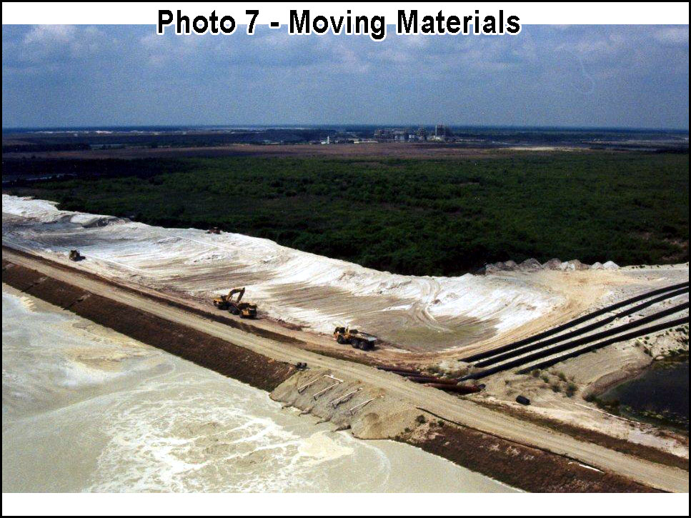

ECONOMIC LIABILITY FOR CLEANUP, MAINTENANCE AND MANAGEMENT COSTS
* Substantive Comment:
3PR questions the adequacy of the environmental analyses in the FAEIS and the accuracy of information therein because it does not address the question of who will bear the staggering cost of pollution cleanup and waste dump maintenance and management after mining has been completed. It is estimated that over 1-billion tons of phosphogypsum has already been stockpiled. That's about 15 tons for each of the nearly 20-million residents of Florida, or nearly 1 ton for every person in China!

DISASTER LIABILITY: HOW CAN THE PUBLIC EVER PAY?
* Substantive Comment:
3PR questions the adequacy of the environmental analyses and the accuracy of information because it does not address how society can possibly pay, or bare the inestimable liability for the many disasters which the phosphate industry has inflicted on humanity. Currently, the phosphate industry is responsible for about 1-billion tons of radioactive phosphogypsum covering many square miles, elevated, dammed toxic clay waste dump currently about 60,000 acres (not including approximately 20,000 acres of new waste clay dumps proposed), and hundreds-of-thousands of acres of otherwise compromised lands which may contain millions of tons of chemical reagents. It is also responsible for countless spills and environmental disasters, most of which are beyond the technical and financial ability for the industry or the taxpayer to clean up or remediate.
The incredible 15-story sink hole in the photo below, which opened under a phosphogypsum stack, is merely one of the many mega-environ-disasters of the phosphate industry. Entire river systems have been destroyed by spill, such as the Alafia River in 1997. Clay waste dams have failed, and countless other spills and releases have occurred.

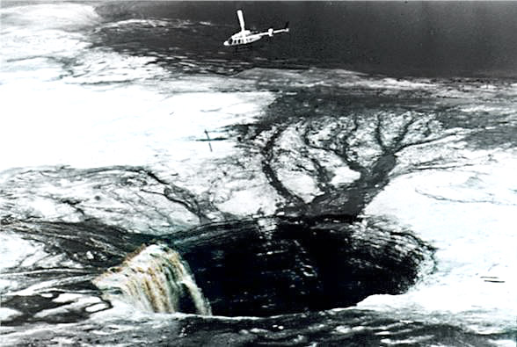

The phosphate industry is a temporary industry. A purely exploitive industry that is "here-then-gone". As the industry mines their way through counties and communities, and ultimately shuts down as ore and profits run out, the inestimable economic and environmental liabilities relating to their disasters and waste dumps (including reclaimed land) will ultimately fall on the people. That is, the taxpayers will inherit the burden of trying to maintain, manage and contain a monumental landscape composed mainly of waste disposal. The FAEIS is inadequate because it does not recognize these liabilities, and place responsibility on the party responsible: The phosphate strip mining and processing industry. The FAEIS is there inadequate and invalid.

PLANT AND ANIMAL RELOCATION AND MITIGATION IN GENERAL
* Substantive Comment:
3PR questions the merits and the validity of relocating plants and animals as a conservation or mitigation strategy and disagrees that mitigation or relocating is a reasonable alternative for native ecosystem protection, or that it provides any significant conservation benefits whatsoever. This is a significant issue. Vast amounts of Florida's native ecosystem have been destroyed in exchange for various forms of mitigation which often fail, or more often, provide no appreciable mitigation at all.
The term "reclamation" merely implies the "taking back of land". The term does not include "ecological restoration", individual "habitat restoration", or even "vegetative community restoration". Herein rests the problem with the concept of "mitigation", which is merely a "lessening of impacts" as interpreted from a particular faction's need or point of view. 3PR cites many important scientific facts as to why replicating or even simulating native vegetative communities or ecosystems is impractical, usually doomed to a rapid failure, and even with the best results provides little if any value. 3PR also cites instances and arguments as to why such attempts may be detrimental to wildlife and ecosystems. All debate aside, the essence of the problem is that mined land is mostly unsuitable to support native ecosystems and biota, especially where upland vegetative communities and ecosystems are involved. Even where some minor facades of native vegetation are created (usually as intensive demonstration project by the industry), and manage to persist for some period of time, it is at great economic expense and usually requires on-going maintenance. In both the short-term and long-term biodiversity (including species richness and evenness as compared to intact references systems) in "reclaimed" lands is lacking, even after long periods of time upland restoration sites are incapable of supporting many plant and animal species because the native soils have been destroyed, that is, replaced with mining wastes, usually in the form of Arents-Hydraquents-Neilhurst. The vast majority of so-called reclaimed lands and abandoned mines are little more than depauperate, weed-infested ecological deserts. Genetic diversity is intrinsically lacking, and ecosystem interaction and context have been removed through large-scale ecosystem destruction and the creation of vast ecological gaps and fragmentations of the remaining areas of habitat (what little there may be of it). Essentially, the best result of "reclamation", "restoration" and on-site or off-site "mitigation" may be considered "managed ecosystems" or pseudo-ecosystems. Scientists agree that maintaining ecosystem services are essential to human existence and that such services depend on protecting and encouraging self-sustaining biodiversity in order to safeguard society (Naeem 1990).
"Unprecedented changes are taking place in the ecosystems of the world, including species losses through local extinctions, species additions through biological invasions, and wholesale changes in ecosystems that follow transformation of wildlands into managed ecosystems. These changes have a number of important effects on ecosystem processes. Recent evidence demonstrates that both the magnitude and stability of ecosystem functioning are likely to be significantly altered by declines in local diversity, especially when diversity reaches the low levels typical of managed ecosystems. Although a number of uncertainties remain, the importance of ecosystem services to human welfare requires that we adopt the prudent strategy of preserving biodiversity in order to safeguard ecosystem processes vital to society." (Naeem 1999)

Essentially, "reclamation", much of which involves and is considered to be "mitigation", in the best case scenario, results in systems which would require high levels of maintenance to buttress their facsimile appearance or facade. As for larger areas of reclamation, which the phosphate industry can not afford to keep on "life support", noxious infestation of cogongrass, non-native species, and other undesirable biota quickly become serious, environmentally and economically untenable problems.
It is well documented that most listed plant species (because they are also usually "endemic" plant species) have very precise environmental requirements, and are therefore found only as integrated components of specialized native vegetative communities, or in restricted plant associations within certain geographically confined ecosystems (Orzell & Bridges 2006) (Cole et al 1994) (Huck 1987). The habitats of listed / rare / endemic species are often supported by highly specific soils, and located in regions of unique geomorphology / physiography. The reason most plant species are listed as "endangered" or "threatened" is therefore because of their very high degree of environmental specificity and narrow geographic ranges, that is, because of their endemism.
3PR questions the adequacy of the environmental analyses regarding listed (endemic) plant species, as well as the merits of the relocation alternative, or mitigation alternative because no studies are presented in the FAEIS indicating which, if any, relocated listed plant species have been successfully established as viable, self-sustaining (an all-important criterion) populations, which continue without human intervention and maintenance into the long term. In fact, 3PR’s opinion is that none of the rare, listed and/or endemic plant species found within the CFPD or the four proposed phosphate mine parcels, can successfully be successfully relocated and reestablished. As previously explained, such plants are entirely dependent on, and specifically adapted to particular native soils and ecological communities, as well as have numerous other environmental requirements which can not be artificially replicated.
Much has been published regarding the failures of rare plant relocation ventures (CDFW 1991), especially failures involving mitigation projects. Many relocation projects involving listed or endemic plant species, which yield living plants for some period of time, later fail for a variety of reasons, both known and unknown, even with considerable artificial cultivation and "life support" efforts. Such failures are due to complex ecological factors which can not be replicated in the reintroduction attempts (Menges 2008). No published research supporting the viability or success of listed plant relocation is cited in the FAEIS. There are hundreds of thousands of individual rare and listed plant species in the CFPD and at the four proposed mine sites. The concept of native plant relocation is flawed because, as previously stated, such rare native plants are very critically integrated with their native environments. That's why the term "critical habitat" is used in relation to their ecological needs. In order to protect rare and listed plants, significant intact tracts of native ecosystem containing their particular critical habitat must be preserved and protected. The FAEIS is a failure and is invalid because it in no way complies or conforms to the NEPA purpose and requirement of "Protection of the Environment".
The image below shows the utter devastation which phosphate strip mining inflicts on the environment, including the annihilation of ecosystems, water resources, traditional agriculture, genetic diversity, community character and public health. It is completely impossible to restore such "moonscapes" to any self-sustaining use, whether environmental, economic or aesthetic. To know the result of mining and so-called reclamation, one only needs to look where mining has been: There nothing of value prevails, only liabilities.
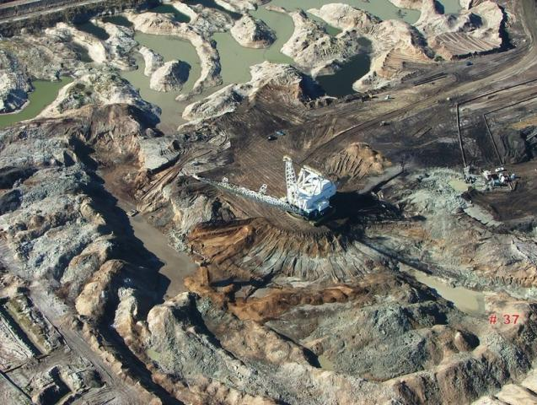

ENDANGERED PLANT SPECIES
* Substantive Comment:
3PR further questions the accuracy of information in the FAEIS because the table of listed plants which purportedly are found in the CFPD is in gross error due to omissions. NEPA directs that the EIS process coordinate and be consistent with state and local agencies and that it solicit expert input. The Florida Department of Agriculture (FDA) acknowledges additional endangered species not listed by the U.S. Fish and Wildlife Service. The State Comprehensive Plan of Florida mandates the protection of endangered species, ecosystems, and requires that mining and mineral extraction protect natural resources (also see previous 3PR comments under "Coordination And Consistency With Local Agencies Lacking" and "Plant And Animal Relocation And Mitigation In General").

RELOCATION OF PLANTS AND ANIMALS
* Substantive Comment:
3PR questions the adequacy of the environmental analyses, the accuracy of information, and the quality of the reasoning and rational of the FAEIS because the statements relating to relocation and avoidance of plants and animals are irrational.
The FAEIS states that "During land clearing, mobile wildlife species would relocate to undisturbed areas; land clearing is proposed to be conducted in a directional manner to allow mobile species to more easily relocate to adjacent habitats. Wildlife species that are displaced by land clearing are expected to re-occupy mined areas after they are reclaimed. Based on the findings of past studies, wildlife use of reclaimed areas is expected to be comparable to wildlife use of unmined areas. Some slow-moving wildlife species may not be able to relocate to undisturbed areas and, therefore, may be injured or killed during land clearing. The potential for incidental animal mortality occurring during land clearing exists but is considered to be relatively low and any losses would have a negligible effect on regional wildlife populations. Certain slow-moving non-listed animal species that are encountered during pre-clearing surveys are proposed to be relocated before land disturbance (along with listed plant species and slow-moving listed animal species) to suitable onsite avoidance or reclamation areas or to suitable sites outside the mine property." This proposal is absurd. It is completely ludicrous for such a statement to appear in a USACE Environmental Impact Statement. The NEPA purpose is "Protection of the Environment", not the wholesale destruction of it. The four mine permit applications involve over 50,000 acres. Animal mortality will be extensive as species are forced away from mining areas across highways, into the occupied territories of other animals, into areas incapable of supporting them, and into residential and urban areas where conflicts with people and pets will occur. Very few animals will survive for any length of time, and because their home habitats will have been annihilated by phosphate strip mining, ecological and population collapse will proceed on a massive scale. Considerable research has been published which demonstrates the fate of animals forced from their habitats. There are a few wide-ranging predators which can move such as fox and coyotes. However, these animals immediately create problems for people and farm animals, and because they are highly mobile suffer an extremely high mortality rate on the highways. It is also well documented that global warming (climate change) is forcing animals to move more rapidly than expected (Welsh 2011). Because of the extremely long permit durations proposed, and a complete lack of consideration in the FAEIS for global warming (climate change) impacts, planning for additional disaster has not been addressed. Florida is one of the most densely populated states in the US, and animal road kills have already reached appalling levels. Road kills of animals in the US are now up to 1-million per day (Braunstein 2012). Further, this statement by the Applicants, in addition to being ridiculous, is completely ambiguous, lacks specificity and scientific support, and is therefore of no value in furthering the understanding of the projects at hand. For example, what "slow moving non-listed animals"? What the Applicants are suggesting would be physically impossible if only 1/1000 of the land were involved. Relocation on these properties, if it were feasible, would involve hundreds-of-thousands of animals. Because it is not feasible, these animals will simply die or live long enough to create problems for ecosystems, agriculture areas and human communities off-site. Even if this fantasy were possible, there is not sufficient off-habitat to support these numbers. Secondly, any "suitable onsite avoidance or reclamation areas" will already be occupied. If it were possible to move even a fraction of species, over population and ecological conflicts would occur. As for plants, 3PR has already explained that such relocations are invariably failures. The rare and endangered plants at these sites have strict soil and ecosystem requirements.
Development of the four strip mines will create irrevocable ecological destruction and collapse on an immeasurable scale. Entire localized genomes will also be lost, which will negatively seriously weaken any remnant animal populations that survive, and which will negatively impact the ecological health and animals patters in surrounding regions.
Some animals inhabit a wide range of habitats and can sometimes utilize non-native, or partially native sites, but plants and animals are products of their environments, that is, products of, and specific to, their particular ecological communities or vegetation associations. It is well documented that most relocation attempts, for most animals, fail in the long-term, if not in the short-term. Functional populations do not normally establish or endure for long periods. It is essential for ecosystems to be preserved in order to protect species, including listed plant and animal species. (This is discussed further in other of 3PR's comments).
* Recommendation:
Based on the current state of scientific literature, there is no evidence that stable populations of any of the listed plant species occurring within the CFPD can be successfully established, in the long term, on reclaimed lands. The FAEIS has offered no data and analyses which would support the feasibility of such experiments. Many species cannot be relocated successfully even into their own habitats, or into sites identical to the donor sites (Menges 2008).
It is important that the long-term status of these token introduction attempts be analyzed as part of any relocation or reintroduction programs, and that a cumulative impact analysis be conducted to quantify the amount/numbers and diversity of important Florida native plant and animal species which have been, and will be eliminated as a result of past, present and proposed future phosphate strip mining, on unmined, but potentially mineable area within the CFPD. Paramount in these studies is the need to evaluate genetic erosion, that is, gene pool destruction of locally adapted taxa including localized ecotypes. Also see previous 3PR comments under "Plant And Animal Relocation And Mitigation In General"

INACCURATE WILDLIFE SURVEYS
* Substantive Comment:
3PR questions the accuracy of the information and the adequacy of the environmental analyses in the FAEIS because of obvious errors and omissions in describing wildlife, and because in-depth site-specific ecosystem and wildlife analyses should have been conducted by "independent", unbiased third parties.
In 2003, the Hardee County Mining Department staff and several professional biologists conducted field surveys to verify wildlife surveys provided by the Applicant for the Ona Mine. The Applicant's data was found to be exceedingly inaccurate in each case, and for each site surveyed/verified. In areas where the Applicant had not reported listed wildlife, hundreds of gopher tortoises, a number of gopher frogs, and several listed or rare plant species were found. Additionally, a primary recipient site used by one phosphate strip mining company for the relocation of gopher tortoises was thoroughly surveyed by county staff, and no tortoises were found. The site consisted of hard, "marly" reclaimed land infested with cogongrass and non-native weedy species. It was found to be completely unsuitable as habitat for tortoise (although apparently authorized as a recipient site by the state). It appears that applicants for mining permits often misrepresent or mischaracterize ecosystem resources and biota, grossly understating the actual species richness, abundance, and habitat quality.

* Recommendation:
The example illustrates the strong need for independent environmental data and analysis for ecosystem evaluations, species surveys and wildlife studies. Important environmental data and analyses must be objective and verifiable, and developed by qualified third party scientists, not by the employees or contractors of permit applicants. It is difficult to determine if such wildlife studies are simply grossly incompetent, or whether the findings are ignored or understated for other reasons. In either case, the studies are inconsistent with several requirements of NEPA, including its purpose of "Protection of the Environment", and the neither the public nor USACE should have any confidence in data or analysis provided by permit applicants.

"COGONGRASS" INFESTATIONS ON MINED LANDS
* Substantive Comment:
3PR questions the accuracy of information and adequacy of the environmental analyses in the FAEIS because the paramount concern of cogongrass infestations on so-called reclaimed land is not adequately addressed. "The National Invasive Species Council (NISC) was established by EO 13112 to ensure that federal programs and activities to prevent and control invasive species are coordinated, effective, and efficient."
The rapid and dense colonization of "reclaimed" mine land by the federally listed noxious weed known as "cogongrass" (Imperata cylindrica) (USDA 2010) represents an exceedingly serious and highly significant environmental and economic issue. Extensive and often contiguous infestations of this highly invasive, environmentally destructive and difficult to control weed dominate the herbaceous layers of many existing "reclaimed" and abandoned mine lands. The species succeeds vigorously in disturbed substrates such as those generated by the phosphate strip mining industry as a result of mining, "reclamation" activities, ancillary operations and activities, and site maintenance. This invasive plant thrives in disturbed areas, especially in nutrient laden substrates, and substrates which do not normally support native ecosystems, such as the marly wastes and excavated materials used to construct so-called "reclaimed land", and which are ubiquitous in the post-mine scenario.
"One of the more recent invaders to plague central Florida is the Asian weed, cogongrass. Cogongrass is not a serious problem on intensively managed agricultural lands where the normal operations include repeated tillage and herbicide applications. However, it has become a serious problem on less intensively managed lands such as rangelands, pastures, roadsides, reclaimed phosphate mines ..." (Bewick 1997).

Cogongrass alters fire ecology because it grows very densely and burns hot (B. Nelson / SWFWMD, Land Management, pers. comm.). These attributes have the effect of preventing or excluding native herbaceous species due to shading, crowding, and radical modification of essential fire regimes. The species is virtually impossible to effectively eradicate on a large scale due to physical land constraints and high economic costs, and because the species simply recolonizes immediately, often with even greater vigor and aggressiveness than before. Mines and so-called reclaimed land represent primary sources of cogongrass seed generation for west central Florida. "Cogongrass spikelets are wind dispersed and have the potential to travel great distances" (Bewick 1997), infecting external properties and causing great economic liability. The species is very difficult to eradicate on a small scale, and virtually impossible to eradicate or even manage on a large scale. Even the most careful radication attempts often irreparably damage the fragile, specialized soils needed to support natural ecosystems such as dry prairie (flatwoods), live oak hammocks, xeric uplands, seeps and transitional habitats.
Because the plants and animals of the native ecosystems in the CFPD require undisturbed native soils, and ecological interaction with hundreds of other plants and animals, the massive cogongrass infestations on mine lands have been devastating. Not only does it dominate many thousands of acres disturbed by mining, but the wide-scale bombardment of seeds causes infestation in natural ecosystems as well, eventually excluding native plants and wildlife, and precluding their return and reestablishment.
Considerable research has been conducted in several states, and several countries, relating to the negative impacts of cogongrass. Inestimable resources have been expended studying this highly serious problem on mined and "reclaimed" phosphate lands. It appears the only way to significantly limit cogongrass on mine lands, and on the surrounding lands it infects, is to limit or stop phosphate strip mining.
Although the cogongrass problem is an immensely significant environmental concern relating directly to phosphate strip mining, mine reclamation, and other mining activities, it is not considered as such in the FAEIS. This noxious species is commonly dominant, or sub-dominant biological upland features associated with phosphate mines, mainly on reclaimed land, waste disposal sites such as CSAs, berms, dams, road shoulders, utility corridors, and other modified or disturbed areas. The FAEIS is therefore inadequate and inaccurate in that it does not appropriately evaluate and consider the devastating effect of cogongrass on the environment, and the continuing problem it presents to natural systems.
The problem of extensive, nearly ubiquitous infestations of cogongrass which occur on "reclaimed" phosphate mined lands should be solved before additional phosphate mine permits are issued. The plant is an extremely serious invasive noxious weed. It is economically unfeasible to eradicate the plant on a large scale, and management attempts can damage native vegetative communities.

FAEIS REFERENCES INAPPROPRIATE
* Substantive Comment:
3PR questions the accuracy of information and adequacy of the environmental analyses in the FAEIS because the references upon which the FAEIS is presumably based are not annotated and much of the decision-making information is reportedly based on improper sources which were not made available to the public. The FAEIS references personal communications, in-house documents and unpublished items which have not been made available for public scrutiny as required by NEPA. It is not therefore possible for the public to know how these items were perceived to be relevant, or how their contents might have been interpreted and/or applied in formulating the various sections of the document. Research and documentation offered by environmental organizations and 3rd party concerns were universally excluded from the FAEIS, in favor of phosphate industry reports and position statements. (Also see 3PR's comments under Related Documents Large And/Or Inaccessible). NEPA requires that "procedures must insure that environmental information is available to public officials and citizens before decisions are made and before actions are taken". Because in many this was not done, the FAEIS is invalid. Further, the Applicant has openly stated that the development of the FAEIS was "not an open process".
Many of the referenced sources in the FAEIS originate from government agencies, the phosphate industry, the Phosphate Council, phosphate consultants, or phosphate industry proponents. These include permit applications, industrial-engineering-hydrology-mining studies, survey results, various data, website access links, and undocumented personal communications. Many of these so-called "references" are merely in-house reports, papers, phone calls or memoranda of the Applicants.
Absent from the FAEIS is objective, 3rd-party scientific research, data and documentation. Of the hundreds, or thousands of relevant research publications relating to ecosystem protection, ecosystem services, agriculture soil conservation, genetic diversity loss, biodiversity loss, endemism and West Central Florida Flatwoods Ecoregion science, none are cited or referenced in the FAEIS. This issue, including the fact that the USACE rejected research from non-phosphate-industry interests, is discussed elsewhere in 3PR's comments.
3PR's comments, objections, and recommendations are based on the scientific knowledge and observations of regional experts, published scientific literature developed by regional environmental experts, and data and analyses developed by (and freely available from) public sources. 3PR has provided scientific legal facts, data and analysis which unequivocally demonstrate that the FAEIS is insufficient and inadequate for its legally required purpose of "Protection of the Environment". The Chapter 7 "References" section of the FAEIS is very revealing as to the history of the documents development. Although over 50,000 acres of land are planned for destruction and/or disruption, and tens-of-thousands of acres of wasteland and wastes dumping will result, there has been no consideration for the NEPA purpose "Protection of the Environment". "Protection" means "A person or thing that prevents someone or something from suffering harm or injury." The provisions of the FAEIS provide no directives which would prevent suffering, harm or injury to the environment.
40 CFR. 1502.9 Draft, final, and supplemental statements.

Except for proposals for legislation as provided in Sec. 1506.8 environmental impact statements shall be prepared in two stages and may be supplemented.

(a) environmental impact statements shall be prepared in accordance with the scope decided upon in the scoping process. The lead agency shall work with the cooperating agencies and shall obtain comments as required in Part 1503 of this chapter. The statement must fulfill and satisfy to the fullest extent possible the requirements established for final statements in section 102(2)(C) of the Act. If a statement is so inadequate as to preclude meaningful analysis, the agency shall prepare and circulate a revised of the appropriate portion. The agency shall make every effort to disclose and discuss at appropriate points in the statement all major points of view on the environmental impacts of the alternatives including the proposed action.

Based on the current levels of data, analyses, and other information which, although not included or considered in the FAEIS, were readily and easily obtainable, should have been included as standard professional practice. Resources should have been obtained independently by soliciting them (as required by NEPA) from regional experts and consulting the commonly available scientific literature, libraries, biological research institutions, and public agencies conducting research. It is clearly evident that for the remaining (unmined) portions of the CFPD, that the scientifically, economically, and morally supported alternative, essential for the protection of the human society, human health and well-being, and the irreplaceable biological, ecological, and hydrologic resources of west-central Florida, is Alternative-1 ("No Action" / "no permit"), that is "no additional phosphate mining" alternative. It is apparent to any scientists who have expert knowledge concerning the biological, ecological, and hydrologic (water resources) of the CFPD, that obtaining and analyzing more environmental information, which is actually specific to the unmined regions of the CFPD, will result in strong, irrefutable evidence supporting Alternative-1 ("No Action", or "no additional phosphate mining") alternative. NEPA requires that The agency shall make every effort to disclose and discuss at appropriate points in the statement all major points of view on the environmental impacts of the alternatives including the proposed action.
Numerous on-site, independent environmental studies need to be conducted throughout the CFPD, and well beyond, including "downstream", that is, along rivers and streams to Charlotte Harbor, Charlotte, Lee and Sarasota counties, and the gulf coastal zones where the ecological disaster, economic damage, and pollution and frequent toxic spills from the phosphate industry will ultimately find their way.
It is unconscionable to entertain the concept of destroying an entire region of subtropical Florida, involving over 50,000 acres, supporting billions of animals, plants, and other living organisms which comprise the natural environment, purely for the benefit of a single industry. In addition to ecological benefits, these lands provide additional benefits to humans including food from agriculture, water, living space, recreational space and climate moderation.
Natural biotic systems constitute the essential biological and physical base which support and sustain human existence. Their destruction places at risk public health, properties and property values, and important resources extending far outside and downstream of the actual confines of the CFPD. Many of the liabilities created by phosphate strip mining, mine reclamation, and other forms of waste disposal, extend perpetually into the future. Phosphate strip mining sacrifices the Earth and the environmental heritage of mankind for short term profits. The counties sustaining the environmental destruction and other impacts do not substantially share in the profits. If no mining were to occur, these large tracts of land would provide space, agriculture, and water for millions of people. Such disregard for the environment and humanity as is inflicted by the phosphate industry is in stark contrast to the stated purpose of NEPA, which is "Protection of the Environment". If the industry had not held land for such long periods of time, Hardee County would already have developed much larger communities and more prosperous industries.
Phosphate mining is a non-sustainable, non-renewable activity, and its extractions and waste disposal have been utterly disastrous to a region of approximately 322,000 acres, and possibly much more. This added to the approximate 114,000 acres currently permitted mines, brings the total loss to about 436,000 acres.
Attempts at reestablishing native ecosystems on mined land are well-documented failures in most every regard. With such a horrendous environmental record, issuing new approvals for additional phosphate strip mining in west-central Florida is in no way acceptable. Even so, the NEPA requirement is "Protection of the Environment". The only FAEIS alternative for the four phosphate strip mines which furthers this requirement is "No Action" or "No Mining".

PROBLEMS WITH FAEIS REFERENCES
* Substantive Comment:
3PR questions the adequacy of the environmental analyses and the accuracy of the information in the FAEIS because many references are not cited according to accepted standards or are entirely erroneous. The majority of reference (bibliographic) citations do not provide adequate source information. Also, see previous comments concerning referenced information and documents, many of which are merely anonymous in-house memoranda or personal communications, to which the public did not, and does not have access. A significant example relates to the following "reference" which appears to reference a document.
Chapter 7 "References":
SWFWMD (Southwest Florida Water Management District). 2009a. Florida Land Use Cover Classification System (FLUCCS).

However, no such document exists. The most recent version of the universally used Florida Land Use Cover Classification System was published by FDOT in 1990. The FAEIS should have referenced this information as the 1999 Land Use GIS data layer developed by SWFWMD contractors. It is digital data, not a document. Also, no download date or metadata is provided. 3PR should be entitled to all digital and other information which was used as basis for the FAEIS so that it may verify the representations made by the Applicants. NEPA requires that public scrutiny be assured. The FAEIS is invalid because nowhere in the process has information been actively and honestly solicited from the non-industry public, and nowhere in the process has public scrutiny of the information purportedly used to assemble the FAEIS been encouraged, allowed, or even possible (because of the many anonymous and/private documents and information sources).
3PR has very significant concerns relating to the methodologies and results of the 2009 SWFWMD GIS mapping of District land uses purportedly using FDOT FLUCCS (1990) as found in 3PR's references below: 3PR finds that this mapping is in error in very significant ways, in that non-mining cover type designations have been used for areas of mining and areas of reclamation. FDOT FLUCCS 1990 requires that once an area has been mined, it remains a "160 Extractive" mining category, the best and highest category of which is "165 Reclaimed Land". 3PR has unanswered questions concerning the application of so-called FLUCCS categories in the mapping of existing land uses and cover types, and the ways in which the "system" was purportedly applied in mapping post-mining cover. However, because the development of the FAEIS has been mostly a private process of the Applicants, which has not been open to public scrutiny as required by NEPA, 3PR has had no opportunity to make comments or suggestions, or to ask questions. This literally, because 3PR's 92 pages of DAEIS comments, which were timely submitted, were thereafter lost or misplaced by the USACE, or by the Applicants (see the "OBJECTION NOTICE" at the beginning of this document).

3PR COMMENTS ARE SUPPORTED BY SCIENTIFIC LITERATURE
* Substantive Comment:
The FAEIS is not adequate or accurate because it does not broadly consider readily available, independent, regionally qualified, third-party research. Adequate independent scientific analysis which has been submitted to public scrutiny, as required by NEPA, is crucial in order to protect the vast repositories of natural resources proposed for destruction by phosphate strip mining. NEPA requires that "information must be of high quality", that "Accurate scientific analysis, expert agency comments, and public scrutiny are essential to implementing NEPA", and that "procedures must insure that environmental information is available to public officials and citizens before decisions are made and before actions are taken".
The FAEIS is further inadequate, incomplete, and generally deficient because the following important, relevant, or regionally applicable data, research, and analyses were omitted and therefore not considered in the decision-making processes during the development the document. In addition, it appears that a significant percentage of the resources cited in the FAEIS were obtained from the phosphate industry, phosphate industry contractors, or established phosphate mining proponents with vested interest in phosphate mining. In addition to the many other problems relating to the FAEIS source materials, which 3PR cited previously, the references cited infer that the base of information used for the FAEIS is not sufficiently impartial, neutral, or qualified.
3PR presents the following comments which are based on the cited publications. Each of these annotated references forms a separate substantive comment that may interrelate with other issues, or information and concepts in other 3PR comments and narratives:

Aoun, M., Samrani, A. G. El, Lartiges, B. S., Kazpard, V., & Saad, Z. 2010. Releases of phosphate fertilizer industry in the surrounding environment: Investigation on heavy metals and polonium-210 in soil. Journal of Environmental Sciences, 22(9), 1387 - 1397.

* Summary:
"This work gives detailed information about heavy elements and 210Po distribution and enrichment around a phosphate fertilizer industry. The survey of the contaminants released by the industry was evidenced on the near environment and supported by studying the mechanisms of transportation and accumulation. Greatly elevated contaminations by Pb, Zn, Mn, Ni, Cr, Cu, and 210Po were recorded inside the fine particle size fraction (< 50m). Studied contaminants decreased with the distance increasing from the industry. The survey revealed three main sources of contamination: (1) storage and vehicles transport of raw materials, (2) phosphogypsum waste free releases, and (3) dust deposits from smelters. Transfer of contaminants was governed by two major mechanisms: a physical transfer by winds and leaching, and a chemical transfer by dissolving the contents of phosphate ores and phosphogypsum in the fine fraction. Mapping the contaminants shows the source of emission and the accumulation sector of each contaminant. In fact, the phosphate industry is the main source of enhancement of naturally occurring radionuclides in the surrounding environment. This survey demonstrated that the region is certainly contaminated and protective measures that assure the public and workers security must be taken. Following this survey, transport and storage of row materials and releases of phosphogypsum waste must be done with respect to the norms applied on environment protection".

* Substantive Comment:
The FAEIS is not adequate or accurate because it does not include, responsibly consider, or reference this important and directly relevant scientific research, and because it does not thoroughly consider dangerous pollutants such as heavy metals and radionuclides which contaminate phosphate lands and products, and which escape into surrounding lands, wetlands, rivers, ecosystems, agricultural lands and human communities. Such contamination is a well known impact of phosphate strip mining, ore processing and product manufacturing, waste disposal and product use.

Bacchus, S. T. 2006. Nonmechanical dewatering of the regional Floridan aquifer system. Geological Society of America, (404) 219 - 234.

* Summary:
Important phosphate mine site-specific research regarding impacts to aquifers, water resources and wetland hydroperiods.

* Substantive comment:
3PR questions the accuracy of information and the adequacy of the environmental analyses in the FAEIS because it does not include, responsibly consider, or reference this important and directly relevant scientific research. This research shows that structural mining of aquifer formations reduces aquifer levels, dewaters the aquifer systems, and alters the normal hydroperiods necessary for sustaining regional ecosystems.
This peer-reviewed, site-relevant research was ignored by the USACE even though it was directly supplied. Such has been the case with virtually all quality, objective, scientific, relevant research supplied to the USACE. Because the USACE has failed to include or acknowledge this and other important studies which are essential to the NEPA purpose of “Protection of the Environment”, the FAEIS is invalid.

Bettencourt, ónioO., Teixeira, M. M. G. R., Elias, M. D. T., & Faisca, M. C. 1988. Soil to plant transfer of Radium-226. Journal of Environmental Radioactivity, 6(1), 49 - 60.

* Summary:
Research relating to Radium-226 uptakes by vegetables. Uptake of the radionuclide depends on various factors, including concentration in substrate and crop type. Increases in radioactivity (Radium-226 concentration) in soils results in increased uptake and crop contamination.
A study of the uptake of ²²⁶Ra by vegetables was carried out in zones contaminated by wastes from an abandoned radium salts factory and from uranium mines and in uncontaminated regions of purely natural radioactivity. Radium-226 uptake depends on its concentration in the soil, the logarithm of its concentration in the vegetables being a linear function of the logarithm of the concentration in the soil. Concentration factors for ²²⁶Ra uptake by cabbage leaves range from 0·007 to 0·11; for herbage, they range from 0·09 to 0·5.

* Substantive Comment:
The FAEIS is not adequate or accurate because it does not include, responsibly consider, or reference this important and directly relevant scientific research. It does not consider the risks to the environment and human society of elevated radioactivity associated within phosphate mining, reclamation, processing, and product and product use. In addition to increases in direct exposure to radiation, Lead-210 and Polonium-210 fallout, radionuclide contamination from Radium-226 uptake also increase risks. No future phosphate strip mining or product processing should be permitted. New mining will only increase the extent and level of overall risks associated with the radiation/radioactivity problem.

Bewick, T. A., Gaffney, J. F., McDonald, S. K., Chase, C. A., & Johnson, E. R. R. L. 1997. Ecology, Physiology, and Management of Cogongrass (Imperata cylindrica). presented at the May-1987, Gainesville, Florida: University of Florida. Florida Institute for Phosphate Research, No. 03-107-140.

* Summary:
An in depth examination of the biology of cogongrass, its properties as a noxious weed, and various concepts and strategies of its management.

* Substantive Comment:
The FAEIS is not adequate or accurate because it does not include, responsibly consider, or reference this important and directly relevant scientific research. (See other related 3PR comments).

Braunstein, Mark M. 2012. U.S. Roads Kill A Million A Day, Driving Animals To Their Graves. Culture Change. http://www.culturechange.org/issue8/roadkill.htm.

* Summary:
Article on road kill with numerous examples and statistics.

* Substantive Comment:
The FAEIS is not adequate or accurate because it does not include, responsibly consider, or reference this important and directly relevant scientific research. It does not consider the negative impacts to public safety and native wildlife that driving animals from the land will cause. The large-scale land clearing proposed by the Applicants will result in a large number of animal fatalities on roads and highways, that is "road kills," and probably human accidents and fatalities as well, as several people are killed in Florida each year because of animals in the road. An estimated 1-million animals are killed each day on US roads. Florida is one of the most densely populated states.

Brenner, D. J. 2003. Cancer risks attributable to low doses of ionizing radiation: Assessing what we really know. Proceedings of the National Academy of Sciences, 100(24), 13761 - 13766.

* Summary:
This research reports that:
"a very small risk, if applied to a large number of individuals, can result in a significant public health problem. At present, we cannot be sure of the appropriate dose–response relation to use for risk estimation at very low doses. Mechanistic arguments exist for suggesting that a linear extrapolation of risks to very low doses is appropriate, but testing such arguments at very low doses is not easy. However, the alternate models shown in Fig. 3, although applicable for some endpoints, are less credible than the linear model as a generic descriptor of radiation carcinogenesis at low doses and low dose rates.
The reader is reminded that this article addresses the risks of low doses of x- and Ý-rays. For densely ionizing radiations, as from radon progeny, mechanistic and epidemiological evidence appear to lead to similar conclusions regarding the credibility of the linear model for the estimation of low-dose risk."

* Substantive Comment:
3PR questions the adequacy of the environmental analyses and accuracy of the information in the FAEIS because it does not include, responsibly consider, or reference this important and directly relevant scientific research. The USACE incorrectly implies a lack of risk where increased radiation involving the phosphate strip mining and chemical industry are concerned. Published research consistently reports that increased radiation results in increased cancer, disease and other risks. This is reinforced by other research supplied herein by 3PR, and by many other scientific and medical publications; all of which are absent from the FAEIS.

Brewer, J. S. 2008. Declines in plant species richness and endemic plant species in longleaf pine savannas invaded by Imperata cylindrica. Biol Invasions 10:1257-1264.

* Summary:
Examines the invasiveness of cogongrass (Imperata cylindrica) into native longleaf pine flatwoods and its impacts on species composition. The research determined that the species excluded many herbaceous species, mainly by shading them out, or through aggressive colonization and expansion. Cogongrass patch expansion results in dramatic declines in species richness. Invasion of longleaf pine communities will likely cause significant losses of short habitat-specialists and reduce the distinctiveness of the native flora.

* Substantive Comment:
3PR questions the adequacy of the environmental analyses and accuracy of the information in the FAEIS because it does not include, responsibly consider, or reference this important and directly relevant scientific research. The FAEIS fails to adequately address impacts from the noxious weed cogongrass, and the economic and environmental consequences of such unbridled comprehensive infestations as occur on previously mined lands, including "reclaimed" lands. Mined and reclaimed phosphate lands arguably host the greatest aerial extent of cogongrass infestations in west central Florida. This is a serious and, for all practical purposes, an insolvable problem caused by large-scale mining disturbances and conversions of native soils to clays, silica, overburden, and other discarded mining wastes, that is, "reclamation" materials. This and other research indicates that cogongrass infestations are highly damaging to native ecosystems and effectively preclude or prevent the success of many types of restoration and reclamation. Also, the vast infestations of cogongrass in the phosphate district act as a seed source for the entire region and, as a result of storms, no doubt infest many distant properties. Cogongrass has proven very difficult and expensive to control, and even much more difficult to eradicate.

* Recommendation:
Additional phosphate strip mining should not be permitted to proceed until the cogongrass disaster and its many serious environmental and economic concerns are resolved.
Brigden, K., Stringer, R., & Santillo, D. 2002. Heavy metal and radionuclide contamination of fertilizer products and phosphogypsum waste produced by The Lebanese Chemical Company, Lebanon, Greenpeace Research Laboratories, Dep. of Biol. Sciences, Uni. of Exeter, Exeter EX4 4PS, UK.

* Summary:
The analyses of phosphate fertilizer products and phosphogypsum has shown that these materials are contaminated with a range of toxic and potentially toxic heavy metals, as well as gamma-emitting radionuclides.
Both the production of these fertilizers and their use on agricultural land can result in impacts to the environment and human health. Ongoing additions of these fertilizers to agricultural land will result in cumulative impacts to the land. These impacts can potentially result in elevated levels of many of these contaminants in crops grown on that land.
The use of end-of-pipe solutions to deal with wastes derived from phosphate fertilizer production, such as the use of phosphogypsum waste as a raw material in cement manufacture, fail to address the issues of concern, and simply shift pollutants from one location to another. The use of cement from such raw materials may result in human health impacts.
The impacts resulting from the production and use of fertilizers derived from contaminated phosphate ores can only be addressed through the conversion to agricultural practices that do not involve the use of these materials, such as organic agricultural practices including the use of natural composts.
"Both the SSP fertilizer and the phosphogypsum sediment also contained significant levels of many of the gamma emitting radionuclides analyzed for. As for heavy metals, many of the radionuclides present are able to accumulate in soils amended with contaminated fertilizers."
"This accumulation constitutes a source of technologically enhanced natural radiation, increasing the total exposure of humans and other species from natural radionuclides."
"The activation concentration of radium (Ra-226) in the SSP fertilizer was found to be 1043 Bq/kg. Although levels in uncontaminated soils can vary, they are typically significantly lower than these levels, with reported values of 12-26 Bq/kg in some unfertilized soils. Ra-226 decays into radon gas (Rn-222), an established human carcinogen. The release of gaseous Rn-222 from these materials may result in elevated levels of expose to this radionuclide by those involved in the use of these materials, potentially causing elevated health risks."

* Substantive Comment:
3PR questions the adequacy of the environmental analyses and accuracy of the information in the FAEIS because it does not include, responsibly consider, or reference this important and directly relevant scientific research.

CDFW. 1991. Mitigation-related transplantation, relocation and reintroduction project involving endangered and threatened, and rare plant species in California. California Department of Fish & Game, June 14, 1991.

* Summary:
This research investigated and evaluated the status of many listed and rare plant projects including the efficacy and overall success of transplantation, relocation, and reintroduction of California State-listed endangered, threatened, and rare species. The primary results indicated that only 15% of 53 attempts were deemed successful. And, only 8% of relocations for mitigation were successful.

* Substantive Comment:
3PR questions the accuracy of information and the adequacy of the environmental analyses in the FAEIS because it does not include, responsibly consider, or reference this important and directly relevant scientific research. Studies showing long-term success for plant and animal relocations are lacking, and because various agencies and independent researchers have shown such mitigation attempts to be failures. 3PR questions the merits of the relocation alternative. In general, the vast majority of endemic/listed plant relocation attempts fail, for many reasons, either in the short or long-term. Many such plants cannot even tolerate minor environmental / ecological changes or disturbances. An action other than the no-action (deny permit) alternative will result in the destruction of vast amounts of irreplaceable endemic/listed plant habitat because ecosystems are destroyed on a massive scale by phosphate strip mining, its related activities, and its short and long term environmental effects (see other 3PR comments).

CFRPC (Central Florida Regional Planning Council). 2002. Land Use Suitability Index for Use in Hardee County. Adopted November 12, 2002, Hardee County Board of County Commissioners.

* Summary:
This site-specific study which examines the Ona Mine proposal in 2002, concluded that: "The results of this study indicate that future land use patterns, in particular the ability to support various types of commercial agriculture and urban development, may be substantially altered as a result of large-scale phosphate mining in Hardee County."

* Substantive Comment:
3PR questions the accuracy of information and the adequacy of the environmental analyses in the FAEIS because it does not include, responsibly consider, or reference this important and directly relevant scientific research. This study indicates that phosphate strip mining results in regional-wide degradation and reduction in the ability of land to support viable agriculture and certain other uses. The scientific findings and the fact that very few "reclaimed" phosphate strip mines have been used for residential or public retail uses, objectively refutes many of the statements of the FAEIS. The following two graphics are very informative in providing a visual representation of the negative impacts of phosphate strip mining on the suitability of land for future use and on the environment. The ecosystem mosaic, with hundreds of isolated and interconnected wetlands, many miles of streams, extensive, broad, ancient oak hammocks, and open dry prairies, is completely destroyed and replaced with greatly expansive, towering clay waste disposal sites and open marly, weed-infested wasteland called "reclamation".

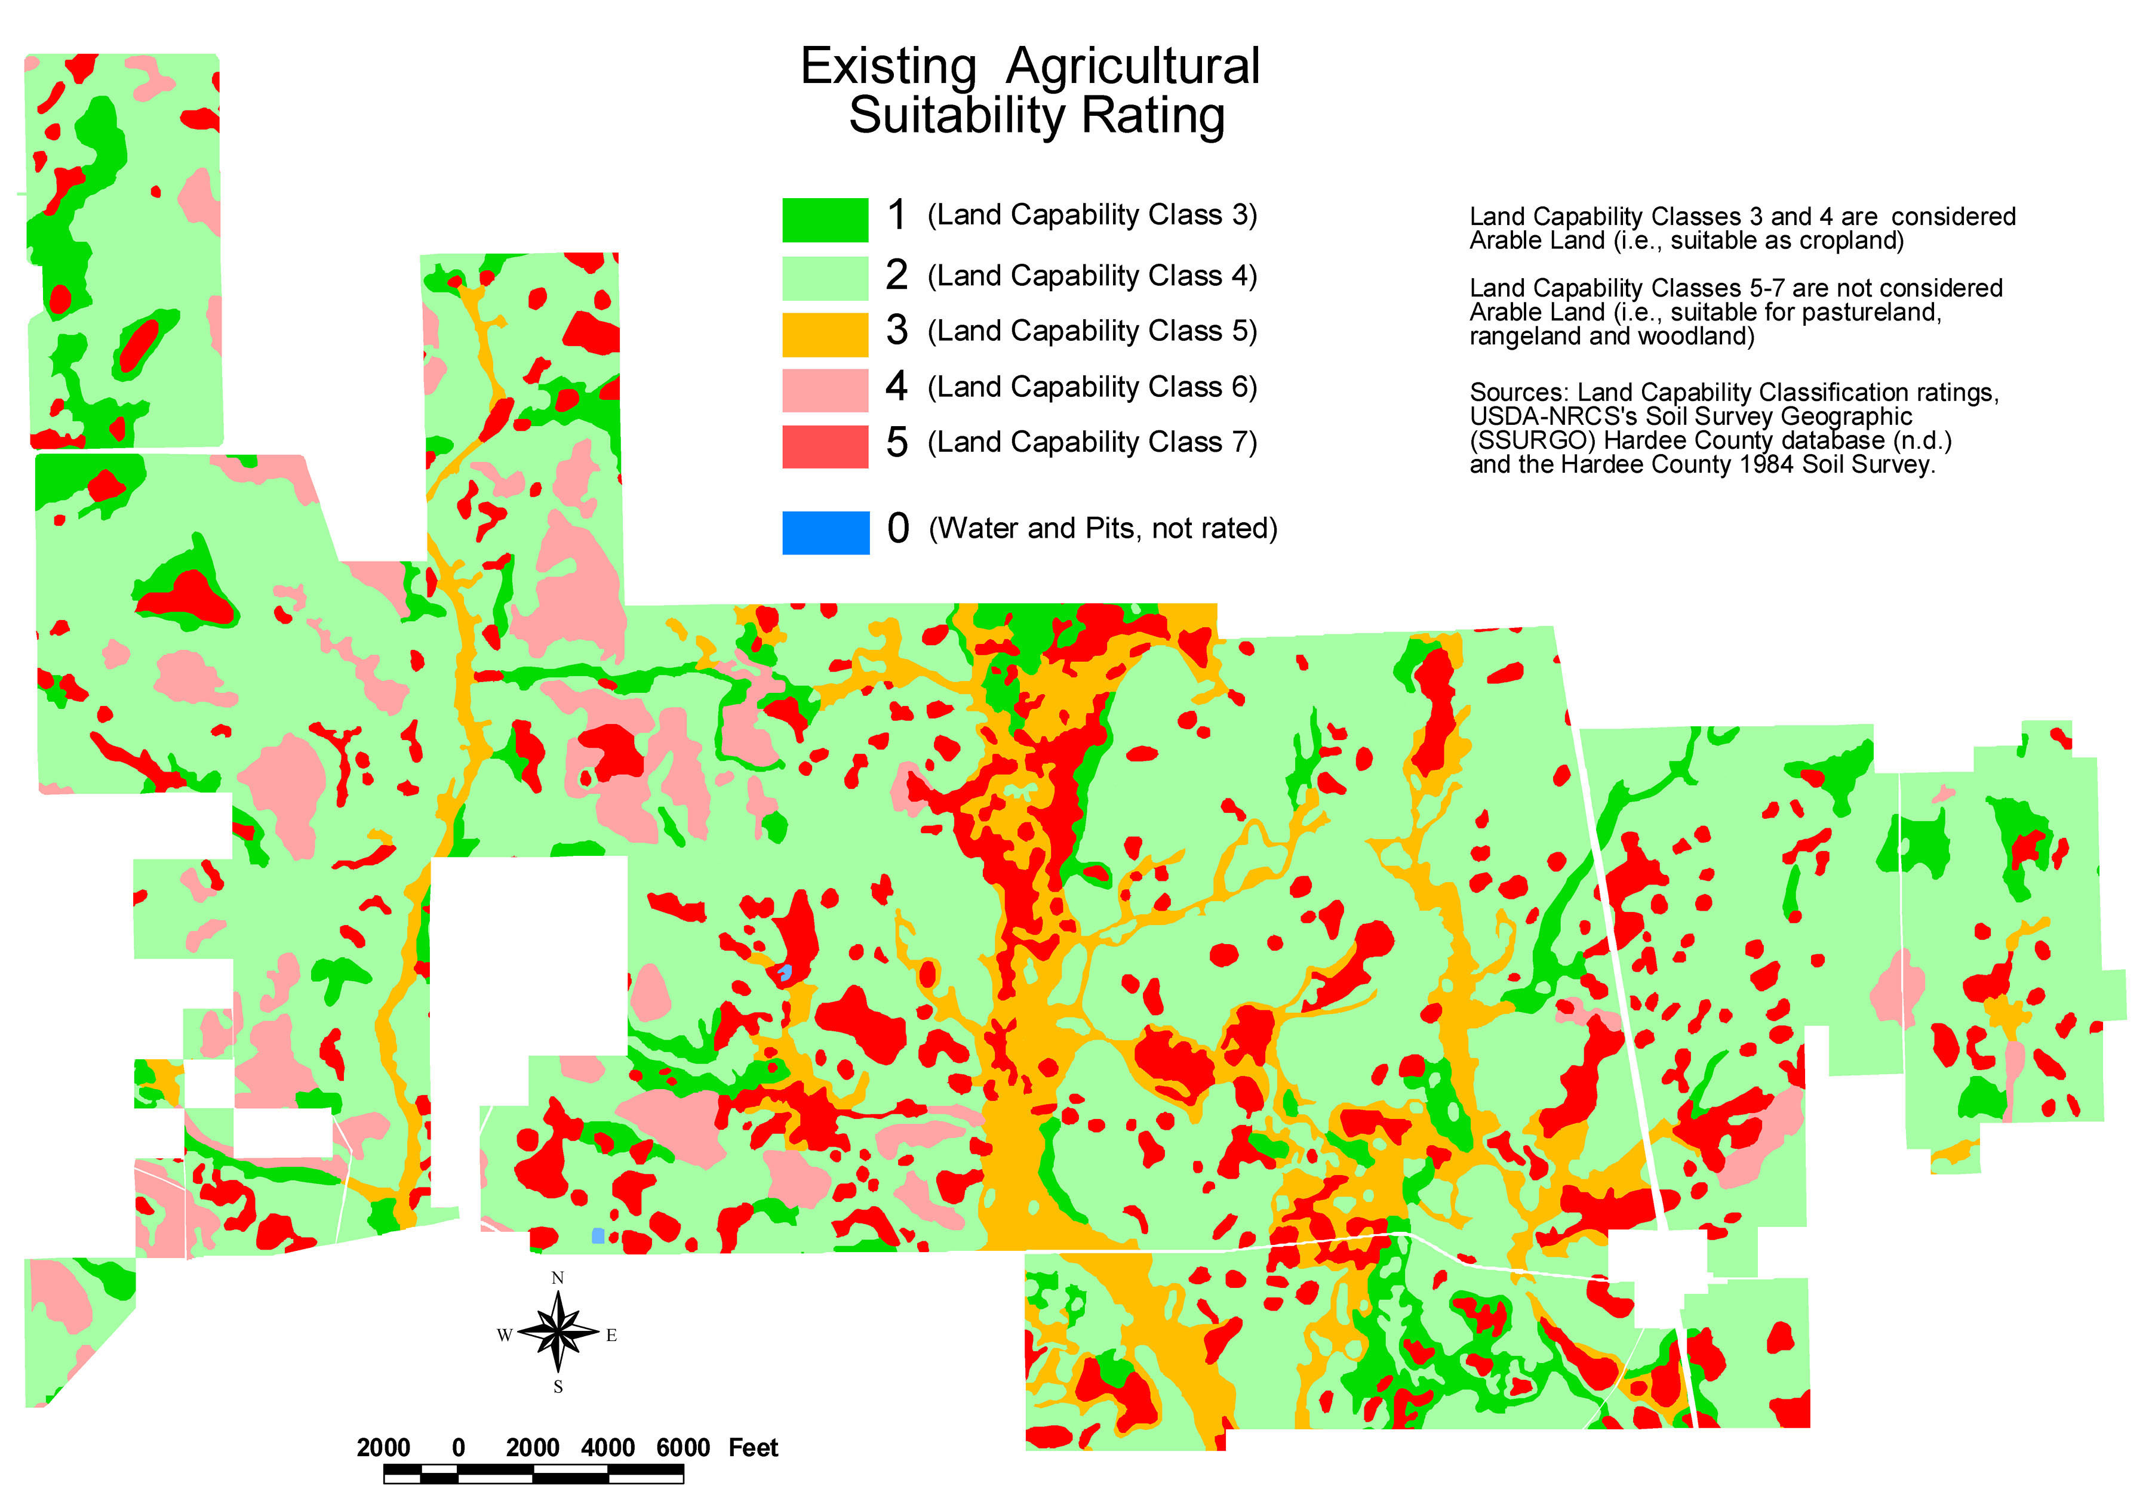

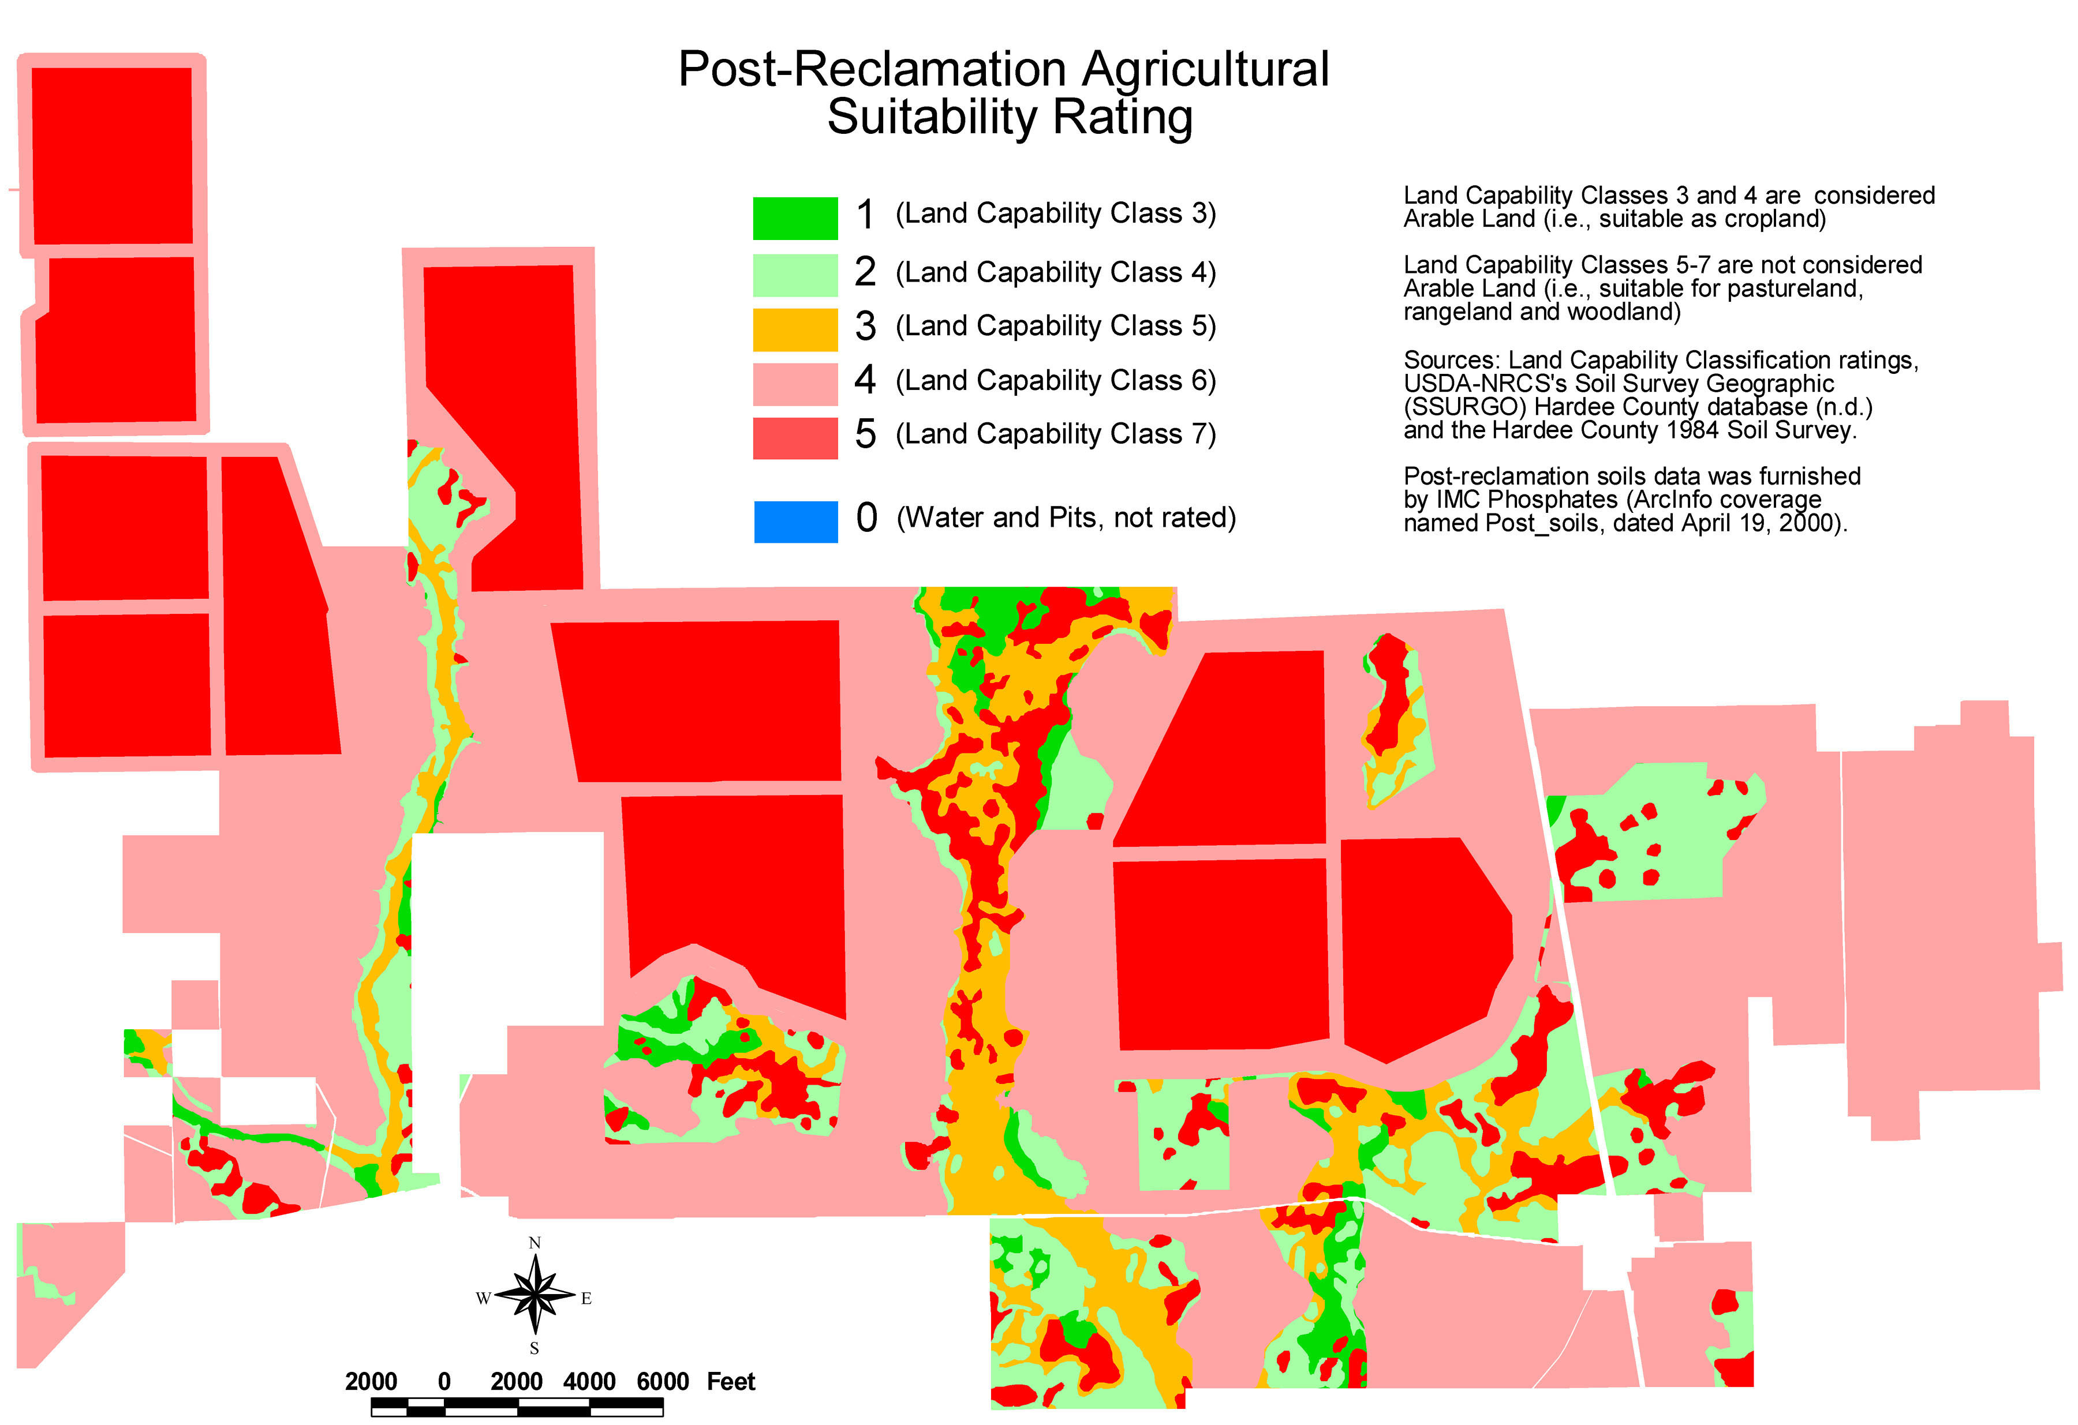

CHNEP. 2010. Charlotte Harbor Regional Climate Change Vulnerability Assessment. Charlotte Harbor National Estuary Program. Port Charlotte, Fla.

* Summary:
Summarizes "Climate Change" as it may affect areas monitored by the CHNEP, and provides a general vulnerability discussion.

* Substantive Comment:
3PR questions the adequacy of environmental analyses and the accuracy of the information contained in the FAEIS because it does not include, responsibly consider, or reference this important and directly relevant scientific research. The projected effects of the phenomenon of climate change have not been thoroughly examined in regard to its impacts to ecosystems and the environment, including, but not limited to, forced migration of animals and the potential inability of plant and vegetative communities to adapt. 3PR also questions the merits of alternatives other than Alternative-1 ("No Action" / "no permit") which are presented in the FAEIS, in part because of the excessively long permit terms. Rises in sea levels have recently been projected to reach as high as 2 meters by the year 2100 (Pfeffer 2008). Such changes will have profound effects on coastal communities, potentially requiring a slow evacuation of the majority of Florida's population (which is concentrated within a few miles of the coast), and the complete restructuring of business and society inland. Not planning for these changes by permitting inland barriers, and large-scale loss of farmland to phosphate strip mining, may not be in the interest of good land-use planning. Changes in climate patterns related to global warming (climate change) are significant concerns for long-range environmental planning, and even short-range planning. Climate change and ozone depletion will affect humans and the natural environment and, in fact, have already had profound negative impacts in Antarctica, where "krill" (the main source of food for larger animals, including seals) has declined as much as 80% during the last 30 years (Reid et al 2010). Increased atmospheric temperatures and concomitant elevated sea levels are causing, among other serious problems, ocean encroachment of coastal lands which will drive coastal communities inland, and which will reduce inland areas as watercourses become wider and deeper. Wetlands and lowlands also will become submerged or inundated for longer periods. Because much of the geographic area and many environmental concerns of the CHNEP study area overlap with the CFPD, the CHNEP Technical Advisory Committee may be considered one of the most important scientific government organizations for the USACE to publicly cooperate with (also see other related 3PR comments).

Cole, S., T. Hingten, and K. Alvarez. 1994. Vegetative characteristics of contiguous dry prairie on two soil types in Hardee County. Resource Management Notes 7(3):15-16.

* Summary:
Species diversity and density were significantly different between soil types, with some species considered "indicators" for specific soil types. There were significant differences in characteristics of less dominant plants species across soil types in dry prairie. Fire regime is very important in maintaining and controlling vegetative characteristics.

* Substantive Comment:
3PR questions the accuracy of information and the adequacy of the environmental analyses in the FAEIS because it does not include, responsibly consider, or reference this important and directly relevant scientific research. (Also see comments under Orzell & Bridges 2006, Huck 1987, and as elsewhere in 3PR's comments).

Daily, Gretchen C. et al. 1997. Ecosystem Services: Benefits Supplied to Human Societies by Natural Ecosystems. Issues in Ecology. No. 2, Spring 1997.

* Summary:
Provides information and research results concerning "Ecosystem Services" and the essential need to protect ecosystems in order for human existence to continue.

* Substantive Comment:
3PR objects to and questions the adequacy of the environmental analysis and accuracy of the information in the FAEIS because it does not include, responsibly consider, or reference this important and directly relevant scientific research. It does not consider the plethora of negative impacts which phosphate strip mining inflicts on biotic ecosystems and essential "ecosystem services". The purpose of NEPA is "Protection of the Environment". Protection of ecosystems, ecosystem services and biodiversity must therefore be the primary focus of the USACE in evaluating past, new, and cumulative environmental impacts of phosphate strip mining. NEPA also requires cumulative analysis. The FAEIS is invalid because it does not consider the need to ensure adequate ecosystems services and does not provide a cumulative analysis of the impacts of phosphate strip mining on ecological and biotic systems.

Diaz, S., et al. 2006. Biodiversity loss threatens human well-being. PLoS Biology 4(8):e277.

* Summary:
This important research summarizes contemporary science involving ecosystem services, and provides a synthesis from the latest scientific literature of the role of biodiversity in ecosystem services and human well-being. The findings indicate that the most dramatic changes in ecosystem services likely come from altered compositions of ecological communities and from the loss of locally abundant species rather than from the loss of already rare species.

* Substantive Comment:
3PR questions the adequacy of the FAEIS because it does not include, responsibly consider, or reference this important and directly relevant scientific research. There is no discussion of ecosystem services, nor are there any similar considerations consisting of rational dialogs and analyses relating to the need for environmental/ecosystems.

FDOT. 1990. Florida Land Use, Cover and Forms Classification System (Handbook), 3rd ed. Dept. of Trans. Surveying and Mapping, Geo., Mapping Sect., Tallahassee.

* Summary:
The standard land use and cover classification and mapping system used by government agencies, professionals, and scientists.

* Substantive Comment:
The FAEIS is not accurate and is inadequate because it purports to have been based on SWFWMD land use mapping data which 3PR contends is in error and does not conform to the primary and universally used standard, which is FDOT 1990 FLUCCS. The FLUCCS system has been inaccurately and improperly applied in developing land use maps for SWFWMD which includes the CFPD. FLUCCS requires that once land has been mined that it must be assigned a "mining" cover type and classification. The FAEIS is therefore invalid.

FFWCC. 2003. The 2001 Economic Benefits of Watchable Wildlife Recreation in Florida. Florida Fish and Wildlife Conservation Commission. Southwick Associates, Fernandina Beach, Fla.

* Summary:
This report examines the contributions of watchable wildlife recreation to the Florida economy. Tables detail the positive economic impact and other revenues from three forms of retail sales and economic impact, earnings, employment, and tax revenues.

* Substantive Comment:
3PR questions the accuracy of the information in the FAEIS because it does not include, responsibly consider, or reference this important and directly relevant scientific research. It relies on questionable sources for its economic analysis, mostly ignores the highly specific Hazen and Sawyer economic analysis, and completely evades considering the self-sustaining self-renewing and very economically significant contributions of "Watchable" wildlife. The AEIS is incorrect in discounting the tremendous economic, and completely sustainable contributions of natural resources, not only in the form of ecosystems services, which are essential to all life, including human existence, but to the local, regional and state economy. This is well-documented.
Phosphate strip mining is a completely exploitive "here-then-gone" industry which provides only a few local full-time jobs, is massively destructive to all aspects of the environment, and leaves a legacy which includes a myriad of completely untenable liabilities, such as many square miles of waste clay disposal sites enclosed by high dams, elevated radiation levels, toxic spills, extensive noxious weed infestations, a vast ecological wasteland, and many other negative impacts and hazards to humans and wildlife alike. Managing natural, self-sustaining ecosystems to aid the economy in the near and long-term, is not only essential to human kind, but is infinitely more reasonable than the self-destructive course of action of area-wide phosphate strip mining, which potentially involves over 100,000 acres in Hardee County alone, and which eventually will consume most of the county. Sources of jobs and revenues involving watchable wildlife, outdoor recreation, and eco-tourism are also much more compatible with the rural, agriculture and family traditions of Hardee County.

FIPR. 1986. Radiation and Your Environment. Florida Institute for Phosphate Research, No. 05-000-036. Bartow, Fla.

* Summary:
Provides general information, concerning ionizing radiation, radon, units of measurement and dose measurement, and well as some household tips. Provides a "Radon Risk Evaluation Chart".

* Substantive Comment:
3PR questions the accuracy of information and the adequacy of the environmental analyses in the FAEIS because it does not include, consider and reference this important and directly relevant scientific information. The following finding of this publication re-enforces the need for current, updated, epidemiological studies of radiation risks, especially where cumulative or additive effects may be involved:
"We do know that large doses of radiation given at high dose rates can cause cancers and genetic disorders, but we do not know for sure that low doses and dose rates cause these effects. For protective reasons (radiation regulations and standards), we assume that low doses also cause human health effects to a directly proportional, but smaller degree".

Most all public research supports the fact that any increase in radiation proportionally increases the risk of cancer and illness. The probability of increased radioactivity where phosphate strip mining and its waste and products are concerned is a well-known, well-demonstrated issue. In preparing the FAEIS, the Applicants simply brush over this important health concern by providing generic statements, buzz terms and jargon. By all professional and scientific evidence, this is an important environmental issue. The FAEIS is invalid because it consistently ignores the NEPA purpose and most of NEPA's requirements regarding quality of information, public scrutiny, and the solicitation of information and participation.

Furukawa, K., Preston, D. L., Lönn, S., Funamoto, S., Yonehara, S., Matsuo, T., et al. 2010. Radiation and smoking effects on lung cancer incidence among atomic bomb survivors. Radiat Res, 174(1), 72-82.

* Summary:
"Rapid increase in excess risk with smoking intensity up to about 10 cigarettes per day, but additive or subadditive for heavy smokers smoking a pack or more per day, with little indication of any radiation-associated excess risk."
"Studies of Hodgkin lymphoma patients treated with radiotherapy suggested a multiplicative interaction between radiation and smoking effects on lung cancer risks."
The joint effect appears to be super-multiplicative for light to moderate smokers (smoking less than a pack of cigarettes per day) but additive or even sub-additive for heavy smokers (smoking a pack or more per day).
"It may be that there is a certain pool of people who are genetically susceptible to lung cancer and that high levels of smoking have saturated that pool so that there is little room for an additional radiation effect. Another possible explanation is that radiation exposure prior to the start of smoking may be less harmful than radiation exposure after smoking initiation. In the LSS, age at exposure is highly correlated with whether radiation exposure occurred before or after initiation of smoking, making it difficult to address this question."

Gnandi, K., Tchangbedji, G., Killi, K., Baba, G., & Abbe, K. 2006. The Impact of Phosphate Mine Tailings on the Bioaccumulation of Heavy Metals in Marine Fish and Crustaceans from the Coastal Zone of Togo. Mine Water and the Environment, 25(1), 56 - 62.

* Summary:
Describes estuary pollution by heavy metals from phosphate mining, processing and waste disposal. Investigates some marine life impacts.

* Substantive Comment:
3PR questions the adequacy of the environmental analyses and accuracy of the information in the FAEIS because it does not include, responsibly consider, or reference this important and directly relevant scientific research. It barely mentions the extensive contamination of the environment by heavy metals from phosphate strip mining, processing and waste disposal, distribution and use of phosphate fertilizer products.

Godt, J., Scheidig, F., Grosse-Siestrup, C., Esche, V., Brandenburg, P., Reich, A., & Groneberg, D. A. 2006. The toxicity of cadmium and resulting hazards for human health. Journal of Occupational Medicine and Toxicology, 1(1), 22.

* Summary:
The research generally details the toxicity of cadmium. Cadmium does not have any physiological function within the human body. It has serious biohazardous potential and can lead to kidney, bone, pulmonary damages, and other health problems. (1) Acute intoxication - respiratory system is affected severely by the inhalation of cadmium-contaminated air: Shortness of breath, lung edema and destruction of mucous membranes as part of cadmium-induced pneumonitis; (2) Kidney damage - causes irreversible damage and failure; (3) Reproductive biology - interferes with reproduction in rats; (4) Bone damage and the Itai-Itai-disease - a connection has been demonstrated between cadmium intoxication and bone damage, e.g. in workers exposed to cadmium-polluted fume and dust; (5) Carcinogenetic - suspected carcinogen.
The authors state that "Phosphate fertilizers also show a big cadmium load."

* Substantive Comment:
3PR questions the adequacy of the environmental analyses of the FAEIS because it does not include, responsibly consider, or reference this important and directly relevant scientific research. It fails to consider that phosphate strip mining, ore processing, and phosphate products may increase human and environmental exposure to, and contamination from, “cadmium”, and from other toxic heavy metals.

Gofman, John W. 1990. Radiation-induced cancer from low-dose exposure: an independent analysis. Committee for Nuclear Responsibility.

* Summary:
Dr. John W. Gofman, M.D., PhD was an established authority on nuclear physics. His research, as well as the research of many others, conclude that there is no safe dose or dose rate of ionizing radiation, that even the lowest conceivable doses present cancer risks, and that larger doses proportionally increase these risks.
Considered by some as the foremost independent authority, Dr. Gofman was Professor Emeritus of Molecular and Cell Biology in the University of California at Berkeley, and Lecturer at the Department of Medicine, University of California School of Medicine at San Francisco. He is the author of several books and more than a hundred scientific papers in peer-reviewed journals in the fields of nuclear / physical chemistry, coronary heart disease, ultra-centrifugal analysis of the serum lipoproteins, the relationship of human chromosomes to cancer, and the biological effects of radiation, with especial reference to causation of cancer and hereditary injury.

* Substantive Comment:
3PR questions the accuracy of information and the adequacy of the environmental analyses in the FAEIS because it does not include, responsibly consider, or reference this important and directly relevant scientific research. It does not consider the potentially negative, cumulative, and variously harmful effects of exposure to increased ionizing radiation which has the potential to result from phosphate strip mining operations, mine reclamation and other waste dumping, such as clay waste disposal and phosphogypsum stacking, the distribution and use of mining products, and the contamination of foods and products (such as tobacco) from phosphate fertilizers.
It is inconceivable that the FAEIS has ignored so much important, landmark research regarding the risk associated with increased radiation and exposure to radionuclides resulting from phosphate strip mining operations. The FAEIS makes no attempt to address "Protection of the Environment" as required by NEPA. The FAEIS is therefore invalid.

Guidry, J. J., Roessler, C. E., Bolch, W. E., McClave, J. T., Hewitt, C. C., & Abel, T. E. 1990. Radioactivity In Foods Grown On Mined Phosphate Lands. Florida Institute for Phosphate Research, Publication No. 05-028-088).

* Summary:
This is a narrow study reporting on radionuclide uptake of Lead-210, Polonium-210 and Radium-226 by certain vegetable crops. The research demonstrates that many vegetables grown on reclaimed land and clay waste dumps were found to have 20 to over 100 times the Radium-226 concentration of those grown on non-mined lands. Strawberries, turnips and mustard greens stand out with some of the highest contamination values.
"In general, lands containing waste clays or sandphosphate "debris" tend to have the highest levels of radiation, followed by lands reclaimed generally with overburden and sand, next followed by mineralized unmined lands, and finally nonmineralized lands."

* Substantive Comment:
3PR questions the adequacy of the environmental analyses of the FAEIS because 3PR questions the accuracy of information and the adequacy of the environmental analyses in the FAEIS because it does not include, responsibly consider, or reference this important and directly relevant scientific research. It does not consider the important public health concern that many foods grown on mined land and mine wastes contain much higher concentrations of radioactive materials than those grown elsewhere. Because other research shows that increases in ionizing radiation concomitantly increase the risk of cancer and other illness, these phosphate-land foods may contribute to these public health problems.
Also, the USACE has failed to consider that these radiological risks are inherently enhanced in children and the young because of many factors including, but not limited to, eating habits and the presence of active developmental and physiological processes. Also, Radium-226 concentrates in bones and certain tissues, the formation of which is much more active during childhood.
Additionally the USACE has failed to consider the additive risks of those who may be working in the more radioactive phosphate-land farms, smoking, drinking water from shallow wells, or who may also be exposed to other radiological risk or disease factors, and who may possess genetically predisposed risks factors.
The FAEIS is therefore inadequate to protect public health in adults, and especially in children. The FAEIS is invalid.

Hazen and Sawyer. 2003. Hardee County, Florida: Economic Impact of the Ona mine to Hardee County. Final Report, July 28, 2003. Hardee County Board of County Commissioners, by Grace Johns, Hazen and Sawyer, Environmental Engineers and Scientists.

* Summary:
Evaluates the potential economic effects to Hardee County from the proposed Ona Mine located in western Hardee County. This analysis estimates the change in employment and income to Hardee County residents that would be generated from the Ona Mine relative to land uses on the Ona property that would take place under baseline conditions. Presents a reasonable scenario of the potential land use given the best available information. Land use of the Ona Property under the baseline or “no-mining” scenario was based on reasonable assumptions of how western Hardee County would likely develop if no additional land was mined. All baseline land uses are consistent with Hardee County housing projections from the University of Florida Bureau of Economic and Business Research and historical agricultural acreage trends in Hardee County and in Florida from the Florida Agricultural Statistics Service.

* Substantive Comment:
3PR questions the accuracy of information and the adequacy of the environmental analyses in the FAEIS because it does not include, responsibly consider, or reference this important and directly relevant, site-specific scientific research.
(Refer to other 3PR comments, including, but not limited to "Environmental Justice" comments).

Hess. 2013a. Materials Safety Data Sheet (MSDA), No. 5 Fuel Oil. Hess Corporation, Woodbridge, NJ. Accessed 31-May-2013: http://hess.com/ehs/msds/0332No5FuelOil.pdf

* Summary:
Provides technical and safety data for No. 5 Fuel Oil.

* Substantive Comment:
3PR questions the accuracy of information and the adequacy of the environmental analyses in the FAEIS because it does not include, responsibly consider, or reference important toxic chemical (reagent) data essential for the protection of public health, the environment and the economy.

Hess. 2013b. Materials Safety Data Sheet (MSDA), Kerosene. Hess Corporation, Woodbridge, NJ. Accessed 31-May-2013: http://www.hess.com/ehs/msds/0290KeroseneK1andK2.pdf

* Summary:
Provides technical and safety data for Kerosene.

* Substantive Comment:
3PR questions the accuracy of information and the adequacy of the environmental analyses in the FAEIS because it does not include, responsibly consider, or reference important toxic chemical (reagent) data essential for the protection of public health, the environment and the economy.

HCBOCC. 2010. Hardee County, Sustainable Hardee Visioning for the Future. Hardee County Board of County Commissioners, Wauchula, Florida.

* Summary:
"The Visioning is aimed at identifying community goals and a means to achieve those goals, both short and long-term. Hardee County is faced with difficult choices in the current economic times. Realizing that growth and development have the ability to either support or hamper the community’s desires, county officials began to develop a Community Vision for the community that could properly guide future development and identify solutions to challenges. The Visioning process is intended to utilize a broad range of community comments, issues and opportunities in developing community recommended strategies. The Visioning process is also intended to develop a framework within which to proactively plan, develop milestones and identify potential community champions for the recommendations. With each successive meeting, the community refined the broader comments into more focused, action-oriented recommendations that will be used to develop the overall final Vision. The strategies identified are not necessarily government directed and/or supported, and in numerous cases involve local community and civic organizations with specific interest or association with related programs. This method creates broad based community support and responsibility for the implementation of the strategy. The County identified five areas of review and analysis that were discussed through a series of “Focus Groups” and community meetings to prepare the Visioning Report and to provide guidance for future projects and decisions. These groups included: Economic Development, Land Use/ Recreation/ Open Space/ Environment, Quality of Life/Housing, Education/ Workforce, Infrastructure."

* Substantive Comment:
3PR questions the adequacy of the FAEIS because it does not contain references to Hardee County's "Visioning" process, or an adequate analysis of how the FAEIS is consistent with the goals, objectives, and policies of the Hardee County Comprehensive Land Use Plan. NEPA requires coordination with state and local agencies in order to help avoid inconsistencies with local regulations and planning:
PART 1506--OTHER REQUIREMENTS OF NEPA
Sec. 1506.2 Elimination of duplication with State and local procedures.
(b) Agencies shall cooperate with State and local agencies to the fullest extent possible to reduce duplication between NEPA and State and local requirements ... such cooperation shall to the fullest extent possible include:
- Joint planning processes.
- Joint environmental research and studies.
- Joint public hearings (except where otherwise provided by statute).
- Joint environmental assessments.

(d) To better integrate environmental impact statements into State or local planning processes, statements shall discuss any inconsistency of a proposed action with any approved State or local plan and laws (whether or not federally sanctioned). Where an inconsistency exists, the statement should describe the extent to which the agency would reconcile its proposed action with the plan or law.

* Recommendation:
3PR suggests that interested persons take aerial and surface tours of previously mined and reclaimed lands in northwestern Hardee County (and of the "four corners" and northwards), then tour areas of unmined lands. They should then drive US-17 from Ft. Meade to Homeland, west on Lithia Pinecrest, north on Keysville, north on Hopewell to SR-60, east on SR-60 to Bartow, then south on US-17 back to Homeland. These tours show the results of phosphate strip mining on the land, the environment and the economy. They educate as to whether phosphate strip mining should be any reasonable part of Hardee County's vision of the future. Phosphate strip mining, chemical processing, waste dumping, and reclamation, completely destroy, pollute, and preclude all future potentials … see Hazen & Sawyer economic study!

Huck, Robin B. 1987. Plant Communities along an edaphic continuum in a central Florida watershed. Florida Sci. 50(2):88-110.

* Summary:
Vegetative gradient analysis in central Florida flatwoods region. Vegetation changed with topography, moisture regimes and soils. A correlation between soil types and vegetation was shown evident. The vegetative communities analyzed included palmetto prairie, savannah, palmetto zone, cypress slough, pine flatwoods, oak-palm woodland, maple swamp forest, ash swamp forest, maple-ash swamp forest, oak woodland, saw palmetto zone, cypress dome, palmetto prairie, and cypress pond.

* Substantive Comment:
3PR questions the adequacy of the environmental analyses of the FAEIS because it does not include, responsibly consider, or reference this important and directly relevant scientific research. It fails to consider that dry prairie vegetative communities, and other communities in ecosystems in the CFPD, can not recover or be restored once the native soils and complex geology have been disrupted or removed. This paper is in support of other 3PR comments explaining the correlation between native soils types, natural geology, natural hydrology and specific native vegetative communities and plant species, particular the substantive comment under the Orzell & Bridges (2006) reference.

Iwanaga, M., Hsu, W. - L., Soda, M., Takasaki, Y., Tawara, M., Joh, T., et al. 2011. Risk of Myelodysplastic Syndromes in People Exposed to Ionizing Radiation: A Retrospective Cohort Study of Nagasaki Atomic Bomb Survivors. Journal of Clinical Oncology, 29(4), 428 - 434.

* Summary:
ABSTRACT: ... Nagasaki atomic bomb survivors: 64,026 people with known exposure distance in the database of Nagasaki University Atomic-Bomb Disease Institute (ABDI) and 22,245 people with estimated radiation dose in the Radiation Effects Research Foundation Life Span Study (LSS). Patients with MDS diagnosed from 1985 to 2004 were identified by record linkage between the cohorts and the Nagasaki Prefecture Cancer Registry. Cox and Poisson regression models were used to estimate relationships between exposure distance or dose and MDS risk.
There were 151 patients with MDS in the ABDI cohort and 47 patients with MDS in the LSS cohort. MDS rate increased inversely with exposure distance, with an excess relative risk (ERR) decay per km of 1.2 (95% CI, 0.4 to 3.0; P < .001) for ABDI. MDS risk also showed a significant linear response to exposure dose level (P < .001) with an ERR per Gy of 4.3 (95% CI, 1.6 to 9.5; P < .001). After adjustment for sex, attained age, and birth year, the MDS risk was significantly greater in those exposed when young.
A significant linear radiation dose-response for MDS exists in atomic bomb survivors 40 to 60 years after radiation exposure. Clinicians should perform careful long-term follow-up of irradiated people to detect MDS as early as possible.

* Substantive Comment:
3PR questions the adequacy of the environmental analyses of the FAEIS because it does not include, responsibly consider, or reference this important and directly relevant scientific research. The USACE has aggressively avoided sincere and responsible consideration of the highly important issue of increased radiation/ radioactivity associated with phosphate strip mining, reclaimed land and other waste disposal sites such as CSAs and phosphogypsum stacks, and product processing, distribution and use. A vast body of peer-reviewed scientific and medical research support that any increases in exposure to ionizing radiation or radioactive materials (radionuclides) results in increased risk of cancer and other disease or damage to public health, as well as being injurious to ecological services and assets. Of particular concern reported in Iwanaga 2011 is the "significantly greater" risks to those exposed to radiation when young. The USACE has been irresponsible in ignoring extremely well-documented important public health concerns. The FAEIS is therefore unqualified, inconsistent with the requirements of NEPA, and invalid.

Kratz, S., & Schnug, E. 2006. Uranium in the Environment Rock phosphates and P fertilizers as sources of U contamination in agricultural soils. (B. J. Merkel & Hasche-Berger, A.) (pp. 57-67).

* Summary:
The paper reports uranium concentration in phosphate fertilizers as compared to farmyard manures, in the context of agricultural soils.
"U concentrations were analyzed in a set of mineral fertilizers with and without P and compared to U concentrations in various organic fertilizers. Mean concentrations between 6 and 149 mg/kg U were found in P containing mineral fertilizers, while mean concentrations in mineral fertilizers without P were below 1.3 mg/kg U."

* Substantive Comment:
3PR questions the adequacy of the environmental analyses of the FAEIS because it does not include, responsibly consider, or reference this important and directly relevant scientific research. A large body of scientific and medical research has been ignored by the USACE. Published, peer-reviewed research and objective 3rd party data and analysis indicate a serious concern with elevated radiation and radioactive materials (radionuclides) in phosphate products. Independently such elevated levels and concentration are a large concern, but even greater when additional risk factors are included. The FAEIS is therefore insufficient for it intended NEPA purposes, and invalid.

Kremen, C. 2005. Managing ecosystem services: what do we need to know about their ecology? Ecology Letters 8:468-479.

* Summary:
Human domination of the biosphere greatly alters ecosystems, yet ecological understanding of ecosystem services is limited. The author discusses methods to incorporate vital ecological information into the environmental policy and management process.

* Substantive Comment:
3PR questions the adequacy of the environmental analyses of the FAEIS because it does not include, responsibly consider, or reference this important and directly relevant scientific research. Significant issues relating to the future of humanity were not discussed. The author stresses that proper understanding of ecosystem services is critical for our human future. There is no discussion of ecosystem services, nor are there any similar considerations for protection of the environment found in the FAEIS.

Krestinina, L. Y., Davis, F., Ostroumova, E., Epifanova, S., Degteva, M., Preston, D., & Akleyev, A. 2007. Solid cancer incidence and low-dose-rate radiation exposures in the Techa River cohort: 1956 2002. International Journal of Epidemiology, 36(5), 1038 - 1046.

* Summary:
"Based on 1836 solid cancer cases with 446 588 person years accrued over 47 years of follow-up, solid cancer incidence rates were found to increase with dose and about 3% of the cases were attributable to radiation exposure. The ERR was 1.0/Gy (P = 0.004 95% CI (0.3; 1.9) in a linear dose-response model. There was no significant non-linearity in the dose response and no indication of effect modification by gender, ethnicity, attained age or age at first exposure.

The Techa River cohort provides strong evidence that low-dose, low-dose rate exposures lead to significant increases in solid cancer risks that appear to be linear in dose. The results do not suggest that risks associated with low-dose rate exposures are less than those seen following acute exposures such as were received by atomic bomb survivors."

* Substantive Comment:
3PR questions the adequacy of the environmental analyses of the FAEIS because it does not include, responsibly consider, or reference this important and directly relevant scientific research. It avoids all important, relevant research concerning the health risks associated with low-level low-dose ionizing radiation. NEPA requires that the FAEIS be founded on high quality information which has been subjected to public scrutiny, and that such should be actively solicited from the public. The FAEIS does not attempt to meet even minimal standards of federal laws. It fails NEPA, and fails to protect the public welfare. It is therefore invalid.

Lyman, Gary H. (MD, MPH) et al. 1985. Association of Leukemia with Radium Groundwater Contamination. JAMA, 254(5):621-626.

* Summary:
Radiation exposure, including the ingestion of radium, has been causally associated with leukemia in man. Groundwater samples from 27 counties on or near Florida phosphate lands were found to exceed 5 pCi/L total radium in 12.4% of measurements. The incidence of leukemia was greater in those counties with high levels of radium contamination (>10% of the samples contaminated) than in those with low levels of contamination. Rank correlation coefficients of 0.56 and 0.45 were observed between the radium contamination level and the incidence of total leukemia and acute myeloid leukemia, respectively. The standardized incidence density ratio for those in high-contamination counties was 1.5 for total leukemia and 2.0 for acute myeloid leukemia. Further investigation is necessary, however, before a causal relationship between groundwater radium content and human leukemia can be established.

* Substantive Comment:
3PR questions the adequacy of the environmental analyses in the FAEIS because it does not include, responsibly consider, or reference this important and directly relevant scientific research. This study and several others consistently and specifically find statistically elevated cancer risks from human exposure to Radium-226 contaminated groundwater. Numerous other published research report elevated low-level radiation associated with various sources within the CFPD, particularly on mined land and at waste clay disposal sites. The Lyman studies were published in the prestigious, peer-reviewed Journal of the American Medical Association (JAMA).

* Recommendation:
The body of research reporting radiation concerns relating to the phosphate strip mining and processing industry speaks for itself in terms of raising serious health concerns. Research consistently shows that any elevations in radiation, or exposure to radionuclides, means elevated risks, and warn about consuming food items from phosphate lands. As suggested elsewhere in 3PR's comments, comprehensive, multi-team, "independent" "peer-reviewed" studies are indicated in order to determine the level of potential threat to humans and the environment. Studies funded by the phosphate industry should be discarded, in favor of objective, credible research conducted by 3rd-party, leading medical researchers, institutions, and epidemiologists, such as Lyman, Stockwell, Gofman, and others. There have been several recent, land-mark studies which greatly reinforce the danger of even small increases in exposure to radiation and radionuclides.

MASS_2012. Public Health Fact Sheet on Radon. Commonwealth of Massachusetts. Accessed 10-Jul-2012: www.mass.gov

* Summary:
Provides basic facts concerning Radon, and described health risks.
"Radon is a naturally occurring radioactive gas. It is produced in the ground through the normal decay of uranium and radium. As it decays, radon produces new radioactive elements called radon daughters or decay products. Radon and radon daughters cannot be detected by human senses because they are colorless, odorless, and tasteless." "When radon undergoes radioactive breakdown, it decays into other radioactive elements called radon daughters. Radon daughters are solids, not gases, and stick to surfaces such as dust particles in the air. If contaminated dust is inhaled, these particles can adhere to the airways of the lung. As these radioactive dust particles break down further, they release small bursts of energy which can damage lung tissue and therefore increase the risk of developing lung cancer. In general, the risk increases as the level of radon and the length of exposure increases."

* Substantive Comment:
Because the FAEIS is required to consider all significant environmental issues, it should have provided a comprehensive evaluation the direct and cumulative risks associated with elevated Radon levels at mined, reclaimed land, CSAs, phosphogypsum stacks, and other waste dump, as well as phosphate products. The FAEIS is inadequate because, although elevated radiation/radioactivity from Radium-226 and Radon-222 and its decay progeny (daughters) are discussed, the document does not evaluate the present and future risks, including cumulative factors and additive risks. This is inconsistent with the requirement "The NEPA process is intended to help public officials make decisions that are based on understanding of environmental consequences, and take actions that protect, restore, and enhance the environment" A point of some note which is provided in the "Fact Sheet" is that radon "daughters" adhere to dust particles in the air. Mining and construction sites are often very dusty, with elevated concentrations of particulates.

Menges, E. S. 2007. Integrating demography and fire management: An example from Florida scrub. Australian Journal of Botany 55:261-272.

* Summary:
Author reviews the ecology of fire in the scrub and analyzes life history and demographic data (most species studied for 10-15 years) of 16 rare and endangered plants of the scrub, and discusses the varied life history patterns of these plants. Some species balance two opposite strategies of survival in a fire-dominated system, seeding and sprouting, and others are more dependent on only one strategy.

* Substantive Comment:
3PR questions the adequacy of the environmental analyses in the FAEIS because it does not include, responsibly consider, or reference this important and directly relevant scientific research. It does not acknowledge the necessity of proper upland ecosystem management through the use of prescribed fire. Fire is essential to the life histories of most plants in the Florida scrub, and as shown elsewhere in 3PR's comments, in the expansive dry prairie/flatwoods/pine-palmetto vegetative communities found throughout the southern half of the CFPD. "Pyrodiversity", the variation of fire regimes in time and space, is essential to the continued natural functioning of Florida's upland ecosystems. The role of fire in maintaining native upland ecosystems is nowhere discussed in the FAEIS. The only mention of fire or fire ecology is vaguely in regard to scrub jay mitigation. 3PR also questions the accuracy of the information in FAEIS because it is stated that "The phosphate industry uses chemical, mechanical, fire, hydrologic, and manual techniques to control nuisance and exotic plant species in mitigation areas." Although this statement is not in the context of fire ecology, it should be pointed out that burning the vast infestations of cogongrass which occur on mined and "reclaimed" lands is not compatible with what few native plant species may remain there, and also may not be compatible with some wildlife species. Also, using fire in an attempt to improve the appearance of land, without any real hope of eradication (as is the case with cogongrass growing in post-mining substrates) creates smoke and other air pollution concerns.

Menges, E. S. 2008. Restoration demography and genetics of plants: When is a translocation successful? Australian Journal of Botany 56:187-196.

* Summary:
This review paper stresses the many complex ecological factors that govern species reintroductions and the many complex ecological relationships that must be re-established for a species reintroduction to be considered a success. Chief among them is the generation time of a species. For long-lived plants, it may take decades for the translocated plants to become reproductive.

* Substantive Comment:
3PR questions the accuracy of information and the adequacy of the environmental analyses in the FAEIS because it does not include, responsibly consider, or reference this important and directly relevant scientific research. Long-term monitoring of species reintroductions is necessary in order to evaluate the success of a project. Adequate funding for such monitoring should accommodate this long-term component of reintroduction projects. Highly detailed base data is essential in order to determine reintroduction success or failure. The FAEIS universally lacks quality base data for the ecosystems, wildlife communities and vegetative communities in CFPD and four proposed mine sites. The data provided is only general and generic, and not suitable for scientific research.

Menges, E.S. and Gordon, D.R. 2010. Should mechanical treatments and herbicides be used as fire surrogates to manage Florida's uplands? A review. Florida Scientist 73:147-174.

* Summary:
Mechanical treatments and herbicide often accelerated vegetation structure changes, but ecological benefits were generally greatest when they were combined with fire. Soil disturbances, weedy species increases, and rapid hardwood resprouting were sometimes problems with mechanical treatments. Fire itself was crucial for maintenance of individual species and species diversity. When feasible, mechanical and herbicide treatments should be used as pretreatments for fire rather than as fire surrogates. Managers should segue to fire-only approaches as soon as possible.

* Substantive Comment:
3PR questions the accuracy of information and the adequacy of the environmental analyses in the FAEIS because it does not include, responsibly consider, or reference this important and directly relevant scientific research. This paper is used in support of other 3PR comments and is only one of many papers indicating that natural fire, or in this case prescribed fire, is the ecologically correct and natural method for the management of xeric upland habitats. The FAEIS is completely inadequate in sufficiently characterizing ecosystems and managing natural areas within the CFPD.

Meyerson, Laura A., et al. 2005. Aggregate measures of ecosystem services, can we take the pulse of nature. Front Ecol Environ 2005; 3(1): 56–59.

* Summary:
Stresses the imperativeness of "ecosystem services" as essential to human well-being and that such services provide life support for the human population. Concludes that "quantifying and monitoring the flows of ecosystem services is critical", and that "quantification of ecosystem services and communication of the information to decision makers and the public is critical to the responsible and sustainable management of natural resources."

* Substantive Comment:
3PR questions the adequacy of the environmental analyses in the FAEIS because it does not include, responsibly consider, or reference this important and directly relevant scientific research. It fails to consider the "essential life support" value of the extensive natural ecosystems which large-scale phosphate strip mining destroys. The FAEIS does not quantify, nor does it provide any direction for, the adequate protection and monitoring of "ecosystem services" within the CFPD and four proposed mine sites. Ecosystem services are essential for the continued existence of both humans and the environment.

Mortved, J. J., & Beaton, J. D. 1995. 6 Heavy Metal And Radionuclide Contaminants In Phosphate Fertilizers. Alabama: National Fertilizer and Environmental Research Center, Tennessee Valley Authority.

* Summary:
Reports on various heavy metals and radionuclides present at elevated amounts in phosphate fertilizers, and provides values, information on uptake by crops, and other data.
"Phosphate rock (PR) contains various metals and radionuclides as minor constituents in the ores. Varying amounts of these elements are transferred to phosphate fertilizers in production processes, and later are applied to soils with these fertilizers. Cadmium (Cd) is the heavy metal of most interest because it is potentially harmful to human health, and much attention is being given to its avenues of entry into the human food chain. Among these avenues is the application of Cd to soil with fertilizers, and the subsequent uptake by vegetable and grain crops."

"Concentrations of other heavy metal and radionuclide contaminants in P fertilizers vary considerably, depending on the PR source. Some metals of possible significance are: arsenic (As), chromium (Cr), lead (Pb), mercury (Hg), nickel (Ni), and vanadium (V). However, these metals are of less concern than Cd, either because they are not as readily absorbed by plants from P-fertilised soils or their apparent relative effects on human health are less than that of Cd. The main radionuclide contaminants in PR are uranium (U), radium (Ra), and thorium (Th)."

"Heavy metal contaminants in P fertilizers may be available to plants. Because of the potentially adverse effects of Cd on human health, most of the studies have been concerned with Cd. An early report (Shroeder and Balassa, 1963) showed that high application rates of TSP containing 35 mg Cd kg-1 P increased Cd concentrations in several vegetable species."

"Williams and David (1973) reported that plant species differed considerably in their ability to take up Cd. Leafy vegetables absorb more Cd than grasses, and only 12-18% of the Cd in cereal plant tops was translocated into the grain. However, soil application of CdCl2 or TSP containing Cd resulted in increased Cd concentrations in both cereal grains and the edible portions of vegetables. Topdressing pastures with TSP also resulted in increased Cd of pasture species, especially that of subterranean clover (Trifolium subterraneum L.)."

"Mortvedt and Giordano (1977) reported greater Cd uptake by maize (Zea mais L.) from commercial DAP fertilizers which contained from 100 to 260 mg Cd kg-1 P than from reagent grade DAP (5 mg Cd kg-1 P) (Table 2). Plant uptake of Cr, Ni, and Pb was quite variable and was not directly related to their concentrations in P fertilizers. Reuss et al. (1978) also found greater Cd uptake by radish (Raphanus sativus L.), lettuce (Latuca sativa L.), and peas from soil applications of TSP containing 870 mg Cd kg-1 P than from Ca(H2PO4)2, which is the main P compound in TSP. Uptake of Cd by all crops was much lower from a calcareous silt loam soil than from an acid sandy soil."

Note that most of the upland agriculture soils in west central Florida (and Florida in general) are "acid sandy soils". This means that Florida crops more susceptible to uptake of Cadmium by crops.

* Substantive Comment:
3PR questions the adequacy of the environmental analyses in the FAEIS because it does not include, responsibly consider, or reference this important and directly relevant scientific research. The USACE consistently avoids any meaningful consideration of the well-known concern of heavy metal contamination in mined lands, and in phosphate mining wastes and products. Further, the USACE does not consider the synergistic and additive effects of the many forms of pollution and contamination which result from phosphate strip mining, land reclamation, clay waste dumping, and phosphogypsum stacking. The USACE does not consider the elevated risks inherent in children to the heavy metal contamination of the environment and foods, combined with increased radiological and chemical reagent toxin threats. The FAEIS is therefore deficient in complying with the requirement of NEPA and other federal regulations, in protecting public health, especially of children, and is invalid.

Naeem, Shahid et all. 1999. Biodiversity of Ecosystem Functioning: Maintaining Natural Life Support Processes. Issues in Ecology. No. 4, Fall 1999.

* Summary:
One of the most conspicuous aspects of contemporary global change is the rapid decline of the diversity of the earth's essential ecosystems.

* Substantive Comment:
3PR questions the accuracy of information and the adequacy of the environmental analyses in the FAEIS because it does not include, responsibly consider, or reference this important and directly relevant scientific research. 3PR objects and questions the adequacy of the environmental analyses and adequacy of the information in the FAEIS because it does not consider the ALL IMPORTANT subject of "biodiversity". The fact that humans need healthy ecosystems for their continued existence, and the phosphate strip mining may be the largest single contributor to the destruction of genetic diversity and the environment in central Florida. NEPA's charter of "Protection of the Environment" is all but ignored in the FAEIS.

O'Meara, T. E., Marion, W. R., Roessler, C. E., Roessler, G. S., Van Rinsvelt, H. A., & Univ., G. Florida. 1986. Environmental Contaminants in Birds: Phosphate-Mine and Natural Wetlands. FIPR No. 05-003-045. Bartow, Fla.

* Summary:
This paper provides basic investigation of the accumulation of Radium in humans, birds, fish, and certain vegetation via food chains. It reports, among other results of considerable concern, that "the average bone concentration (of Radium-226) in waterfowl from settling ponds in central Florida was about 4 times the recommended maximum for humans." Food chain accumulation of radionuclides is also serious concern.

* Substantive Comment:
3PR questions the adequacy of the environmental analyses in the FAEIS because it does not include, responsibly consider, or reference this important and directly relevant scientific research. The results of this research inspire great concern for birdlife and the general environment, in and near phosphate strip mines, and especially at or near disposal areas, including, but not limited to clay waste dumps (CSAs), phosphogypsum stacks, and so-called reclaimed lands. The FAEIS mostly avoids any responsible and morally correct discussion of elevated radiation and radionuclide risks as it relates to phosphate strip mining, reclaimed land, waste disposal, or its products and related industries. The exceedingly minimal and erroneous discussion regarding radiation in the FAEIS is evidence of the strong bias of the USACE toward the profit-seeking goals of the Applicants. Published research clearly indicates that human health, plant and animal life, and environment are at risk. The NEPA purpose is "Protection of the Environment". The FAEIS is invalid because it does not address this important, well established environmental concern and human health risk.

Orzell, Steve L., and Bridges, Edwin L. 2006. Species Composition and Environmental Characteristics of Florida Dry Prairies from the Kissimmee River Region of South-Central Florida. Avon Park Air Force Range, Environmental Flight. Proc. Fla. Dry Prairie conf.

* Summary:
Species composition and environmental characteristics of prairies (dry prairie / palmetto / pineland) within the Kissimmee River region. Six community types were recognized and characterized: dry-mesic, mesic, wet-mesic spodic, wet-mesic, acidic wet, wet-mesic alfic and calcareous wet prairies. The latter two represent previously unrecognized community types in south-central Florida. Overall, 269 vascular plant taxa were recognized. Species richness was measured, and soils and soils horizons were identified and names using hydrologic modifiers, then measured, and characterized for each community type. Quantitative vegetation sampling and multivariate statistical analysis was conducted for vegetation classification and ordination. Community analysis involved Canonical Correspondence Analysis (CCA). Soils were analyzed using 38 variables, including 33 environmental/physical/chemical attributes.

* Substantive Comment:
3PR questions the adequacy of the environmental analyses in the FAEIS because it does not include, responsibly consider, or reference this important and directly relevant scientific research. It fails to include readily available landmark central Florida research which examines the highly precise relationship between individual species and their specific soils and vegetative community type. This research should have been included in evaluations of the environmental impacts of phosphate strip mining, and in it decision-making for "Protection of the Environment", which is the NEPA purpose. Further, the FAEIS fails to consider the loss of species diversity that will result from additional phosphate strip mining due to the destruction of the irreplaceable native soils necessary for the self-sustaining existence of the native ecosystems which occur in the CFPD.
Orzell and Bridges clearly established the existence of a high degree of soil and hydrologic specificity for native dry prairie plant species. Although the study was conducted east of the Lake Wales Ridge in the Osceola Plain and Okeechobee Plain, the ecosystems and environmental conditions which were examined in the study area are very similar to those in the southern half of the CFPD. The study is widely known and adopted by Florida plant ecologists and used by federal land managers in the conservation of important, often very large federal reserves and properties.
3PR further questions the adequacy of the environmental analyses in the FAEIS because the results of other highly important, very relevant landmark ecological studies were not considered in its development, and because expert regional restoration and conservation scientists such as those at nearby federal institutions like the Natural Resources Flight of the Avon Park Air Force Range and Archbold Biological Station (the premier research biological research institution in Florida), were not "solicited" and engaged for consultation, were not asked to provide relevant research, or retained to conduct much-needed site-specific ecosystem analyses in the CFPD, particularly in those regions planned for destruction by the phosphate strip mining industry. Additionally, the analyses provided in the document insufficiently characterizes the cumulative impacts to these rapidly dwindling communities, which are all but extinct in some cases, and does not, with particularity and specificity, address their ecological sensitivity, as required in order to fulfill the stated purpose of NEPA which is "Protection of the Environment". 3PR contends that the FAEIS is particularly insufficient and inaccurate because it does not specifically include analyses of the dry prairie (flatwoods, pine/palmetto flatwoods) vegetative communities that will be lost to phosphate strip mining mainly in the southern half of the CFPD. It is further insufficient because scientific research indicates a strong correlation to native plant species and highly specific natural soil types, which indicates that the destruction of these communities, and the ecosystems of which they are an integral part, will be permanent. Also see Cole et al 1994.

Osmond, J. K., Cowart, J. B., Humphreys, C. L., & Wagner, B. E. 1984. Radioelement Migration in Natural and Mined Phosphate Terrains. Tallahassee: Dept. of Geology, Florida State University. Florida Institute for Phosphate Research, No. 05-002-027.

* Summary:
As a result of mining and processing operations, most of the radioelements accumulate in the waste clays. Radium and thorium also are present in the gypsum stacks and uranium is present in the acid products and fertilizer.

* Substantive Comment:
3PR questions the accuracy of the information and adequacy of the environmental analyses in the FAEIS because it does not include, responsibly consider, or reference this important and directly relevant scientific research. A large body of research exists which suggests that increased radiation and radioactivity associated with phosphate strip mining, ore processing, its reclamation and other waste dumping including clay waste disposal and phosphogypsum stacking, and the use of its products, are potential threats to humans and the environment, and to the FAS ( as indicated below). Two of the primary transport mechanisms through which the FAS may become contaminated are along well casings and via "induced recharge". This research further validates the radiation problem, and also raises cause for concern due to increased vulnerability of the FAS from consumptive use / withdrawals. (Also, see several previous 3PR comments). The following findings are notable:
"The regional distribution of uranium and radium in groundwaters and surface waters appears not to have been disturbed. The one possible exception is in the Floridian Aquifer in the immediate areas of mining.' Higher than normal, though not exceptionally unusual, uranium concentration values are observed. We speculate that this may be related in some way to enhanced industrial water useage".
"A large proportion of the radioelements in phosphate ore ends up in the clay even before the adsorption process hypothesized above. We calculate that approximately 45% of the uranium and radium, and 55% of the thorium in the original matrix is in the clays that are removed by the washing process. In the gypsum residue resulting from further treatment stages are found 3% of the uranium, 30% of the radium, and 35% of the thorium of the original matrix. Less than 10% of the radium and thorium end up in fertilizer and chemical products, but as much as 30% of the uranium does".

Palmer, Margaret A., et al. 2005. Ecological science and sustainability for the 21st century. Front Ecol Environ 2005; 3(1): 4–11.

* Summary:
Ecological science has contributed greatly to our understanding of the natural world and the impact of humans on that world. Now, we need to refocus the discipline towards research that ensures a future in which natural systems and the humans they include coexist on a more sustainable planet. Acknowledging that managed ecosystems and intensive exploitation of resources define our future, ecologists must play a greatly expanded role in communicating their research and influencing policy and decisions that affect the environment. To accomplish this, they will have to forge partnerships at scales and in forms they have not traditionally used. These alliances must act within three visionary areas: enhancing the extent to which decisions are ecologically informed; advancing innovative ecological research directed at the sustainability of the planet; and stimulating cultural changes within the science itself, thereby building a forward-looking and international ecology. We recommend: (1) a research initiative to enhance research project development, facilitate large-scale experiments and data collection, and link science to solutions; (2) procedures that will improve interactions among researchers, managers, and decision makers; and (3) efforts to build public understanding of the links between ecosystem services and humans.

* Substantive Comment:
3PR questions the adequacy of the environmental analyses and the accuracy of information in the FAEIS because it does not include, responsibly consider, or reference this important and directly relevant scientific research. The FAEIS document represents a failure in the scientific process. This research clearly establishes the need for better research initiatives, and improvement between the interactions of researchers and decision makers. For many sections of the FAEIS it is difficult to determine which information or position to evaluate and comment upon. Clarity is lacking, objectivity is lacking, scientific qualification is lacking, and there are many opposing statements.

* Recommendation:
The FAEIS should be rejected and completely rewritten, this time employing "independent" scientific authorities and credible research institutions to provide scientific information, analyses, and required research. "Objective", actively “solicited”, “third-party public involvement needs to be much greater, and information and research need to be actively sought from qualified, neutral sources. Many highly important cumulative analyses are needed in order to resolve the plethora of important, unresolved concerns relating to the seemingly limitless myriad of extensive and severe negative impacts of large-scale phosphate strip mining and its associated industries.

Papastefanou, C. 2001. Radiological impact from atmospheric releases of 238U and 226Ra from phosphate rock processing plants. Journal of Environmental Radioactivity, 54(1), 75 - 83.

* Summary:
PubMED ABSTRACT: Phosphate rocks are used extensively, mainly as a source of phosphorus for fertilizers and secondarily for phosphoric acid and other speciality chemicals. Phosphates are typically enriched in uranium and are thus one of the sources of technologically enhanced natural radiation (TENR) which increases exposure to man from natural radionuclides. Emissions from phosphate rock processing plants in gaseous and particulate form contain radionuclides, such as 238U and 226Ra, which are discharged into the environment causing radiation exposures to the population. About 10 MBq each of 238U and 226Ra are discharged into the environment each year from SICNG, a phosphate rock processing plant in Thessaloniki area, Northern Greece. The collective dose commitment to lung tissue resulting from atmospheric releases was estimated to be approximately 2 x 10(-9) person Gy t-1 for 238U and approximately 0.1 x 10(-9) person Gy t-1 for 226Ra, i.e., about 2 times higher than that estimated in the UNSCEAR reports issued in 1982, 1988, and 1993.

* Substantive Comment:
3PR questions the adequacy of the environmental analyses and the accuracy of information in the FAEIS because it does not include, responsibly consider, or reference this important and directly relevant scientific research. The FAEIS fails to thoroughly consider the environmental and public health consequences of increased exposure to radiation and radionuclides, or increased radiation and radionuclides, resulting from phosphate strip mining, so-called reclamation and other forms of waste disposal such as clay waste and phosphogypsum, and from phosphate products and their use. Published scientific research reports that radiological pollution from these activities is recognized as a significant problem world-wide. However, the FAEIS does not consider or report any this publicly available research. This is highly irresponsible and neglects federal responsibility to protect public health and the NEPA requirement of "Protection of the Environment", public scrutiny requirement, and high quality base information requirement. Because the USACE has neglected the important public health and environmental concern, the FAEIS is fatally deficient and invalid.

Patel, S. K., & Schreiber, A. E. 2001. Fate and Consequences to the Environment of Reagents Associated with Rock Phosphate Mining. BCI Engineers & Scientists, Inc., for Florida Institute for Phosphate Research, No. 02-104-172.

* Summary:
Examines some basic aspects of reagent migration, and presents other information about rock phosphate processing.

* Substantive Comment:
3PR questions the accuracy of information and the adequacy of the environmental analyses in the FAEIS because it does not include, responsibly consider, or reference this important and directly relevant scientific research. (Also see previously provided 3PR comments and discussion relating to reagents).

Pfeffer, W.T., Harper, J.T., O’Neel, S. 2008. "Kinematic Constraints on Glacier Contributions to 21st-Century Sea-Level Rise". Science 321 (5894): 1340–3.

* Summary:
Analyzes global warming (climate change) and sea level rise (SLR).

* Substantive Comment:
3PR questions the accuracy of information and the adequacy of the environmental analyses in the FAEIS because it does not include, responsibly consider, or reference this important and directly relevant scientific research. (Also see CHNEP 2010, above).

Preston, D. L., Ron, E., Tokuoka, S., Funamoto, S., Nishi, N., Soda, M., et al. 2007. Solid Cancer Incidence in Atomic Bomb Survivors: 1958–1998. Radiation Research, 168(1), 1 - 64.

* Summary:
This research shows increased cancer rates with increased low-level low-dose ionizing radiation, as well as additional increased cancer risks for adolescents and young adults.
"However, there was emerging evidence from the present data that exposure as a child may increase risks of cancer of the body of the uterus. Elevated risks were seen for all of the five broadly classified histological groups considered, including squamous cell carcinoma, adenocarcinoma, other epithelial cancers, sarcomas and other non-epithelial cancers. Although the data were limited, there was a significant radiation-associated increase in the risk of cancer occurring in adolescence and young adulthood."

* Substantive Comment:
3PR questions the accuracy of information and the adequacy of the environmental analyses in the FAEIS because it does not include, responsibly consider, or reference this important and directly relevant scientific research. The FAEIS fails to thoroughly consider the environmental and public health consequences to children and young adults of increased exposure to radiation and radionuclides, or increased radiation and radionuclides, resulting from phosphate strip mining, so-called reclamation and other forms of waste disposal such as clay waste and phosphogypsum, and from phosphate products and their use. The FAEIS is further deficient because it avoids all credible, objective, publicly available research relating to this subject. The excluded research is peer-reviewed and published in preeminent journals of science and medicine. The FAEIS is therefore inadequate and invalid.

Preston, D. L., Cullings, H., Suyama, A., Funamoto, S., Nishi, N., Soda, M., et al. 2008. Solid Cancer Incidence in Atomic Bomb Survivors Exposed In Utero or as Young Children. JNCI Journal of the National Cancer Institute, 100(6), 428 - 436.

* Summary:
This research shows

"There were 94 eligible cancers in the in utero group and 649 in the early childhood group. The excess relative risk (ERR) increased with dose for both in utero (age 50, ERR = 1.0 per Sv, 95% confidence interval [CI] = 0.2 to 2.3 per Sv) and early childhood (age 50, ERR = 1.7 per Sv, 95% CI = 1.1 to 2.5 Sv) exposures. The ERR declined (P = .046) with increasing attained age in the combined cohort. Excess absolute rates (EARs) increased markedly with attained age among those exposed in early childhood but exhibited little change in the in utero group. At age 50, the estimated EARs per 10000 person-years per Sv were 6.8 (95% CI = <0 to 49) for those exposed in utero and 56 (95% CI = 36 to 79) for those exposed as young children."
"Both the in utero and early childhood groups exhibited statistically significant dose-related increases in incidence rates of solid cancers."

* Substantive Comment:
3PR questions the accuracy of information and the adequacy of the environmental analyses in the FAEIS because it does not include, responsibly consider, or reference this important and directly relevant scientific research. (Also see Preston 2007 above, and other related 3PR comments).

Proctor, R. N. 2006. Puffing on Polonium. New York Times, Dec. 1, 2006. Op-Ed Contributor. Accessed 2-Jun-2013: http://www.nytimes.com/2006/12/01/opinion/01proctor.html?pagewanted=print&_r=0

* Summary:
Science article relating to polonium in tobacco from phosphate fertilizers, Robert N. Proctor, a professor of the history of science at Stanford University.

"Using precision analytic techniques, the researchers found that smokers inhale an average of about .04 picocuries of polonium 210 per cigarette."

"People smoke a lot of cigarettes — about 5.7 trillion worldwide every year, enough to make a continuous chain from the earth to the sun and back, with enough left over for a few side-trips to Mars. If .04 picocuries of polonium are inhaled with every cigarette, about a quarter of a curie of one of the world’s most radioactive poisons is inhaled along with the tar, nicotine and cyanide of all the world’s cigarettes smoked each year. Pack-and-a-half smokers are dosed to the tune of about 300 chest X-rays."

* Substantive Comment:
The FAEIS is inadequate and inaccurate because it does not include, responsibly consider, or reference this important and directly relevant scientific research. It does not consider this important scientific literature and guide to the NEPA process. Nowhere does the USACE express responsible and moral concern for public health and safety in regard to increased exposure to radiation and radionuclides resulting from phosphate mining, processing and products.

Rau, J. G. and Wooten, D. C. 1980. Environmental Impact Analysis Handbook. McGraw-Hill, New York. 737pp.

* Summary:
This publication has long been a "standard" for applying the NEPA EIS environmental assessment process, and is designed to "provide environmental planners, analysts, and decision-makers with specific techniques and tools that can be used to assess and predict the environmental impact of projects." It provides a very thorough and cohesive framework for evaluating the environmental impacts of large projects, and also clearly explains sound principals of ecological evaluation and decision making. It is cited and used by the Bureau of Land Management (BLM) and other federal agencies. The methodologies, procedures, and scientific determination presented in this handbook were specifically developed for NEPA environmental analyses.

* Substantive Comment:
The FAEIS is inadequate and inaccurate because it does not consider this important scientific literature and guide to the NEPA process. The "Environmental Impact Analysis Handbook" specifically identifies and discusses significant environmental issues directly relevant to the type of impacts caused by phosphate strip mining. It should have been relied upon and referenced extensively in the development and decision-making of the FAEIS. Instead of following the standard procedures and analyses contained in this handbook, which is used throughout the U.S., its territories, and possessions, the FAEIS disproportionally favors the representations and proposed methodologies of the Applicants.

Reid, K. et al. 2010. Krill population dynamics at South Georgia: implications for ecosystem-based fisheries management. Marine Ecology-progress Series - MAR ECOL-PROGR SER, vol. 399, pp. 243-252.

* Summary:
Analysis of Krill-based food web in Antarctica. Krill populations are down by more than 80% due to global warming (climate change) effect on sea ice plankton.

* Substantive Comment:
3PR questions the accuracy of information and the adequacy of the environmental analyses in the FAEIS because it does not include, responsibly consider, or reference this important and directly relevant scientific research. (Also see CHENP 2010 reference and other related 3PR comments).

Reigner, W. R., & Winkler, C. 2001. Reclaimed phosphate clay settling area investigation: hydrologic model calibration and ultimate clay elevation prediction. BCI Engineers & Scientists, Inc., for Florida Institute of Phosphate Research, No. 03-109-176.

* Summary:
This research included monitoring hydrologic and meteorological conditions, mapping soils and vegetation, and developing topographic maps using photogrammetry. Field and laboratory data were used in models to estimate the effects of clay consolidation on post-reclamation topography and to calibrate hydrologic simulation programs. This report presents the research objectives, work plan, and study results of a research project designed to monitor and evaluate the hydrology and clay consolidation behavior of phosphate CSAs.
The author's research published in 2001 reported that "There are more than 100,000 acres of clay settling areas (CSAs) in Florida. Presently operating phosphate mines in Florida have over 60,000 acres of above ground clay settling areas (CSAs), with an additional 20,000 acres designated for future CSAs." Also determined was that "The present guidelines used in CSA design relative to hydrology will probably prevent downstream flooding during large rain events. Though, these guidelines also result in post-reclamation conditions that fail to restore the low flow characteristics of the pre-mined land form".

* Substantive Comment:
3PR questions the adequacy of the environmental analysis and the accuracy of the information in the FAEIS because it does not include, responsibly consider, or reference this important and directly relevant scientific research. The findings of this research both differ directly from the assertions of the FAEIS in that they indicate that the designs of CSAs fail to restore the low-flow characteristics of the pre-mined land, and also indicate difficulty in the predictability of some aspects of CSA hydrology. The incredible amounts of clays and unused mining materials which the phosphate strip mining industry disposes of in "CSAs" and over other post-mining areas, together with the astronomical tonnage of reagent chemicals returned with these wastes, and generalized elevated radiation as well, are ample reason to discontinue all phosphate strip mining in Florida. In addition, the report states that CSA design relative to hydrology will "probably" prevent downstream flooding "during large rain events". The term "probably" is not very reassuring, especially because it is merely used in the context of a large rain storm, and does not address the larger concern of tropical hurricanes, and the "super" hurricanes predicted to result from global warming (climate change). The additional highly distressing finding is that the low-flows of native soils and geology cannot be engineered into one CSA, much less 180,000 acres of waste clay containments, or approximately 34 sq miles. 3PR suspects even this figure is inaccurate because it likely only involves designated CSAs, and not all other clay disposals of the phosphate strip mining industry, and of course does not include the vast volumes of "sand clay mix" waste that has also been dumped back into the environment and called "reclaimed" land.
It appears that only the Applicants present neutral statements, or allude to false benefits of phosphate strip mining. Everyone else knows with certainly that it is an unequivocal disaster for the Earth and mankind, not only regionally, but globally because of the damage from phosphate fertilizer contamination in ecosystems and agriculture worldwide.

Ross et al. 1997/9. FIPR Hydrologic Model, Parts III & IV: SWFWMD. For, the Florida Institute of Phosphate Research. By, Dept. of Geology, Univ. of S. Fla.

* Summary:
Describes the application of FHM to the SWFWMD data base. Provides various tables, including Land Use Attributes for a Generalized GIS Coverage of Land Use which correlates FLUCCS codes and descriptions to several hydrologic factors, such as "Plant ET Coeff".
"The plant ET coefficient is used in the integration to modify the remaining potential ET after all surface water ET fluxes are determined. The plant ET coefficient limits the plant ET in the ground water based on the vegetative land cover. Plants that transpire very little will require a plant ET coefficient much less than one. Plants that readily transpire at the potential given the proximity of the water table within the root zone water will have a plant ET coefficient close to one. Urban areas may obviously use plant coefficients near zero. The limits of the plant ET coefficient are between 0.0 and 1.0."

* Substantive Comment:
3PR questions the accuracy of information and the adequacy of the environmental analyses in the FAEIS because it does not include, responsibly consider, or reference this important and directly relevant scientific research. [Used as data source: See Table 3].

Smith et al. 2006. Eutrophication of freshwater and marine ecosystems. Limnol. Oceanogr., 51(1, part 2), 2006, 351-355.

* Summary:
Nutrient enrichment of aquatic ecosystems typically results in significant alterations in biogeochemical cycling over both space and time. Concludes that it has been clearly established that two primary nutrients (P and N) can regulate aquatic primary productivity in most lakes and coastal marine ecosystems, although the actual response of primary producers to N and P enrichment can be modified by factors such as light limitation, hydrology, and grazing. The management of nutrient loading thus can be expected to remain a keystone to maintaining desirable quality in our surface waters. Echoes the conclusion of Schindler (2006) that despite these very significant advances, eutrophication remains one of the foremost problems in protecting freshwater and coastal marine ecosystems.

* Substantive Comment:
3PR questions the adequacy of the environmental analyses and accuracy of the information in the FAEIS because it does not include, responsibly consider, or reference this important and directly relevant scientific research. The eutrophication of aquatic systems is a very serious issue and concern which has been correlated to increases in phosphorus (P) and nitrogen (N). Some of the substrates with which the phosphate strip mining industry replace the native soils and landscapes are high in phosphorous. This issue is a potential concern which relates to the on-site environment of phosphate lands after mining, but most significantly to offsite destinations via drainage, regular discharges, spills, and other transport mechanisms. Elevated phosphorous in the Peace River, as compared to historical values, has been a serious problem in the past. The downstream destinations of Charlotte, Lee, and Sarasota counties are of particular concern due to their large coastal populations and high property values. Also, it seems that many, if not most or all, or the pits, ditches, ponds, CSAs and other artificial water bodies, temporary, intermittent and permanent, are elevated in nutrients as a consequence of their construction, substrates, and materials involved.

Stockwell, Heather G., Lyman, Gary H., Waltz, Julie and Peters, John T. 1988. Lung Cancer in Florida, Risks Associated with Residence in the Central Florida Phosphate Mining Region. Am. J. Epidemiol. (1988) 128 (1): 78-84.

* Summary:
This research was a case-control study that included 25,398 cases of lung cancer among Florida residents. It was conducted to determine if residence in the central Florida phosphate mining region was associated with an increased risk of lung cancer. A twofold increase in lung cancer risk was observed among male nonsmokers who lived in the study area. Risks were elevated for all major lung cancer cell types.

* Substantive Comment:
3PR questions the adequacy of the environmental analyses of the FAEIS because it does not include, responsibly consider, or reference this important and directly relevant scientific research. The FAEIS fails to appropriately evaluate the issue of increased radiation and exposure to dangerous radionuclides which may be increased as a result of phosphate mining, waste disposal, and other related processes, activities and products. The USACE has failed to ensure that this serious problem will not threaten public health, wildlife, water resources, other aspects of the environment, and the economy.

* Recommendation:
The public and environmental health issue must be completely evaluated. 3rd-part comprehensive analyses and epidemiological studies are needed before additional phosphate strip mining permits are considered. The FAEIS is invalid because it does responsibly address the radiation problem and does not ensure protection through its actions. (See other comments involving the issue of elevated radiation risks).

Tidd, M. J. 2008. The big idea: polonium, radon and cigarettes. Journal of the Royal Society of Medicine, 101(3), 156 - 157.

* Summary:
Recent research providing results relating cancer to polonium-210 and Lead-210 (from radon-226) on tobacco crops.

* Substantive Comment:
3PR questions the adequacy of the environmental analyses of the FAEIS because it does not include, responsibly consider, or reference this important and directly relevant scientific research. The FAEIS fails to consider the public health risks associated with the increased radiation and exposure to dangerous radionuclides at phosphate mines, at mining waste disposal sites, such as reclaimed land, clay waste dumps, phosphogypsum stacks and in phosphate products. This is in violation of the provisions of NEPA. The FAEIS is therefore invalid because it makes no attempt to responsibly address this problem and protect public health. The FAEIS does not even include the most minimal review of scientific and medical literature and therefore further violates the requirements of NEPA.

USCCR (U.S. Commission on Civil Rights). 2003. Not in My Backyard: Executive Order 12898 and Title VI as Tools for Achieving Environmental Justice. Washington, DC.

* Summary:
Details the problems of discrimination and government negligence where protecting minority and low-income communities (populations), and explains the duties and requirements of federal agencies to comply with all laws and mandates (such Executive Order 12898) in protecting such disadvantages classes.

* Substantive Comment:
3PR questions the accuracy of information and the adequacy of the environmental analyses in the FAEIS because it does not include, responsibly consider, or reference this important and directly federal document.
Where protection of the environment is concerned, federal agencies are required to conduct studies to determine the needs of minority communities and low-income communities, and to provide consideration through NEPA in federal actions. There is no mention of this publication, or of the "Commission on Civil Rights" in the FAEIS. The treatment of "Environmental Justice" in the FAEIS is inappropriate, inaccurate, and completely inadequate to address the concerns of the highly disadvantaged low-income and minority classes of Hardee and DeSoto counties (as detailed in previous 3PR comments).

USDA. 1990. Soil Survey of Polk County, Florida. U.S. Dept. of Agriculture. Natural Resources Conservation Service (NRCS).

* Summary:
Soil Survey of Polk County, Florida. Hard Copy.

* Substantive Comment:
3PR questions the accuracy of information and the adequacy of the environmental analyses in the FAEIS because it does not include, responsibly consider, or reference this important and directly relevant scientific research. Information in the Polk County soil survey indicates that mined or reclaimed mined lands are unsuitable for most forms of agriculture and most meaningful, or viable forms of development. (Used as general reference).

USDA. 2012. Federal Noxious Weed List. U.S. Department of Agriculture (USDA/APHIS), effective December 10, 2010, updated February 1, 2012.

* Summary:
Contains the current (as of Feb. 1, 2012) list of federally listed noxious plant species. The National Invasive Species Council was created by: "Executive Order 13112 On Feb 3, 1999, Executive Order 13112 was signed establishing the National Invasive Species Council. The Executive Order requires that a Council of Departments dealing with invasive species be created."

* Substantive Comment:
3PR questions the accuracy of information and the adequacy of the environmental analyses in the FAEIS because it does not include, responsibly consider, or reference this important and directly relevant official public document.
In addition to several other noxious species which colonize "reclaimed" land, this list contains "cogongrass" (Imperata cylindrica).

USDA. 2012a. National Soil Survey Handbook (NSSH), title 430-VI. U.S. Department of Agriculture, Natural Resources Conservation Service (NRCS): http://soils.usda.gov/technical/handbook/. Accessed 24-July-2012.

* Summary:
Provides new information about soils properties and qualities including the implementation of new engineering criteria which has resulted in extensive changes in hydrologic group designations within the CFPD, specifically involving the "splitting out" of many A/D hydrologic group soils polygons from B/D polygons.

* Substantive Comment:
(No comment is necessary because the information in the handbook is simply needed for discussion).

USDA. 2012b. Detailed Soil Survey for Hardee County - GIS Shapefile Data. U.S. Department of Agriculture, Natural Resources Conservation Service (NRCS). Soil Data Mart Database. Accessed: 24-July-2012.

* Summary:
(No comment is necessary. Provided as a reference and used as a basis for maps only).

USEPA. 1997. Interim Final Guidance For Incorporating Environmental Justice Concerns In EPA's NEPA Compliance Analyses. USEPA.

* Summary:
EISs are required to be broad in scope, addressing the full range of potential effects of the proposed action on human health and the environment. Regulations established by both the Council on Environmental Quality (CEQ) and EPA require that socioeconomic impacts associated with significant physical environmental impacts be addressed in the EIS. This guidance highlights important ways in which EPA-prepared NEPA documentation may help to identify and address ENVIRONMENTAL JUSTICE concerns.

* Substantive Comment:
3PR questions the validity of the FAEIS because it does not include, responsibly consider, or reference this important and directly relevant scientific research. It is evident that the rights of citizens of the low-income and minority communities in DeSoto and Hardee counties have not been properly protected, and they have not been appropriately informed as to the impacts that area-wide phosphate strip mining will have on their lives and communities. It is clear that Environmental Justice is to be administered at the "community" level. Also, see 3PR's previous, primary Environmental Justice comments.

USEPA. 2010. EPA's Action Development Process, Interim Guidance on Considering Environmental Justice During the Development of an Action. USEPA.

* Summary:
Provides list of steps, definitions, and explanations for considering "Environmental Justice" during the development of an action. Explicitly integrates Environmental Justice considerations into the fabric of EPA’s ADP from rule inception through all the stages leading to promulgation and implementation. Provides additional information and decision-making processes relating to Environmental Justice concerns during the development of an action.

* Substantive Comment:
3PR questions the validity of the FAEIS because it does not include, responsibly consider, or reference this important and directly relevant scientific research. It is evident that the rights of citizens of the low-income and minority communities in DeSoto and Hardee counties have not been properly protected, and they have not been appropriately informed as to the impacts of area-wide phosphate strip mining will have on their lives and communities. Clearly indicates that Environmental Justice is to be administered at the "community" level. Also, see 3PR's previous, primary Environmental Justice comments.

Watson, A. P. 1983. Polonium-210 and lead-210 in food and tobacco products: a review of parameters and an estimate of potential exposure and dose. TN (USA): Oak Ridge National Lab. Florida Institute for Phosphate Research, No. 05-DFP-015.

* Summary:
This research addresses some aspects of the accumulation of Polonium and Lead in foods and tobacco. It indicates that these contaminants are mobile through various transport mechanisms, such as food chain transport, including inhalation exposure involving tobacco. It also provides an enlightening description of the process of aerial deposition.

* Substantive Comment:
3PR questions with reasonable basis the adequacy of environmental analyses in the FAEIS because it does not include, responsibly consider, or reference this important and directly relevant scientific research, or any meaningful research relating to elevated radioactivity associated with phosphate mining, reclaimed land and other mining waste dumps such as clay waste disposal sites. An important and relevant finding of this research is that "For most food items and tobacco, aerosol deposition seems to be the principal mode of Pb-210 and Po-210 entry. This feature is of particular concern for leafy vegetables. As a result, only fruit-bearing crops such as citrus, berries, and cane fruits should be grown on phosphate-reclaimed land."
The FAEIS avoids all of the readily available, relevant, important research relating to the environmental and public health risk. The FAEIS does not fully examine and address potential risks to humans and the environment, particularly cumulative exposure, synergistic effects, genetic predisposition, and compound risks, such as, radiation in the workplace (phosphate mining and processing) + smoking + gender + contaminated food from phosphate fertilizers + others.
Much has been published indicating a serious concern, but none of the available peer-reviewed research is presented or discussed in the FAEIS. The NEPA purpose is "Protection of the Environment". Nowhere does the FAEIS focus on this purpose. The FAEIS is therefore invalid.

* Substantive Comment:
3PR questions the adequacy of the environmental analyses in the FAEIS because it does not appropriately address the serious concern of Lead-210 and Polonium-210 fallout from increased radioactivity on mined lands, from mining wastes, including reclaimed land, mining-disturbed land, phosphogypsum disposal and stacking, and clay waste, and from phosphate products. Further, the FAEIS does not cite readily available related scientific research, and it does not specifically address the problem of crop contamination from these radionuclides.

* Recommendation:
The following change/revisions are necessary in order to address the inadequacies of the FAEIS: Comprehensive studies are needed which include, but are not limited to, epidemiological investigations assessing the potential affects of elevated radioactivity and increased exposure to radionuclides relating to phosphate strip mining, reclamation and other waste disposal including clay waste dumps (CSAs) and phosphogypsum piles, ore processing, and product use. Such studies must be comprehensive, employ the highest and best state of current technology, and must be conducted in an open, peer review environment. The studies should not only measure individual source, but all cumulative, additive and biomagnification effects. All phosphate mining should cease until this important issue is resolved.

Welsh, Jennifer. 18-Aug-2011. Warming Planet Pushing Species Out of Habitats Quicker Than Expected. LiveScience. http://www.livescience.com/15640-species-shifting-climate-change.html.

* Summary:
Article on global warming (climate change) which reports that many native animal populations are being forced out of their ecosystems sooner than expected due to accelerated global warming (climate change). This data is somewhat outdated now due to the fact that the year following the publication yielded another all-time record high average annual temperature. 2013 is expected to break all previous records once again.

* Substantive Comment:
3PR questions the accuracy of information and the adequacy of the environmental analyses in the FAEIS because it does not include, responsibly consider, or reference this important and directly relevant scientific research. Recent research and monitoring proves that global warming (GW) is proceeding at an ever-increasing rate. The FAEIS does not consider the many impacts that GW will incur, nor does it factor recent projections into the long-range planning and consequences of phosphate strip mining on society, the environment, and the future economy.

White, W. A. 1970. The geomorphology of the Florida peninsula. Fla. Dept. Nat. Resour., Bur. Geol. Bull. 51:1-164.

* Summary:
General mapping of the physiographic features and regions of peninsula Florida. Universally used as a standard.

* Substantive Comment:
3PR questions the accuracy of information and the adequacy of the environmental analyses in the FAEIS because it does not include, responsibly consider, or reference this important and directly relevant scientific research. This standard reference explains and depicts the physiographic complexity of west-central Florida. It has been extremely well established that endemism and ecological uniqueness is strongly related to geomorphologic complexity. However, the USACE has neglected to consider the important endemism and endemism tied to unique or unusual geomorphology.

Wikipedia. 2013a. Phosphate. Retrieved from https://en.wikipedia.org/wiki/Phosphate.

* Summary:
WikiPedia page for "Phosphate". Some discussion of heavy metals and other info.

Wikipedia. 2013b. Exxon Valdez. Retrieved from http://en.wikipedia.org/wiki/Exxon_Valdez_oil_spill.

* Summary:
Wikipedia page for the "Exxon Valdez oil spill" tanker disaster in Prince William Sound along the Alaskan coast. History of event, with estimates of impacts.

Zhang, P. 2008b. An investigation of floating reagents, final report. Florida Institute for Phosphate Research, No. 02-158-227. Bartow, Fla.

* Summary:
Describes "floating" reagents and various processes. Provides data and information on a number of reagents and their utility in phosphate refinement/recovery.

* Substantive Comment:
3PR questions the accuracy of information and the adequacy of the environmental analyses in the FAEIS because it does not include, responsibly consider, or reference this important and directly relevant scientific research. This publication reports the astronomical volumes of toxic chemical reagents used by the phosphate industry in ore processing. The USACE has consistently avoided meaningful and moral consideration of the use and “fate” of these chemicals. (Also see previously provided 3PR comments and discussion relating to reagents).

PROVIDED RESEARCH AND COMMENTS MUST BE INCORPORATED
* Substantive Comment:
3PR questions the adequacy of the environmental analyses in the FAEIS because considerable scientific research was provided to the USACE at various stages through the process, but was not considered or incorporated in the formulation of the document, or even referenced. The previous list of research is highly relevant to the process, and each publication must be reviewed in the context of the entire FAEIS, and the document must be modified to reflect the finding and concerns expressed in the research. 3PR's comments, including the scientific references, must be included in their entirety in the FAEIS.

3PR FINAL RECOMMENDATIONS
* Substantive Comment:
3PR comments, recommendations and published research indicate with strong and reasonable basis that the FAEIS is not consistent with the NEPA purpose of "Protection of the Environment", and is clearly inconsistent with most of NEPA's requirements. The many deficiencies identified through 3PR's foregoing comments, the gross inadequacies in the environmental analyses, and problems with the accuracy of information, render the FAEIS invalid, and make it unfit for public release.
The FAEIS should be rejected in its entirety and replaced by a much more concise and complete document which is based entirely on objective, rational, complete, 3rd party scientific analyses. A review and comment period of at least 12 months should be provided. A 30-day review period for a 2,794 document effectively precludes public review and comment. It is imperative that notifications and public involvement be greatly expanded and improved in terms of informing and educating the public concerning the varied impacts of phosphate strip mining. Because of a total lack of transparency during FAEIS development (where only the Applicants and USACE interact), public scrutiny has also been effectively quashed by the USACE. In order for "fair" review to take place, it is essential that interested parties and potential reviewers be provided: (1) access to the four proposed phosphate strip mine properties so that the information and assertions of the Applicants may be verified, and so that 3rd-party assessments, studies and environmental sampling may be conducted; (2) all referenced and related documents, communications, and resources consulted or relied upon (in digital formats); (3) that interactions between the USACE and the Applicants take place only in a public forum, or that complete records of such communications be recorded and immediately made available for public viewing.

Executive Office of the President of the United States: http://ceq.hss.doe.gov/
U.S Dept. of the Int., U.S. Geol. Sur. Understanding Ecosystems and Predicting Ecosystem Change.
US Census Bureau, "Quick Facts", DeSoto County, FL: http://quickfacts.census.gov/qfd/states/12/12027.html
US Census Bureau, "Quick Facts", Hardee County, FL: http://quickfacts.census.gov/qfd/states/12/12049.html
FDEP GIS data sets: Conceptual Phosphate Mineable Limit; Drainage Basins 1997 (areas).
"Piney Point phosphate plant leaking again, threatening Tampa Bay", by Craig Pitman. Tampa Bay Times, 3-June-2011
FIPR - http://www.fipr.state.fl.us/about-fipr-general.htm.
Hardee County Dept. of Planning Development, PowerPoint report to BOCC, 2-July 2002.
NEPA - 40 CFR 1500.1 Purpose

